Character
High School
21st Century Skills Package

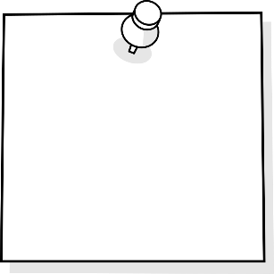
Embody GRIT –
Go For It &
Finish It
Set Challenges
Be Organized
Self Regulate
TABLE OF CONTENTS
Purpose 3
Why is this important?
Key Steps in Implementing

Self Assessment Rubrics 4
Be Organized
Embody GRIT - Go for it & finish it
Self-Regulate
Set Challenges

Resources 5
SMART GOAL Template…………………………………………………………………………………………….…….6-7

Be Organized …8-9
Embody GRIT - Go for it & finish it ..10-12
Self-Regulate ..13-16
Set Challenges …17
Purpose
Why is this important?
Character is a key 21st Century skills that students need to embody in order to self-direct their learning. Having the skills and abilities to be organized, express GRIT, self-regulate, and set challenges, allows students to successful participants in the planning of their instruction and assessment. In order “to use the full potential of their minds, students must learn to filter distractions and interruptions and to think deeply and critically” (Cash, 5).
Cash, Richard M. Self-Regulation in the Classroom Helping Students Learn How to Learn: Free Spirit Publishing, 2016

Key Steps in Teaching Character Strategies
- Isolate the skill needed to be taught
- Provide students with direct teaching to learn strategies and practice self-awareness
- Provide and allow opportunities for students to practice the skills and strategies and reflect often. This takes time at first, but students are rewarded for their efforts once they are able to master their practiced skill.
- Revisit strategies and skills often.

Character | 1 | 2 | 3 | 4 | 5
Be organized | I am never prepared for class. I do not have a planner to record deadlines or prioritize class work yet. | I am rarely prepared for class. I do not use a planner to record deadlines or prioritize class work. | I am usually prepared for class. I need support and reminders to record deadlines and prioritize class work in my planner. | I am prepared for class. I use a planner to record deadlines, but I am continuing to improve on creating and prioritizing my own deadlines and class work. | I am always prepared for class. I use a planner to record and make my own deadlines to make sure I don't fall behind. If there is too much to do I work out the most important tasks and do them first.
Embody Grit –  Go for it/finish it | I cannot cope with set-backs yet. I need help and support with identifying strategies for accomplishing my best work. | I rarely cope with set-backs. I do not know what methods work for me. I need to learn how to identify situations that might challenge me. | I usually cope with set-backs. I know what methods work for me, but do not always use them effectively. I need to learn how to identify future situations that might challenge me, and strategies for coping with them. | I cope with set-backs. I know what methods work for me and use them to accomplish my best work. I am learning to identify future situations that might challenge me, but require help to apply coping strategies. | I cope with set-backs. I can explain how I coped with a difficult problem and how I kept myself going even after failing the first time. I know what methods work for me and apply them to accomplish my best work. I can identify future situations that might challenge me and have the skills to cope with these situations.
Self-Regulate | I never congratulate myself when I have done something well. When something goes wrong I do not admit it to myself yet. I cannot identify if my behavior is helpful or harmful yet. I need help to identify negative emotions, and need to find strategies for being open to this help. | I rarely congratulate myself when I have done something well. When something goes wrong I do not admit it to myself. . I rarely identify if my behavior is helpful or harmful. I ignore the feelings that made me feel down. I need help to find and apply strategies for managing my emotions, but I don't know how to ask for this help. | I usually congratulate myself when I have done something well. When something goes wrong I usually admit it to myself and identify if my behavior is helpful or harmful. I often ignore the feelings that made me feel down. I need help to find and apply strategies for managing my emotions. | I congratulate myself when I have done something well. When something goes wrong I admit it to myself. I can identify if my behavior is helpful or harmful. I don't ignore the feelings that made me feel down, but I need help to find and apply strategies to manage my emotions. | I congratulate myself when I have done something well. When something goes wrong I admit it to myself. I can identify if my behavior is helpful or harmful. I don't ignore the feelings that made me feel down, but find and apply ways to manage and overcome my emotions. I have created strategies for dealing with these feelings successfully in the future.
Set Challenges | I do not act as a leader yet. I am uncomfortable trying new activities that involve risk. | I rarely act as a leader. I sometimes volunteer to try new activities, but I am not comfortable taking risks. | I usually act as a leader and volunteer to try new activities regardless of my apprehensions. I am becoming more comfortable about taking risks, but still need help recognizing the benefits of them. | I act as a leader. I often volunteer to try new activities and see them through. I am comfortable taking calculated risks, but am unable to recognize the benefits of them yet. | I act as a leader. I continually volunteer to try new activities and see them through regardless of my apprehensions. I am comfortable taking calculated risks and I recognize the benefits of them.

General Resources
Websites:
- http://blissfulkids.com
  - Website teaching students about Mindfulness strategies and a simple introduction to how their brain works.

- https://www.understood.org/en/learning-attention-issues/child-learning-disabilities/executive-functioning-issues/5-ways-kids-use-working-memory-to-learn
  - Self-regulation is supported by a student’s working memory. Understanding our working memory can impact how we understand why some students may struggle with some parts of self-regulation. Closely working with your SST team is beneficial.

- https://ed.ted.com/featured/nvJHP79R
  - “Don’t Eat The Marshmallow” Ted Talk - Joachim de Posada about delayed gratification. Lots of replicated activities developed for classrooms.
- https://www.youtube.com/watch?v=HyYhoCqo58w
  - “Brain-Based Learning”- Eric Jensen

Smart Goal Resources:
- https://www.teacherspayteachers.com/Product/Goal-Setting-for-Students-1370670?aref=rfvm3u53
  - SMART Goal Booklet – worksheets, posters, suggestions on how to use. Currently costs $5, occasionally can download for free

- https://www.edutopia.org/blog/smart-goal-setting-with-students-maurice-elias
  - SMART Goal Setting in regards to students character
- https://www.quora.com/What-are-good-goals-for-a-high-school-student-to-have
  - Ideas for student goals
  - Includes educational, social, and emotional goals

SMART Goal Worksheet

Today’s Date: _________ Target Date: ____________ Start Date: _______________

Date Achieved: _______________

Goal: _________________________________________________________________
______________________________________________________________________
______________________________________________________________________

Verify that your goal is SMART:

Specific: What exactly will you accomplish?
__________________________________________________________________________________________________________________________________________________________________________________________________________________
Measurable: How will you know when you have reached this goal?
__________________________________________________________________________________________________________________________________________________________________________________________________________________

Achievable: Is achieving this goal realistic with effort and commitment? Have you got the resources to achieve this goal? If not, how will you get them?
__________________________________________________________________________________________________________________________________________________________________________________________________________________

Relevant: Why is this goal significant to your life?
__________________________________________________________________________________________________________________________________________________________________________________________________________________

Timely: When will you achieve this goal?
____________________________________________________________________________________________________________________________________________

This goal is important because:
____________________________________________________________________________________________________________________________________________

The benefits of achieving this goal will be:
__________________________________________________________________________________________________________________________________________________________________________________________________________________

Take Action!

Potential Obstacles Potential Solutions
_______________________________ ______________________________
_______________________________ ______________________________
_______________________________ ______________________________
_______________________________ ______________________________
_______________________________ ______________________________
_______________________________ ______________________________

Who are the people you will ask to help you?

__________________________________________________________________________________________________________________________________________________________________________________________________________________

Specific Action Steps: What steps need to be taken to get you to your goal?

What? Expected Completion Date Completed

____________________________ _____________ ___________
____________________________ _____________ ___________
____________________________ _____________ ___________
____________________________ _____________ ___________
____________________________ _____________ ___________

Be Organized Resources
The following activities are for students struggling with “Be Organized”.
Part of being organizing involves understanding/breaking down tasks and planning for achievement. See below for activities and lessons.
- Understanding “Executive Functioning Skills”
  - https://www.understood.org/en/learning-attention-issues/child-learning-disabilities/executive-functioning-issues/a-day-in-the-life-of-a-child-with-executive-functioning-issues
    - Steps of Executive Functioning:
      - Analyze a task. Figure out what needs to be done.
      - Plan how to handle the task.
      - Get organized. Break down the plan into a series of steps.
      - Figure out how much time is needed to carry out the plan, and set aside the time.
      - Make adjustments as needed
      - Finish the task in the time allotted.
  - Executive Function Strategies such as:
    - Eat Way Visual Timers
    - Chunking Assignments
    - Writing the time on their assignment when you check in on them
    - Graphic Organizers
    - Color code handouts
- Time Matrix - 4 quadrants of time management
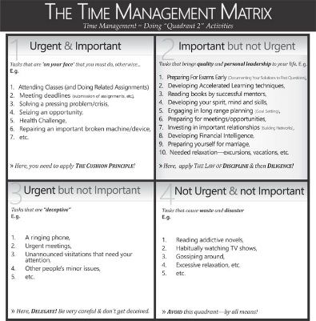
- Day Planners or electronic Calendars to set appropriate timelines
Polk Elementary's ideas on why, when, how to get students organized and resources to use: http://polkdhsd7.sharpschool.com/staff_directory/p_b_s_behavior_intervention/tier_3_interventions/organizational_tools/
- The why of getting organized and lesson plans for teachers: https://www.yourstoragefinder.com/why-teachers-must-invest-in-teaching-kids-organizational-skills
- Tedx about Life Balance and why multi-tasking doesn't work: Sara Cameron https://www.youtube.com/watch?v=II_Qyf0Vw9g
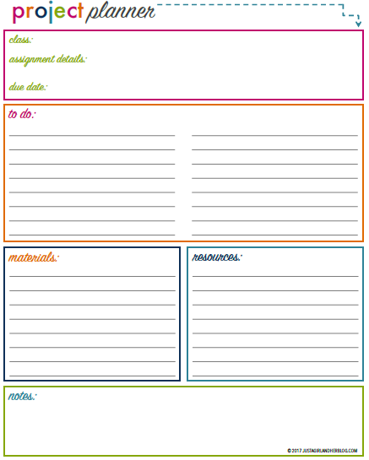
Embody GRIT – Go for it/Finish it! Resources
The following activities are for students struggling with “Embody GRIT – Go for it/Finish it”.
Part of embodying GRIT involves having a growth mindset and setting SMART goals. See below for activities and lessons.

- Growth Mindset Activities
  - Carol Dweck- “The Power of Yet”
- G.R.I.T. Activities
  - Angela Lee Ducksworth- The Key to Success- Grit
    - GRIT Quiz- https://angeladuckworth.com/grit-scale/
  - Soar A Short Animated Video
  - Pixar Short Films
GRIT Quiz

- Anchor Charts for classroom & on student desks – STUCK? Use SNOT Poster (pages 13-14)
- Goal Setting Activities or Action Plans – SMART Template (pages 6-7)

- Direct teach students about metacognition – Do students know how they best learn?

Stuck?
Use SNOT!
SELF – What notes do you have in your book? Have you checked the textbook glossary, index, and assigned pages?
Neighbour – Ask someone sitting close to you for help.
Other – Have you watched a video? Can you google it?
Teacher – Try this person after you have tried the other three.
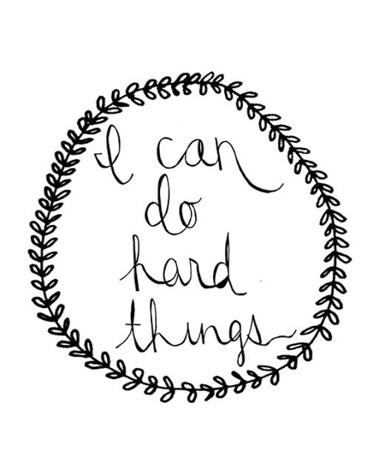
The goal is to teach you grit, perseverance, and independence.
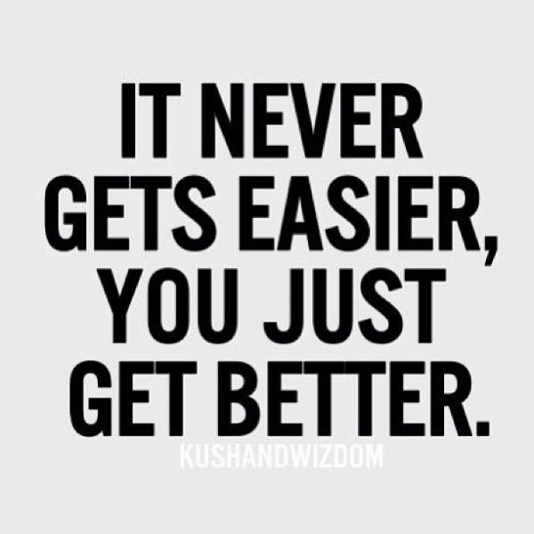

Self-Regulate Resources
The following activities are for students struggling with “Self-Regulation” Section.
Part of self-regulating is reflecting on your successes, recognizing areas of improvement, and managing your emotions. See below for activities and lessons.
- Self-Reflection activities
  - Exam reflection sheets
  - Off Task Behavior Tracking sheets
  - Weekly reflection (page 14)
  - Daily reflection (page 15)

- Direct teaching of self-regulation and self-management strategies
  - Graphic organizer (page 16)

Student Self-Reflection: This week… Date: ______________
- Were you on time for class (in your seat ready to start)? 1 2 3 4 5
- Did you bring all necessary materials to class? 1 2 3 4 5
- Did you work until the bell? 1 2 3 4 5
- Did you only leave class when necessary? 1 2 3 4 5
- Did you use your class time wisely? 1 2 3 4 5
- Did you use technology appropriately (no games, social media, videos, etc.)? 1 2 3 4 5
What do you need to improve on and how will you achieve this: ________________________
_____________________________________________________________________________________________________________________________________________________________________________________________________________________________________________________________________________________________________________________________________________________________________________________________________
Teacher Comments: ___________________________________________________________
______________________________________________________________________________________________________________________________________________________________________________________________________________________________________________________________________________________________________________________________________________________________________________________________________
____________________________________________________________________________________________________________________________________________________________

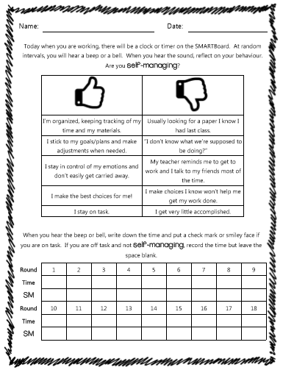
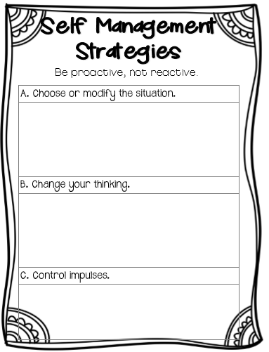
Set Challenges Resources
The following activities are for students struggling with “Set Challenges” Section.
Part of setting challenges involves being a leader, and taking healthy risks. See below for activities and lessons.
- Elements of Leadership Lesson – https://cdn.studentleadership.ca/wp-content/uploads/2014/02/elementsofleadership.pdf
- Leadership Activities – https://eduzenith.com/leadership-activities-for-high-school-students
- Leadership Skill Building – https://www.confidencecenter.com/pdf-docs/Teen-BonusReport.pdf

