Collaboration
Middle Years
Resources
I Can Build On My Team’s Strengths
I Can Cooperate
I Can Help Find Solutions
I Can Evaluate My Team
TABLE OF CONTENTS
Purpose 3
Changes In Collaboration
what we know about collaboration and collaborative learning
Why It’s Important

Self Assessment Rubrics 4
I Can cooperate
i can build on my team strengths
I can evaluate my team
I can help find solutions

Resources 6
General Communication Strategies
I Can cooperate
i can build on my team strengths
I can evaluate my team
I can help find solutions
Purpose
Changes in Collaboration
Collaboration is increasingly mentioned as an important educational outcome and most models of 21st century education include collaboration as a key skill. The value of collaboration has been assumed for many years, and over the past two decades we have seen leading businesses and organizations move to facilitate team building and team-based work. The ability to work effectively with others has become a critically important skill for career and life success.
Here is what we know about collaboration and collaborative learning:
- Emphasis on collaboration remains traditional, reflecting older models of interaction
- Use of technology does not always boost collaborative learning or improved digital literacy
- Students learn best from a mix of individual and group-based learning experiences
- Collaboration can enhance the development of critical thinking skills
- Four categories of assessment exist for evaluating collaboration as a process and outcome for both groups and individuals
- Collaborative problem solving is an area to watch with new assessments

Collaboration. P21 Partnership for 21st Century Learning. http://www.p21.org/our-work/4cs-research-series/communication. Web. May 7, 2018

Why it’s important: Students of the digital age are social by nature. They text, post, update, share, chat, and constantly co-create in technological environments with each other. When they are unable to do this in school, they become disengaged and unattached to their learning. Connection and collaboration with others are essential not only to their learning but their mental and emotional health. It is a skill that educators must exercise with them regularly, and understanding Collaboration Fluency will assist with this.
https://globaldigitalcitizen.org/collaboration-fluency-video/

Watanabe-Crockett, Lee. The Critical 21st Century Skills Every Student Needs and Why. Global Digital Citizen Foundation. https://globaldigitalcitizen.org/21st-century-skills-every-student-needs. Aug 2 2016. Web May 6, 2018

Collaboration | 1 | 2 | 3 | 4 | 5
Cooperate | I do not participate with others to accomplish common goals yet. I do not follow guidelines yet. | I sometimes participate with others to accomplish common goals. I sometimes follow guidelines. | I can participate with others to accomplish common goals. I usually follow guidelines. | I always participate with others to accomplish common goals. I respect and follow guidelines. | I always participate with others to accomplish common goals. I respect and follow guidelines and encourage others to as well.
Build team strengths | I rarely work productively with my group. My feedback is mainly negative. | I sometimes work productively with my group on the task at hand. I encourage my team members, but not always in a positive way. | I work productively in my group on the task at hand. I usually encourage my team members in a positive way. | I work productively in my group and I attempt to make sure that everyone is heard by sticking up for group members and inviting them to speak. I help make sure everyone contributes, by encouraging them in positive ways. | I work productively in my group and I actively prevent negativity, promote solutions and positive actions, and make sure every member of the team feels listened to and valued.
Evaluate the team | I rarely acknowledge what my group has accomplished. I don’t praise others yet. | I can praise my team on a job well done, but don’t always do so. | I can personally praise members when work has been done well and/or accomplished on time. | At the end of the group task, I am able to make the team feel proud of the work they have achieved and share our successes with people outside of our team. | At the end of the group task, I am able to make the team feel proud of the work they have achieved. I am able to reflect positively on improvements for next time, and share our successes with people outside of our team.
Find solutions | I do not start solving problems on my own yet. | I sometimes can identify a problem but need support to find solutions. | I can identify a problem but need support breaking it down into smaller tasks. I can start solving the problem. | I can identify a problem, and can brainstorm and suggest strategies for solving. I can collaborate with others to solve it. | I can recognise a problem and break it up into smaller tasks, and collaborate with others to solve it effectively.

General Collaboration Resources

- https://globaldigitalcitizen.org/

The Global Digital Citizen Foundation is a non profit organization creating exceptional resources for educators and dedicated to cultivating responsible, ethical, global citizens for a digital world—learners who strive together to solve problems that matter to create a bright future for all.
https://solutionfluency.com/en/downloadables/clf-quickstart-skills-guide

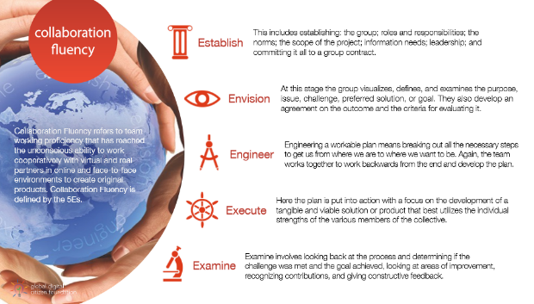

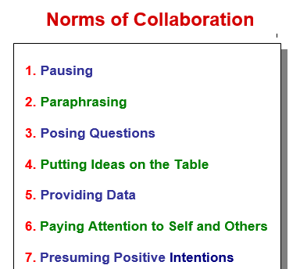
- Setting the Norms for Group Work and Collaboration. This website has posters, and various student inventories and assessments for self-reflection and group reflection.
http://www.thinkingcollaborative.com/norms-collaboration-toolkit/

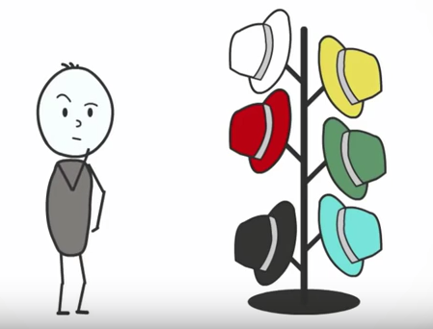
- Edward des Bono’s- Six Thinking Hats is a simple, effective parallel thinking process that helps people be more productive, focused, and mindfully involved. A powerful tool set, which once learned can be applied immediately! You and your team members can learn how to separate thinking into six clear functions and roles. Each thinking role is identified with a colored symbolic "thinking hat." By mentally wearing and switching "hats," you can easily focus or redirect thoughts, the conversation, or the meeting.
Many resources are already created for this strategy. Do a quick google search and many already made activities are ready for you.
http://www.debonogroup.com/six_thinking_hats.php
https://www.youtube.com/watch?v=UZ8vF8HRWE4
- General Collaboration Activities. Below is just a sample of many different types of classroom culture activities.
https://www.smore.com/0udr-fun-critical-thinking-activities

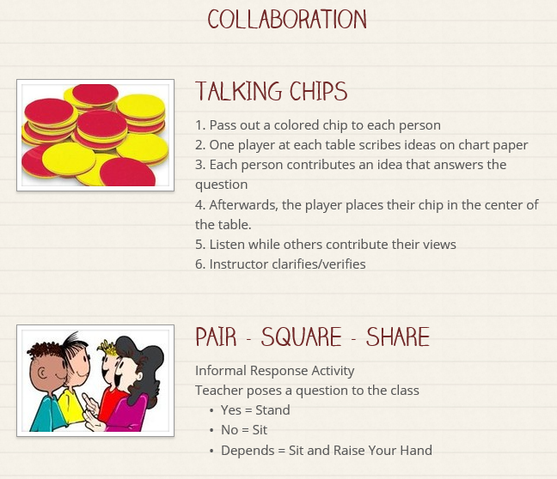

Design Your Classroom For Collaboration in a 21st Century Space
Display:  - Genius bar  - Activate back wall  - Studio corners  - White boards with one device for immediate collaboration  - Visual gallery/display at lower levels  - Interactive displays  - Only necessary items shown | Storage:  - Remove clutter  - Not used in last year…toss  - Individual white boards  - Make containers, bins, etc easy to identify  - Critical thinking games ( labeled clearly, lego, marble works, puzzles,e tc)
Furniture:  - Easy to move around  - Create space  - Circle/kidney tables  - Bigger tables  - Matts  - Big pillows  - Comfy chairs  - Circle of chairs  - Yoga balls, stools  - Shell shaped chairs that rock | Teaching Zone:  - Moved into class  - Clean, efficient space  - Useable  - SMARTboard easily seen by all
Personality:  - colour  - promote collaboration, student lead learning, exploration, digital technologies, creativity  - lights off, lamps used  - blues and greens have calming affects | Other:  “ Active Student Learning”  - classroom corners: critical thinking corner, creativity corner  - quiet space/ booths “ Cave space”  - walking lanes  - Tinker Station  - Video booth from a fridge box

Questions to Consider:
- What are your key routines and activities?

- When are classroom successes amplified?

- When are challenges seen by physical environment?

- How do your students learn best?

- Identify THREE priorities you would like to transform. ( Example: peer to peer learning, environment of trust and comfort, flow and mobility, teaching zone efficiency, storage, student furniture)

- Decide what you feel is already working: ( keep class motos, beliefs, displays, etc)

- What isn’t working in your classroom and brainstorm ways to tackle this issue.

- What supplies and materials do students use most often? Brainstorm the best ways to store them.

Adapted from TheThirdTeacher+, http://www.edutopia.org/blog/steps-to-redesign-your-classroom-melanie-kahl ( December, 2103).

I Can Cooperate Resources
Collaboration | 1 | 2 | 3 | 4 | 5
Cooperate | I do not participate with others to accomplish common goals yet. I do not follow guidelines yet. | I sometimes participate with others to accomplish common goals. I sometimes follow guidelines. | I can participate with others to accomplish common goals. I usually follow guidelines. | I always participate with others to accomplish common goals. I respect and follow guidelines. | I always participate with others to accomplish common goals. I respect and follow guidelines and encourage others to as well.
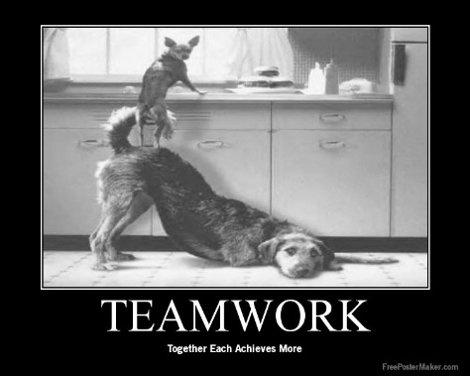
- Using Tech Tools- have students create posters for the school around cooperation & teamwork. Link to health outcomes. https://www.educatorstechnology.com/2013/02/the-best-10-tools-to-create-posters-for.html

- Together watch and discuss videos that have both positive and negative cooperation. See sample videos below. Use exit slip as formative assessment.
https://www.youtube.com/watch?time_continue=19&v=8Amu3UBj-qw
https://www.youtube.com/watch?v=ZnjJpa1LBOY
https://www.youtube.com/watch?v=fUXdrl9ch_Q

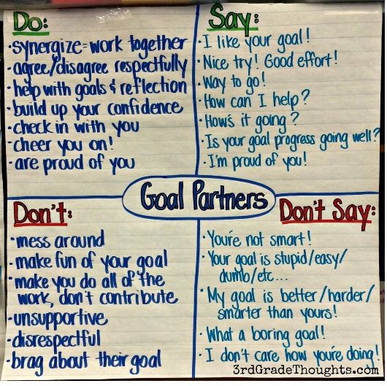
- Create anchor charts of what participating in a group looks like. Group collaboration norms.

Collaboration | 1 | 2 | 3 | 4 | 5
Build team strengths | I rarely work productively with my group. My feedback is mainly negative. | I sometimes work productively with my group on the task at hand. I encourage my team members, but not always in a positive way. | I work productively in my group on the task at hand. I usually encourage my team members in a positive way. | I work productively in my group and I attempt to make sure that everyone is heard by sticking up for group members and inviting them to speak. I help make sure everyone contributes, by encouraging them in positive ways. | I work productively in my group and I actively prevent negativity, promote solutions and positive actions, and make sure every member of the team feels listened to and valued.
I Can Build On My Team’s Strengths Resources

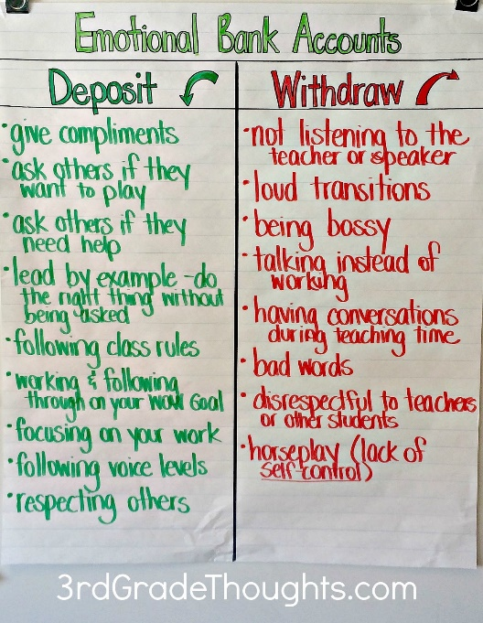
- Steven Covey’s- 7 Habits of Highly Effective People talk about “Emotional Bank Account”. A good way to talk to students about being a good group member and building on everyone’s strengths. Lots of free activities & youtube videos available for more information and activity ideas.
https://www.youtube.com/watch?v=qktDB08EBCM

- Encourage ALL group members to have a voice by using activities (I.e. Socratic seminars or fishbowl activities) to get active participation by everyone.
  - https://www.facinghistory.org/resource-library/teaching-strategies/fishbowl?utm_source=WeAreTeachers&utm_medium=8FunWaysArticle&utm_content=FacingHistory&utm_campaign=EMCPub_Article

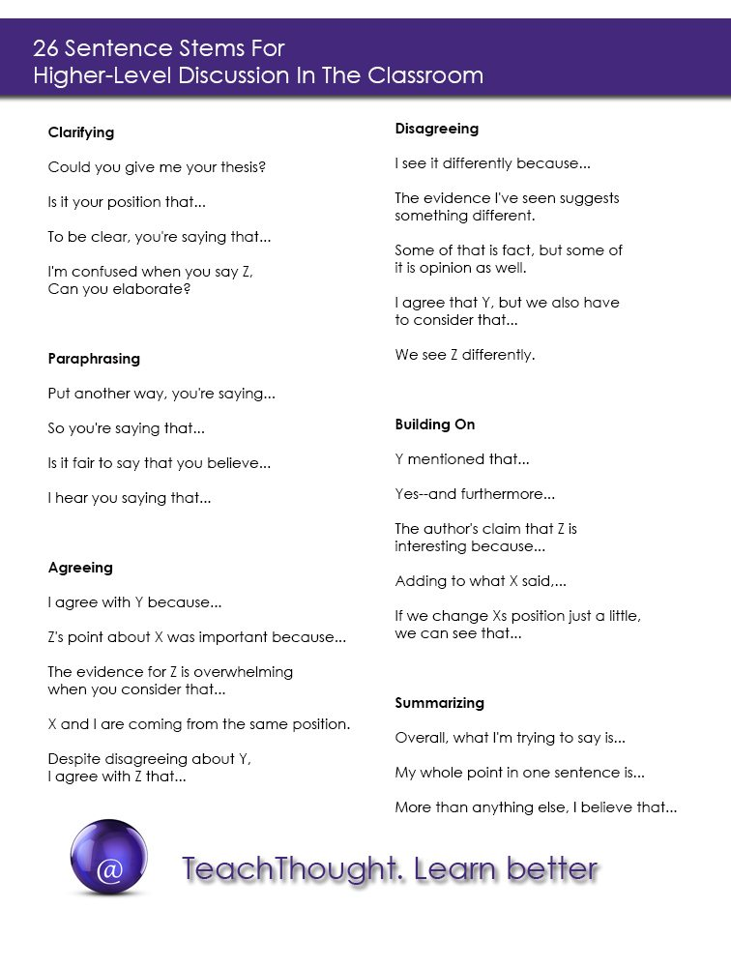
- Model Collaboration & practice in short activities:
https://www.edutopia.org/practice/teaching-group-work-building-student-collaboration-and-agency

- One of the best ways to train your students to work collaboratively is through game playing. Cooperative classroom games help students become critical thinkers, learn to work with one another and establish a positive classroom environment. The best part? Kids have fun while developing these skills!
  - Sample team building games/activities
https://www.teachthought.com/critical-thinking/10-team-building-games-that-promote-critical-thinking/
https://www.wrike.com/blog/team-building-games/

- Create sentence starts for students to brainstorm in creative ways to have discussion. “Accountable Talks” Link to some free bookmarks from Teachers Pay Teachers.
https://www.teacherspayteachers.com/Browse/Search:accountable%20talk%20bookmarks
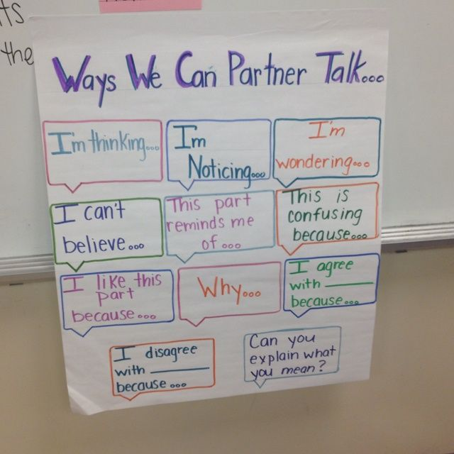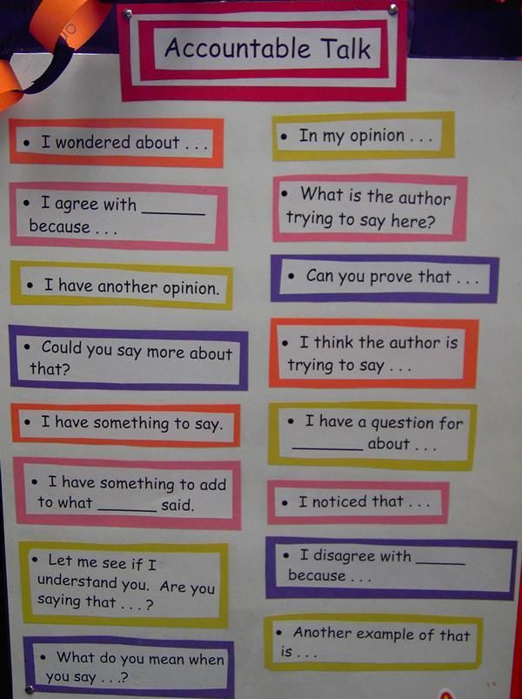

I Can Evaluate My Team Resources
Collaboration | 1 | 2 | 3 | 4 | 5
Evaluate the team | I rarely acknowledge what my group has accomplished. I don’t praise others yet. | I can praise my team on a job well done, but don’t always do so. | I can personally praise members when work has been done well and/or accomplished on time. | At the end of the group task, I am able to make the team feel proud of the work they have achieved and share our successes with people outside of our team. | At the end of the group task, I am able to make the team feel proud of the work they have achieved. I am able to reflect positively on improvements for next time, and share our successes with people outside of our team.

- Group & Self Assessment Rubrics to open up discussion. Co-create partner assessments according to the group norms you agreed upon.

http://www.readwritethink.org/files/resources/printouts/Group%20and%20Self%20Evaluation.pdf

- Teach kids how to celebrate & recognize the good work others have done. Brainstorm a list of ways to celebrate and thank your team.

Collaborative Group Rubric
Student Name:_________________________________________________________________ Date:______________________
Project Title: __________________________________________________________________ Outcome:_________________
Individual Tasks | Learning Level | Feedback
Responsibilities of individual role. Student contributed to a group as an active member
Group Tasks | Learning Level | Feedback
Research
Group included key facts, information, and criteria regarding subject area.
Literacy Skills and Strategies
Group included appropriate ideas with supporting details. Findings were summarized.

Communication of Ideas
Group communicated ideas efficiently both written and verbally and was aware of their audience.
Collaboration
Students were able to communicate ideas among each. Students demonstrated respect among each other. Students used appropriate language to diffuse disagreements and celebrate accomplishments.
KEY:  5: Wow!  4: I get it and I can show someone else  3: Got it!  2: Getting There  1: Need more practice | Overall  Learning Levels:
I Can Help Find Solutions Resources
Collaboration | 1 | 2 | 3 | 4 | 5
Find solutions | I do not start solving problems on my own yet. | I sometimes can identify a problem but need support to find solutions. | I can identify a problem but need support breaking it down into smaller tasks. I can start solving the problem. | I can identify a problem, and can brainstorm and suggest strategies for solving. I can collaborate with others to solve it. | I can recognise a problem and break it up into smaller tasks, and collaborate with others to solve it effectively.

- Teach Problem Solving Skills & Mindset:
  - IDEO Company- IDEO is a global design company. We create positive impact through design. https://www.ideo.com/
https://www.youtube.com/watch?time_continue=6&v=XrpAveg7ZIg
  - Design Thinking is an approach to addressing challenges in a thoughtful and fun way, where you get to apply the 4Cs -- collaboration, creativity, critical thinking, and communication –- to your own work as you develop new solutions for your classroom, school, and community. https://www.edutopia.org/what-is-design-thinking-for-educators
https://www.youtube.com/watch?time_continue=4&v=Ee4CKIPkIik
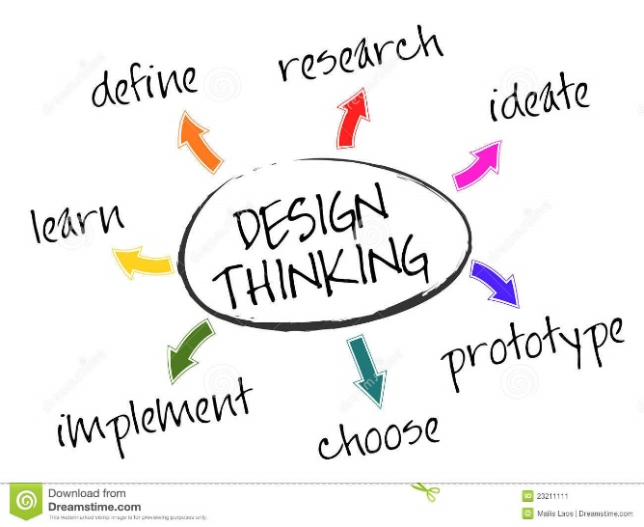

https://www.edutopia.org/blog/10-ready-borrow-project-ideas-suzie-boss

