Self-Management
Middle Years
Part of the SECRET Skills Ladder

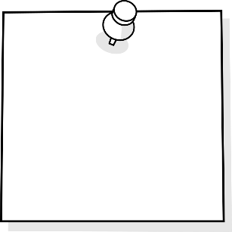
I Manage Risks
I Am Organized
I Go For It &
Finish It
I Manage
Emotions
TABLE OF CONTENTS
Purpose 3
Why is this important?
Key Steps in Implementing?

Self Assessment Rubrics 4
I manage risks
i manage emotion
I Go for it & finish it
I am Organized

Resources 6
I manage risks 8
i manage emotion 9
I Go for it & finish it 10
I am Organized 11

Purpose
Why is this important?
Self-management skills are key 21st Century skills that students need to be ready to self-direct in their learning. Having these key skills allow them to be part of the planning in their instruction and assessment. In order “to use the full potential of their minds, students must learn to filter distractions and interruptions and to think deeply and critically” (Cash, 5).
Cash, Richard M. Self-Regulation in the Classroom Helping Students Learn How to Learn: Free Spirit Publishing, 2016

Key Steps in Teaching Self-Management Strategies
- Isolate the skill needed to be taught
- Provide students with direct teaching to learn strategies and practice self- awareness
- Provide and allow opportunities for students to practice the skills and strategies and reflect often. This takes time at first but students are rewarded for their efforts once they are able to master their practiced skill.
- Revisit strategies and skills often.

I Self-Manage: “confident, resilient self-motivated people who relate well to others”
I Self-Manage
Criteria | Level 1 | Level 2 | Level 3 | Level 4 | Level 5
I Manage risk | I need help to set my goals to create a plan in order to complete my work.  I need reminders to work and stay on task and finish my work. | I need some assistance to try new things.  I am a little nervous to make mistakes. | I try new things to help improve my skills.  I know if I make mistakes I will learn from them. I don’t like to make mistakes, so sometimes I avoid trying new things. | I am excited to try new things.  I know that if I make mistakes I will learn from them.  I look for opportunities and decide which are best for me. | I am helpful, not disruptive and help others in class.  I can effectively work alone
I am organized | I need help to manage my materials and time.  I have trouble knowing what’s most important to do first.  I have a hard time working ahead.  I miss deadlines. | Sometimes I need help organizing my materials and time.  I am sometimes reliable and I often need help to know what is most important to do first.  I have a hard time working ahead.  I need deadlines. | I have my time and materials organized.  I am good at having my priorities in order.  I am reliable.  I start thinking about future projects ahead of time.  I meet deadlines. | I have all my materials when I need them, and have my priorities in order.  I can manage my time and I am always reliable. I have my work done ahead of a deadline.  I set my own deadlines and always hand things in on times. | I organize my materials the way I learn best ( including digital formats)  I can set my own pace that is accurate which allows me to anticipate the demands needed to complete my tasks.  I share my organizational strategies with other to help them improve.
I Go For It & Finish | I need help to set my goals to create a plan in order to complete my work.  I also need reminders to work independently and stay on task and finish my work. | Sometimes I need help to set goals and create a plan in order to complete my work.  I can have a hard time working on my own. | I am able to set goals and create a plan in order to complete my work.  I can focus on my tasks to finish my work. | I am able to set my own goals without help and create a plan and make adjustments.  I am able to work on my own or ask for help when I need it to complete my tasks. | I am able to independently and efficiently complete my tasks to high standards.  I help others achieve their tasks if they need help.
I Manage Emotions | It is a challenge for me to control my body and emotions and I am often a disruption to the class.  I need many reminders watch my emotions and stay in control.  My participation in class is often disruptive and off task. | I can sometimes control my body and emotions but need reminders to keep them under control and stay on task.  I sometimes have a positive attitude and sometimes participate in class. | I am in control of my body and emotions and use appropriate actions and words to express myself.  I have a positive attitude by show confidence and participating in class. | I am always in control of my body and my emotions and can help other people control theirs too.  I am aware of how I feel (good and bad) and I take pride in my control over my reactions to things.  I have a great attitude towards learning. | I have an incredibly positive attitude towards learning and am insightfully aware of my emotions and have flawless control over my body.  I always encourage others to have a positive attitude and help them to see the best in others.  I have a Growth Mindset!

General Resources
Websites:
- http://blissfulkids.com
  - Website teaching students about Mindfulness strategies and a simple introduction to how their brain works.

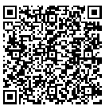
- https://www.understood.org/en/learning-attention-issues/child-learning-disabilities/executive-functioning-issues/5-ways-kids-use-working-memory-to-learn
  - Self-regulation is supported by a student’s working memory. Understanding our working memory can impact how we understand why some students may struggle with some parts of self-regulation. Closely working with your SST team is beneficial.

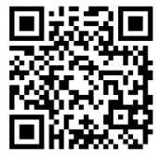
- https://ed.ted.com/featured/nvJHP79R
  - “Don’t Eat The Marshmallow” Ted Talk - Joachim de Posada about delayed gratification. Lots of replicated activities developed for classrooms.
- https://www.youtube.com/watch?v=HyYhoCqo58w
  - “Brain-Based Learning”- Eric Jensen
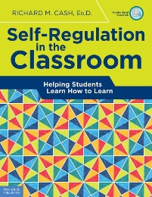
Books:
Each school should have copy of this book in their library.

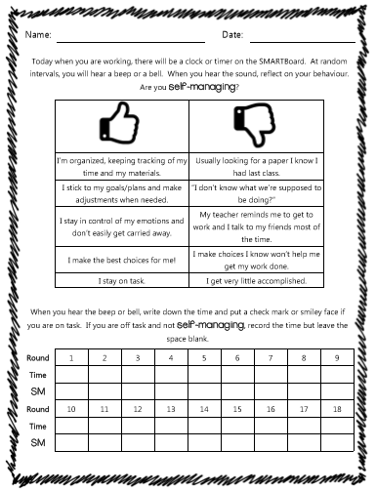

I Manage Risks Resources
Many activities fit perfectly here for students struggling with “I Manage Risks” Section. Below are activities you could easily search up and find endless resources.
- Growth Mindset Activities
  - Class Dojo Growth Mindset Video Series
  - Carol Dweck- “The Power of Yet”
  - Link themed picture books and novels

- G.R.I.T. Activities
  - Angela Lee Ducksworth- The Key to Success- Grit
  - Soar A Short Animated Video
  - Pixar Short Films

I Am Organized Resources
Many activities fit perfectly here for students struggling with “I am Organized” Section. Below are activities you could easily search up and find endless resources.
- Understanding “Executive Functioning Skills”
  - https://www.understood.org/en/learning-attention-issues/child-learning-disabilities/executive-functioning-issues/a-day-in-the-life-of-a-child-with-executive-functioning-issues
    - Steps of Executive Functioning:
      - Analyze a task. Figure out what needs to be done.
      - Plan how to handle the task.
      - Get organized. Break down the plan into a series of steps.
      - Figure out how much time is needed to carry out the plan, and set aside the time.
      - Make adjustments as needed
      - Finish the task in the time allotted.
  - Executive Function Strategies such as:
    - Eat Way Visual Timers
    - Chunking Assignments
    - Writing the time on their assignment when you check in on them
    - Graphic Organizers
    - Color code handouts
    - Pictures of organized locker (a standard for students to compare too daily)

- Time Matrix - 4 quadrants of time management
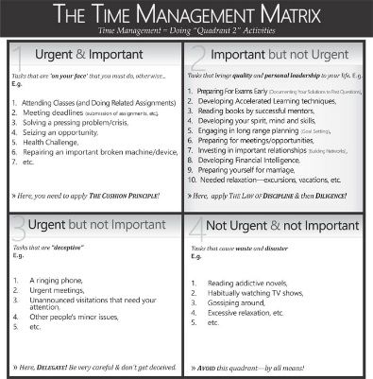

- Day Planners or electronic Calendars to set appropriate timelines
Polk Elementary's ideas on why, when, how to get students organized and resources to use: http://polkdhsd7.sharpschool.com/staff_directory/p_b_s_behavior_intervention/tier_3_interventions/organizational_tools/
- The why of getting organized and lesson plans for teachers https://www.yourstoragefinder.com/why-teachers-must-invest-in-teaching-kids-organizational-skills
- Tedx about Life Balance and why multi tasking doesn't work: Sara Cameron https://www.youtube.com/watch?v=II_Qyf0Vw9g

I Go For It & Finish It Resources
Many activities fit perfectly here for students struggling with “I Go For It & Finish It” Section. Below are activities you could easily search up and find endless resources.
- Anchor Charts for classroom & on student desks:
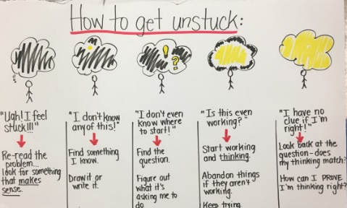
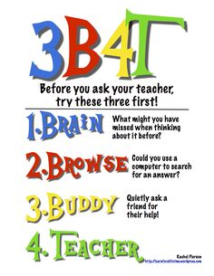
  - How To Get Unstuck
  - Ask 3 Before me Strategy

- Goal Setting Activities or Action Plans

- Direct teach students about metacognition
- Self-Reflection activities
  - Exam reflection sheets
  - Off Task Behavior Tracking sheets

I Manage Emotion Resources
Many activities fit perfectly here for students struggling with “I Manage Risks” Section. Below are activities you could easily search up and find endless resources.
- “How Does Your Engine Run”

- Mindfulness and the Brain
  - Body Scan
  - Blissful Kids

Cards for Identifying Angers and Providing Tools to Self Manage:
**needs to be attached to file

