Writing Lesson with Plasticene
Materials:
- Paper plates, one per student
- Plasticene in several different colors, enough so each student has several different small balls
- Overhead projector or chalkboard
- Sticky notes and pencils or pens
Steps:
- Pass out a paper plate to each student.
- Give each student at least three small balls of plasticene. Have extra plasticene on hand in case someone what more as the lesson progresses.
- Urge the students to keep the plasticene on the paper plate.
- Ask the students to “create something” with the plasticene. Be intentionally vague.
- On the overhead or chalkboard, record any questions you hear the students say, such as: “What should I make?”, “Is this okay?”, or “Can I do this?”. Do not answer the questions; just refocus the students on the assignment. Circulate around the room.
- Give the students 8 – 15 minutes (depending on the age of the students).
- Show the students the list of questions and see if they have any additional ones to add.
- Give each of the students another piece of plasticene. Tell them that they have two minutes to ADD something to their piece.
- As they work, write down any additional questions or comments that you hear (whether good or bad).
- Next, tell them that they have two minutes to REMOVE something. Continue to add questions/comments to the list.
- Finally, give them two minutes to CHANGE something so that their sculptures are the way they want them, again adding new questions/comments.
- Have the students come up with a title for their piece and write the name on the paper plate.
- Divide the class in half. Have half of the students stay at their desks, while the other half will circulate around looking at the sculptures of those seated. Instruct the “circulating” students that they have two responsibilities for this task:
  - Make a favorable comment about the piece you are visiting. It should be a substantive comment such as “I like how your elephant looks like it is very playful”, rather than “Good job”. With older students you could have them write the comments on a sticky note and leave it at the desk where they are making their visit.
  - Ask a “Good” question related to the piece. The “sculptor” then will answer the question.
- Switch roles.

- As a group, discuss how this activity is like the writing process: (adjusting to fit the writing process stages that you use with your students)
  - Stage 1 = think of an idea
  - Stage 2 = write/create (make the sculpture)
  - Stage 3 = edit/revise (add to the sculpture, remove from the sculpture)
  - Stage 4 = finish/publish/make the good copy (making the final changes)
  - Stage 5 = give your work a name
- As a large group, refer to the list of questions/comments you generated while they were working. Discuss how those questions that they had in today’s lesson are the same sorts of questions that they have when they write. If time permits, talk about each question and how it relates to what they would go through and the questions they ask themselves when they are writing.
- Discuss that feedback process:
  - First of all, the teacher was giving feedback when s/he asked the students to add, remove, change their sculptures. Talk about how that feedback made them feel. Explain that if you feel really strongly that any of those “editing” ideas would change your “story” too much, and if you can explain why you feel that way, then it would not be necessary to make the changes. Also talk about the importance of being “open-minded” to the suggestions of others and giving their ideas serious and careful consideration.
  - Peer feedback was given as the students circulated around the room, looking at each other’s pieces. Talk about the importance of that feedback, how it made them feel, and how the suggestions of others could add to the quality of your work.
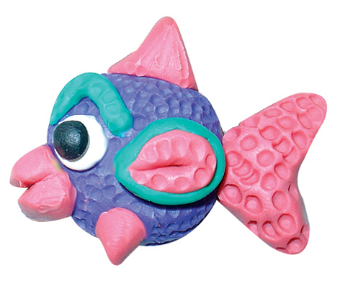
  - Discuss the importance of getting helpful feedback, both from the teacher and from their peers. It is the feedback that will make the writing easier for them.

