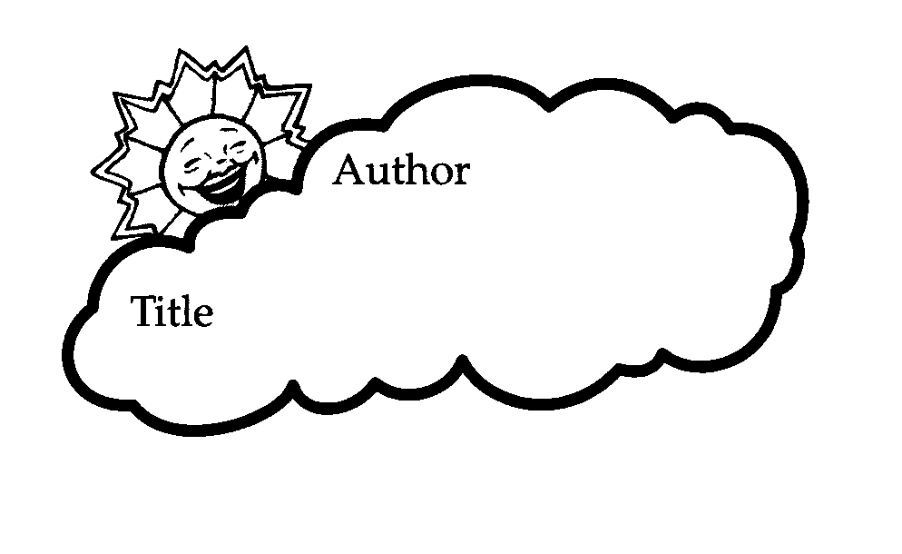

Date: ______________

Name: ______________

Story Stars

Who is the main character in the story?______________

Minor characters: ______________________________

____________________________________________What is the setting of the story?

Where: _____________ When: ______________

What is the problem in the story?

________________________________________________________________________________________________________________________________________________________________________________



What happened first?

________________________________________________________________________________________________________________________________________________________________________________



Then what happened?

________________________________________________________________________________________________________________________________________________________________________________

What happened next?

________________________________________________________________________________________________________________________________________________________________________________



How does the story end?

________________________________________________________________________________________________________________________________________________________________________________



What is the most exciting part of the story? This is called the climax.

________________________________________________________________________________________________________________________________________________________________________________