W | R | I | T | E
Write 5 words that describe you. | Write 5 words that describe your Mom or Dad. | Write about your favorite time of year. | Make a list of all of the things hanging on the walls in your house. | Write an alliterate sentence for any letter. Include at least 5 words.
Write a favorite memory or when you were in grade one or two. | Write about the funniest thing that ever happened to you. | Write a letter to your teacher telling him/her about your favorite subject in school and why. | Write a journal entry about something that happened in your life in the last week/month/  year. | Read a story. Use a graphic organizer to write a brief summary of the story.
Write about your best friend. | Make a list of your favorite foods. | 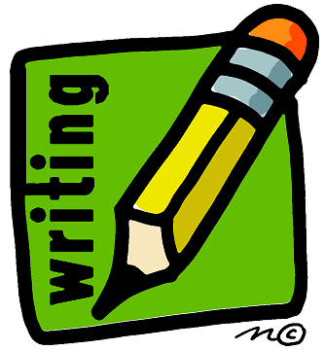 | Write about the main character of the book you read recently. | Write 3 questions you would like to ask your favorite author.
Make a list of 10 things that you can hear when you are outside in the springtime. | Write a thank you note to someone. | Write a recipe about the makings of a good story. | Write about 3 of your best accomplishments. | Write an article trying to persuade Mom/Dad/  your teacher that you should be allowed to do something.
Write about your favorite animal. | Write about your favorite sport. | Write 2-3 sentences about today’s weather. | Write a poem of your choice. | Write a story of your choice.

