Character
Middle Years
Part of the SECRET Skills Ladder

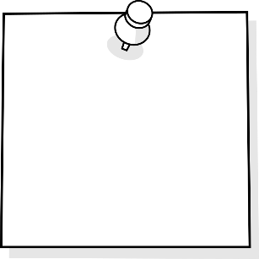
I Can Embody
GRIT/ Go For
It & Finish It
I Can Be
Organized
I Can
Self-Regulate
I Can Set
Challenges

TABLE OF CONTENTS
Purpose 3
Why is this important?
Key Steps in Implementing?

Self Assessment Rubrics 4
I can be organized
I can embody GRIT
I can self-regulate
I can set challenges

Resources 6
I can be organized
I can embody GRIT
I can self-regulate
I can set challenges

Purpose
Why is this important?
Character is one of the 21st Century skills that students need in order to be ready to self-direct in their learning. Having the key skills that come along with strength of character allows students to be part of the planning of their instruction and assessment. In order “to use the full potential of their minds, students must learn to filter distractions and interruptions and to think deeply and critically” (Cash, 5).
Cash, Richard M. Self-Regulation in the Classroom Helping Students Learn How to Learn: Free Spirit Publishing, 2016

Key Steps in Teaching Self-Management Strategies
- Isolate the skill needed to be taught
- Provide students with direct teaching to learn strategies and practice self- awareness
- Provide and allow opportunities for students to practice the skills and strategies and reflect often. This takes time at first but students are rewarded for their efforts once they are able to master their practiced skill.
- Revisit strategies and skills often.

Character | 1 | 2 | 3 | 4 | 5
Be organized | I am never prepared for class with needed supplies. I do not record deadlines or prioritize class work yet. | I am rarely prepared for class with needed supplies. I do not record deadlines or prioritize class work yet. | I am usually prepared for class with my supplies. I need support and reminders from parents and teachers to record deadlines and prioritize class work. | I am regularly prepared for class. I have a method that works for recording and meeting deadlines. I can still improve on prioritizing class work at times. | I am always prepared for class. I have a method that ensures I meet all deadlines independently. When I have a lot on my plate I am able to prioritize important tasks first, and complete all my class work!
Embody Grit - Go for it/finish it | I cannot cope with set-backs yet. I need help and support with identifying strategies for accomplishing my best work. | I rarely cope with set-backs. I don't know what methods work for me. I need to learn how to persevere in situations that might challenge me. | I usually cope with set-backs. I sometimes struggle to be resilient after failing. I know what methods work for me, but I don't always use them effectively. | I cope with set-backs. I usually show resilience when facing challenges. I know what methods work for me and use them to accomplish my best work. I am learning to identify future situations that might challenge me, but require help to apply coping strategies. | I cope with set-backs. I always show resilience was facing challenges. I know what methods work for me and apply them to accomplish my best work. I can identify future situations that might challenge me and have the skills to cope with these situations independently.
Self-Regulate | I never celebrate my accomplishments. I cannot apply strategies for managing my emotions yet. I can not identify if my behavior is helpful or harmful yet. | I rarely celebrate my accomplishments. I need help to find and apply strategies for managing my emotions. I rarely can identify if my behavior is helpful or harmful. | I usually celebrate my accomplishments. I sometimes need help to find and apply strategies for managing my emotions. I usually can identify if my behavior is helpful or harmful. | I can celebrate my accomplishments. When something goes wrong I admit it to myself, and manage my emotions appropriately. I can identify if my behavior is helpful or harmful. | I celebrate my accomplishments. I have a toolbox of methods to handle how I manage my emotions in various situations. I can identify if my behavior is helpful or harmful.
Set Challenges | I never act as a leader. I do not try new things or take risks yet. | I rarely act as a leader. I rarely try new things and am uncomfortable taking risks. | I am able to act as a leader. I sometimes try new things. I am learning to be more comfortable taking risks and seeing the benefits. | I usually act as a leader. I often try new things and see them through. I can take risks but sometimes don’t recognize the benefits. | I act as a leader. I always try new things and see them through. I am comfortable taking risks and recognize the benefits of them.

General Resources
Websites:
- http://blissfulkids.com
  - Website teaching students about Mindfulness strategies and a simple introduction to how their brain works.

- https://www.understood.org/en/learning-attention-issues/child-learning-disabilities/executive-functioning-issues/5-ways-kids-use-working-memory-to-learn
  - Self-regulation is supported by a student’s working memory. Understanding our working memory can impact how we understand why some students may struggle with some parts of self-regulation. Closely working with your SST team is beneficial.

- https://ed.ted.com/featured/nvJHP79R
  - “Don’t Eat The Marshmallow” Ted Talk - Joachim de Posada about delayed gratification. Lots of replicated activities developed for classrooms.
- https://www.youtube.com/watch?v=HyYhoCqo58w
  - “Brain-Based Learning”- Eric Jensen
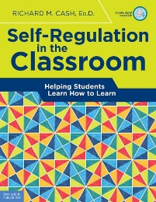
Books:
Each school should have copy of this book in their library.

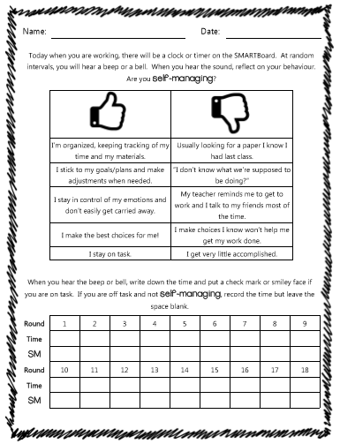

I Can Set Challenges Resources
Many activities fit perfectly here for students struggling with “I Can set” Section. Below are activities you could easily search up and find endless resources.
- Growth Mindset Activities
  - Class Dojo Growth Mindset Video Series
  - Carol Dweck- “The Power of Yet”
  - Link themed picture books and novels

Linked to Goal Setting Resources

A Guide to Your Best Year Teaching With Smart K12 Goal Setting Methods

I Am Organized Resources
Many activities fit perfectly here for students struggling with “I am Organized” Section. Below are activities you could easily search up and find endless resources.
- Understanding “Executive Functioning Skills”
  - https://www.understood.org/en/learning-attention-issues/child-learning-disabilities/executive-functioning-issues/a-day-in-the-life-of-a-child-with-executive-functioning-issues
    - Steps of Executive Functioning:
      - Analyze a task. Figure out what needs to be done.
      - Plan how to handle the task.
      - Get organized. Break down the plan into a series of steps.
      - Figure out how much time is needed to carry out the plan, and set aside the time.
      - Make adjustments as needed
      - Finish the task in the time allotted.
  - Executive Function Strategies such as:
    - Eat Way Visual Timers
    - Chunking Assignments
    - Writing the time on their assignment when you check in on them
    - Graphic Organizers
    - Color code handouts
    - Pictures of organized locker (a standard for students to compare too daily)

- Time Matrix - 4 quadrants of time management
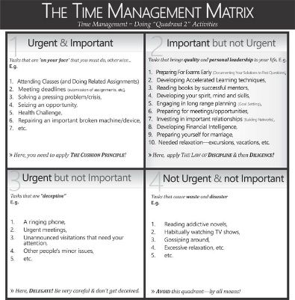

- Day Planners or electronic Calendars to set appropriate timelines
Polk Elementary's ideas on why, when, how to get students organized and resources to use: http://polkdhsd7.sharpschool.com/staff_directory/p_b_s_behavior_intervention/tier_3_interventions/organizational_tools/
- The why of getting organized and lesson plans for teachers https://www.yourstoragefinder.com/why-teachers-must-invest-in-teaching-kids-organizational-skills
- Tedx about Life Balance and why multi tasking doesn't work: Sara Cameron https://www.youtube.com/watch?v=II_Qyf0Vw9g

- I Can Embody GRIT (Go For It & Finish It) Resources
Many activities fit perfectly here for students struggling with “I Go For It & Finish It” Section. Below are activities you could easily search up and find endless resources.
- Anchor Charts for classroom & on student desks:
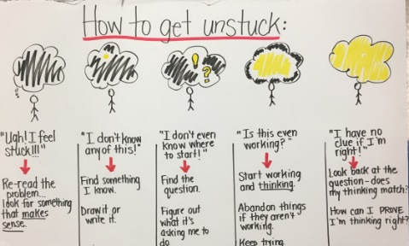
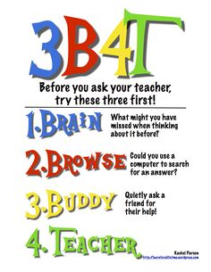
  - How To Get Unstuck
  - Ask 3 Before me Strategy

- Goal Setting Activities or Action Plans

- Direct teach students about metacognition
- Self-Reflection activities
  - Exam reflection sheets
  - Off Task Behavior Tracking sheets
- G.R.I.T. Activities
  - Angela Lee Ducksworth- The Key to Success- Grit
  - Soar A Short Animated Video
  - Pixar Short Films

I Can Self-Regulate Resources
Many activities fit perfectly here for students struggling with “I Manage Risks” Section. Below are activities you could easily search up and find endless resources.
- “How Does Your Engine Run”

- Mindfulness and the Brain
  - Body Scan
  - Blissful Kids

Cards for Identifying Angers and Providing Tools to Self Manage:
**needs to be attached to file

