Communication
Middle Years
Resources
I Can
I Can Ask
For Feedback
I Can
I Can Be Clear
I Can
I Can Express My Opinions
I Can
I Can Share My Learning
TABLE OF CONTENTS
Purpose 3
Why is this important?
Practical communication skills are needed for all students

Self Assessment Rubrics 4
I Can Share my learning
i can express my opinion
I can be clear
I can ask for feedback
Digital Communication Continuum 5

Resources 7
General Resources 7
I Can Share my learning
i can express my opinion
I can be clear
I can ask for feedback
Purpose
Why is this important?
Communication is one of the key components of 21st century learning, yet it has not attracted the same level of research or attention as creativity, collaboration, or critical thinking. Communication competence involves mediated and digital communication, interpersonal, written and oral communication. As our society evolves, we cannot assume that our students will gain communication competence on their own.
Practical communication skills are needed for all students
- Speech language development is a key aspect of preschool and early learning
- Social and emotional learning studies address positive classroom communication interventions
- Business-related communication assessments (like the elevator pitch assessment) are also applicable to education contexts
- Digital and media literacy provide unique approaches to analyzing communication skills
- Additional research and interventions are needed to support 21st century communication skills

Communication. P21 Partnership for 21st Century Learning. http://www.p21.org/our-work/4cs-research-series/communication. Web. May 7, 2018

Communication | 1 | 2 | 3 | 4 | 5
Share learning | I do not share my learning with students, teachers or parents yet. | I sometimes share my learning with students, teachers and/or parents. | I usually share what my learning with students, teachers and parents. | I share my learning in a variety ways, with students, teachers and parents. I also self-reflect on my learning to share strengths and areas of improvement. | I consistently self-reflect on my learning in a variety ways, with students, teachers and parents. I also self-reflect on my learning to share strengths and areas of improvement. I can give examples as evidence for my learning.
Persuade other | I do not persuade others or express my opinions yet. | I sometimes use my knowledge to persuade others and express my opinions. | I can use evidence to persuade others and express my opinions in a positive manner. | I persuade others using evidence and examples. I express my opinions clearly. I help others understand my perspectives in a positive manner. | I consistently persuade others using evidence and examples. I express my opinions clearly. I help others understand my perspectives in a positive manner.
Be clear | I have trouble communicating clearly. | I need guidance to communicate effectively. | I use clear language to communicate effectively. | I use a variety of ways to communicate effectively. | I consistently use a variety of ways to communicate my thoughts and ideas clearly and effectively.
Invite feedback | I do not invite feedback yet. | I can ask for feedback on my work but I have difficulty accepting help or making changes. | I can improve my work after receiving comments about my work. | I respect and seek out different viewpoints as feedback and use them to improve my work. | I consistently respect and seek out different viewpoints as feedback and always use them to improve my work and expand my mindset.

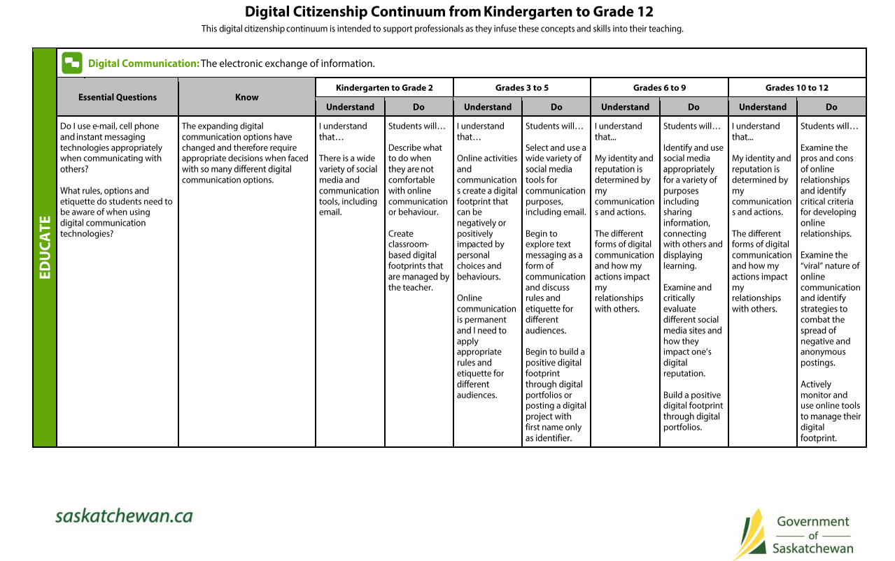
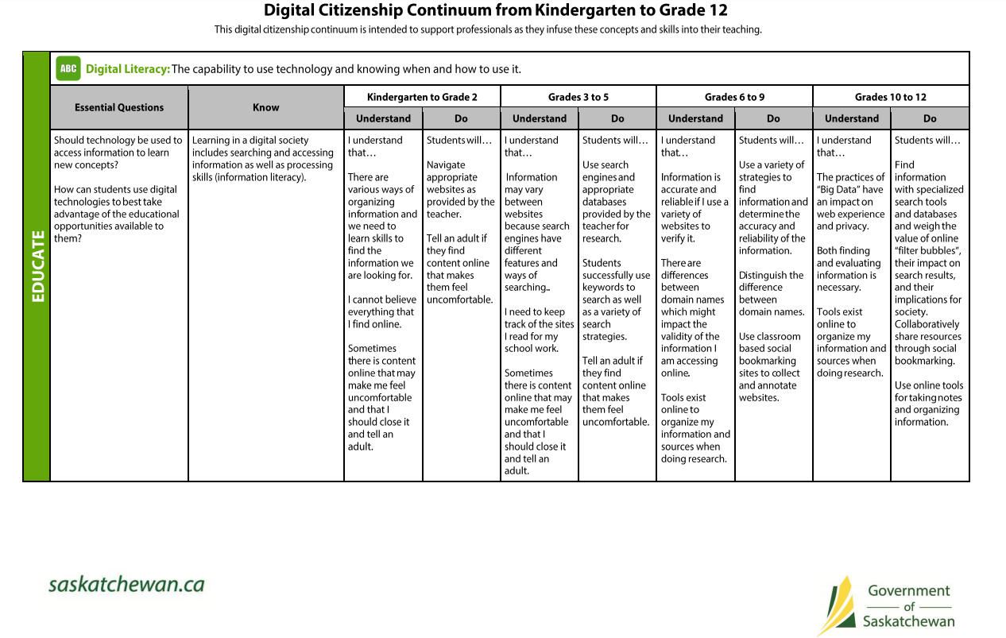

General Communication Resources
- Digital Communication Lessons: http://mediasmarts.ca/

- Describe what makes a good listener.

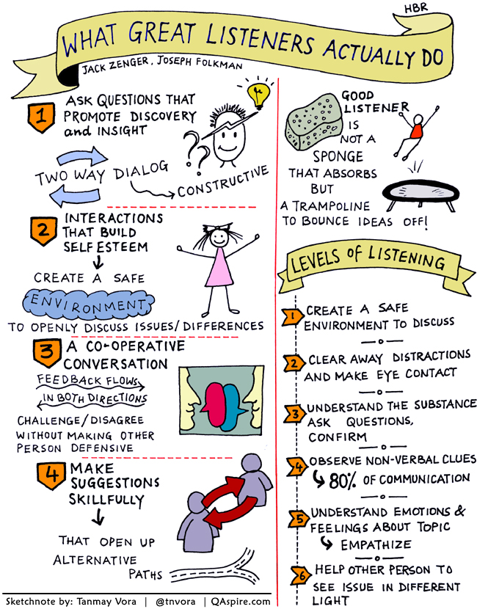
I Can Share My Learning Resources
Communication | 1 | 2 | 3 | 4 | 5
Share learning | I do not share my learning with students, teachers or parents yet. | I sometimes share my learning with students, teachers and/or parents. | I usually share what my learning with students, teachers and parents. | I share my learning in a variety ways, with students, teachers and parents. I also self-reflect on my learning to share strengths and areas of improvement. | I consistently self-reflect on my learning in a variety ways, with students, teachers and parents. I also self-reflect on my learning to share strengths and areas of improvement. I can give examples as evidence for my learning.
- Students can create different types of ways to share their knowledge through different medias:
  - Poster
  - Essay
  - Presentation
  - Brochure
  - Technology Apps
    - http://appcrawlr.com/ios-apps/best-apps-formative-assessment

    - https://www.educatorstechnology.com/2017/06/9-good-android-formative-assessment.html

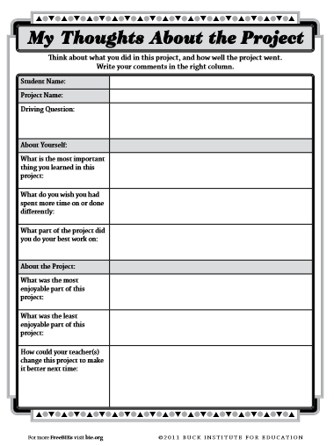
http://www.bie.org/object/document/my_thoughts_about_the_project

I Can Express My Opinions Resources
Communication | 1 | 2 | 3 | 4 | 5
Persuade other | I do not persuade others or express my opinions yet. | I sometimes use my knowledge to persuade others and express my opinions. | I can use evidence to persuade others and express my opinions in a positive manner. | I persuade others using evidence and examples. I express my opinions clearly. I help others understand my perspectives in a positive manner. | I consistently persuade others using evidence and examples. I express my opinions clearly. I help others understand my perspectives in a positive manner.

- Can your students tell the difference between fact, opinion and fiction? Below is a great link to a lesson to engage and review the difference with your class.

https://www.oercommons.org/courseware/lesson/17757/overview

- Ideas to help express ideas and create higher-level discussions:
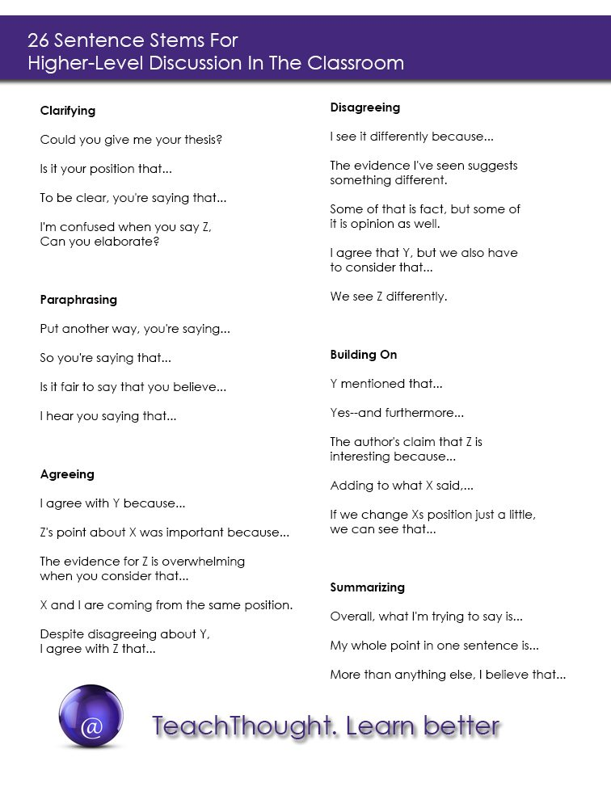

I Can Be Clear When Communicating Resources
Communication | 1 | 2 | 3 | 4 | 5
Be clear | I have trouble communicating clearly. | I need guidance to communicate effectively. | I use clear language to communicate effectively. | I use a variety of ways to communicate effectively. | I consistently use a variety of ways to communicate my thoughts and ideas clearly and effectively.

- 7 C’s of Communication. A checklist, video and sample examples of each one of the C’s to review with the students of both good and bad types of communication.
- Clear.
- Concise.
- Concrete.
- Correct.
- Coherent.
- Complete.
- Courteous.

https://www.mindtools.com/pages/article/newCS_85.htm

- Communication "practice" resources:
https://www.facinghistory.org/resource-library/teaching-strategies/fishbowl?utm_source=WeAreTeachers&utm_medium=8FunWaysArticle&utm_content=FacingHistory&utm_campaign=EMCPub_Article

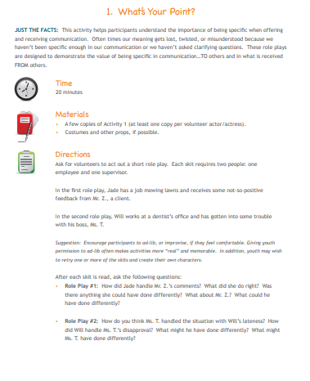
https://www.dol.gov/odep/topics/youth/softskills/Communication.pdf

I Manage Emotion Resources

Communication | 1 | 2 | 3 | 4 | 5
Invite feedback | I do not invite feedback yet. | I can ask for feedback on my work but I have difficulty accepting help or making changes. | I can improve my work after receiving comments about my work. | I respect and seek out different viewpoints as feedback and use them to improve my work. | I consistently respect and seek out different viewpoints as feedback and always use them to improve my work and expand my mindset.

  - What is feedback? Brainstorm together what this looks like for the particular classroom. Engage student about what good feedback looks like so they can work together. What is the purpose of feedback?

https://chooseyourfuture.cps.edu/sites/default/files/lesson12-8-i7.pdf

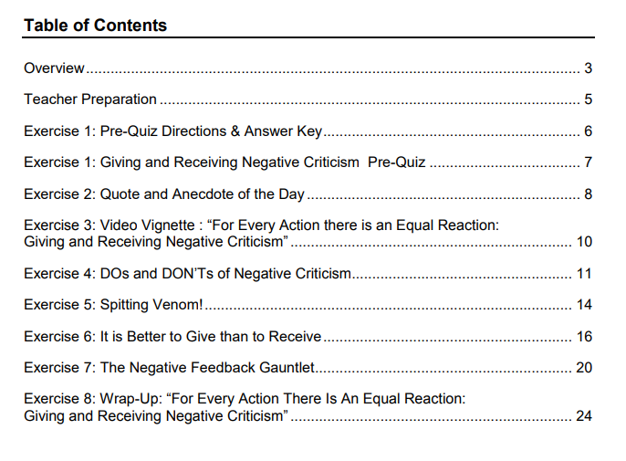

2. https://www.settlementatwork.org/lincdocs/linc5-7/03-interact.w.others/pdfs/social.interact.LINC7/09.being_assertv_crticsm.pdf

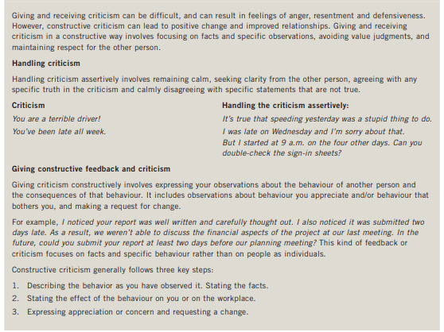

  - Open up a discussion around the Rubric. Can they explain “why” they chose that answer? Are they afraid? Embarrassed?

  - Constructive Criticism lesson ideas:
- https://www.dol.gov/odep/topics/youth/softskills/

- http://teaching.monster.com/benefits/articles/9154-teaching-students-to-accept-criticism

- http://thespeechroomnews.com/2014/03/accepting-feedback-social-skills-activities.html
