Collaboration
High School
21st Century Skills Package

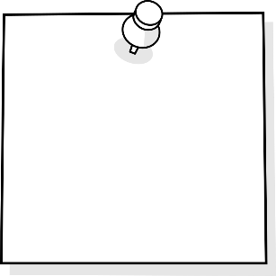
Evaluate the
Team
Cooperate
Find Solutions
Build Team
Strengths
TABLE OF CONTENTS
Purpose 3
Why is this important?
What We Know
Collaborating Today and into the Future

Self Assessment Rubrics 4
Cooperate
Build Team Strengths
Evaluate the Team
Find Solutions

Resources 5
General Resources ………………………………………………………………………..……………………….…….5-6

Cooperate 7
Build Team Strengths 8-9
Evaluate the Team 10-12
Find Solutions 13-15

Purpose
Why is this important?
Collaboration is a key 21st Century skills that is increasingly mentioned as skill students need in order to be successful in their learning. Having the skills and abilities to cooperate, build team strengths, evaluate your team (and your place in that team), and find solutions, allows students be participants in their learning. Collaboration requires action. The value of collaboration has been assumed for many years, and over the past two decades we have seen leading businesses and organizations move to facilitate team building and team-based work. The ability to work effectively with others has become a critically important skill for career and life success. Students need to learn the strategies for collaborating in effective ways so they can apply them successfully.
Here is what we know about collaboration and collaborative learning:
- Emphasis on collaboration remains traditional, reflecting older models of interaction
- Use of technology does not always boost collaborative learning or improved digital literacy
- Students learn best from a mix of individual and group-based learning experiences
- Collaboration can enhance the development of critical thinking skills
- Four categories of assessment exist for evaluating collaboration as a process and outcome for both groups and individuals
- Collaborative problem solving is an area to watch with new assessments

Collaboration. P21 Partnership for 21st Century Learning. http://www.p21.org/our-work/4cs-research-series/communication. Web. May 7, 2018

Collaborating today and into the future: Students of the digital age are social by nature. They text, post, update, share, chat, and constantly co-create in technological environments with each other. When they are unable to do this in school, they become disengaged and unattached to their learning. Connection and collaboration with others are essential not only to their learning but their mental and emotional health. It is a skill that educators must exercise with them regularly, and understanding Collaboration Fluency will assist with this.
https://globaldigitalcitizen.org/collaboration-fluency-video/

Watanabe-Crockett, Lee. The Critical 21st Century Skills Every Student Needs and Why. Global Digital Citizen Foundation. https://globaldigitalcitizen.org/21st-century-skills-every-student-needs. Aug 2 2016. Web May 6, 2018

Collaboration | 1 | 2 | 3 | 4 | 5
Cooperate | I do not listen, ask for, or share opinions yet. I am not polite to team members. I do not acknowledge others perspectives yet. I disagree and am unable to compromise to reach team goals. I do not do my part to ensure shared responsibility yet. | I rarely listen and ask for, or share opinions. I am not polite to team members yet. I rarely acknowledge others perspectives. I disagree and am unable to compromise to reach team goals. I rarely do my part to ensure shared responsibility. | I usually listen, ask for, and share opinions and encourage others to do the same. I am polite and kind to team members, but do not always acknowledge others perspectives. I disagree respectfully, but still have difficulty compromising to reach team goals. I usually do my part to ensure shared responsibility. | I listen and ask for opinions and encourage others to do the same. I am polite and kind to team members. I often acknowledge others perspectives. I disagree respectfully and am able to compromise to reach team goals. I often do my part to ensure shared responsibility. | I listen and ask for opinions and encourage others to do the same. I am polite and kind to team members and always acknowledges others perspectives. I disagree respectfully and am able to compromise to reach team goals. I always do my part to ensure shared responsibility.
Build team strengths | I am not involved in the team yet. | I am rarely involved in the team. I participate minimally in discussions and rarely provide feedback or work to achieve group goals. | I am usually involved in the team. I usually share ideas, opinions and feedback. I can recognize that the group has a goal, but I still need to work on solving and managing team conflicts. | I take part in effective discussions that promote ideas and opinions. I often provide useful feedback and work to achieve group goals. I take part in discussions that promote all opinions, and often manage team conflicts effectively. | I initiate effective discussions that promote all opinions and ideas. I provide useful feedback and work to achieve group goals in a collaborative way. I help the team solve problems and manage conflicts successfully.
Evaluate the team | I do not recognise my place in the team yet. I cannot identify areas of growth yet. I am not proactive yet. | I rarely recognise my place in the team. I rarely identity areas of growth. I am not proactive yet. | I am usually able to recognise my place in the team. I usually lead my team towards our goals. Most of the time I can identify, but I need to work on my ability to recommend, areas of growth. I am usually proactive, but still need to encourage others to do the same. | I am able to recognise my place in the team, and can lead my team towards our goals; however I do not always do this. I can identity and recommend areas of growth. I am proactive, and I usually encourage others to do the same. | I am able to recognise my place in the team and lead my team towards our goals. I can identity and recommend areas of growth. I am proactive and encourage others to do the same.
Find solutions | I am unable to identify problems or work to find solutions. I am unaware of resources available to me and I stay stuck. | I am rarely able to identify problems or work to find solutions.  I do not seek out resources and I stay stuck. | I am usually able to identify problems and work to find solutions. I usually seek out resources so I do not stay stuck, but still need help determining the best resources. | I am able to identify problems, but still need support to find the best solutions. I seek out resources so I do not stay stuck. | I am able to identify problems and apply the best solutions most of the time. If I am unable to find solutions, I can seek out appropriate resources so that I do not stay stuck.

General Resources
- https://solutionfluency.com/en/downloadables/clf-quickstart-skills-guide

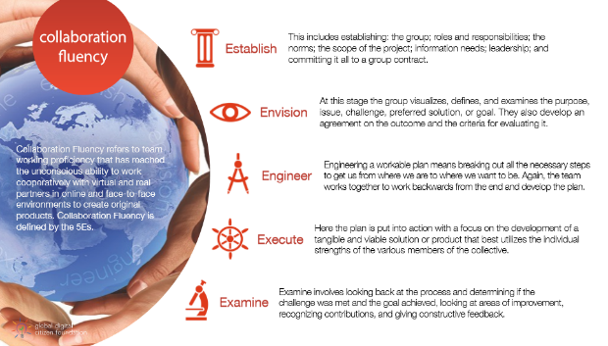

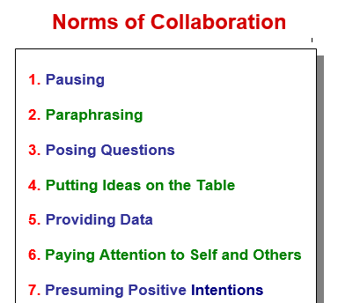
- Setting the Norms for Group Work and Collaboration. This website has posters, and various student inventories and assessments for self-reflection and group reflection.
http://www.thinkingcollaborative.com/norms-collaboration-toolkit/

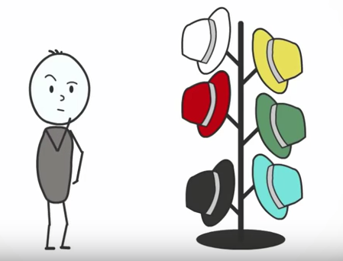
- Edward des Bono’s- Six Thinking Hats is a simple, effective parallel thinking process that helps people be more productive, focused, and mindfully involved. A powerful tool set, which once learned can be applied immediately! You and your team members can learn how to separate thinking into six clear functions and roles. Each thinking role is identified with a colored symbolic "thinking hat." By mentally wearing and switching "hats," you can easily focus or redirect thoughts, the conversation, or the meeting.
Many resources are already created for this strategy. Do a quick google search and many already made activities are ready for you.
http://www.debonogroup.com/six_thinking_hats.php
https://www.youtube.com/watch?v=UZ8vF8HRWE4
- General Collaboration Activities. Below is just a sample of many different types of classroom culture activities.
https://www.smore.com/0udr-fun-critical-thinking-activities

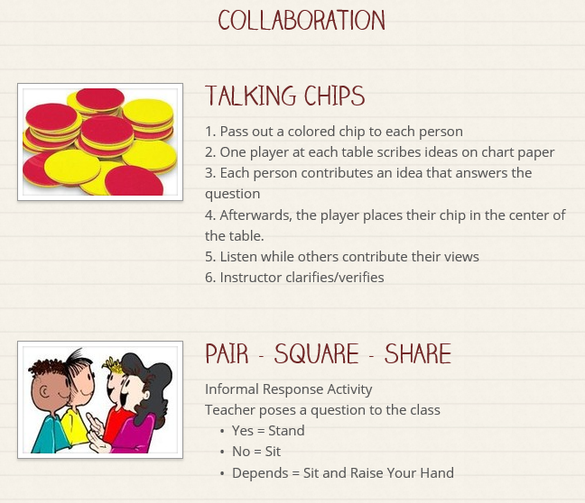

Cooperate Resources
The following activities are for students struggling with “Cooperate”.
Part of being able to cooperate means listening to and acknowledging others, sharing your own perspectives, and engaging in respectful shared responsibility. See below for activities and lessons.
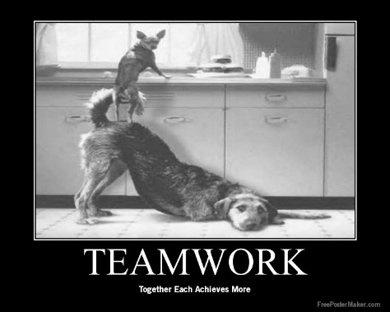
- Using Tech Tools- have students create posters for the school around cooperation & teamwork.

- Together watch and discuss videos that have both positive and negative cooperation. See sample videos below. Use exit slip as formative assessment.
https://www.youtube.com/watch?time_continue=19&v=8Amu3UBj-qw
https://www.youtube.com/watch?v=ZnjJpa1LBOY
https://www.youtube.com/watch?v=fUXdrl9ch_Q

- Create anchor charts of what participating and cooperating in a group looks like. Group collaboration norms.
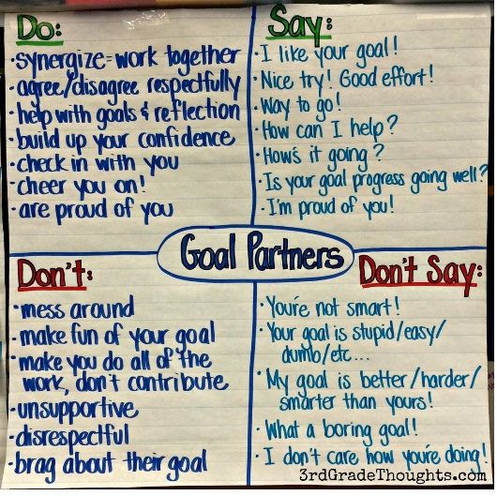
Build Team Strengths Resources
The following activities are for students struggling with “Build with Team Strengths”.
Part of being able to build team strengths means initiating and promoting effective discussion, providing and accepting useful feedback, and solving and managing conflicts successfully. See below for activities and lessons.
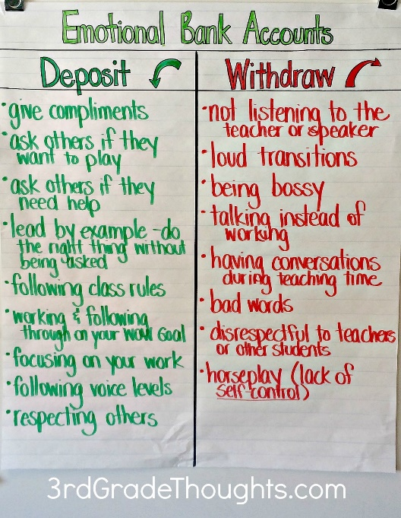
- Steven Covey’s- 7 Habits of Highly Effective People talk about “Emotional Bank Account”. A good way to talk to students about being a good group member and building on everyone’s strengths. Lots of free activities & YouTube videos available for more information and activity ideas.
https://www.youtube.com/watch?v=qktDB08EBCM

- Create sentence starts for students to brainstorm in creative ways to have discussion. “Accountable Talks” Link to some free bookmarks from Teachers Pay Teachers.
https://www.teacherspayteachers.com/Browse/Search:accountable%20talk%20bookmarks
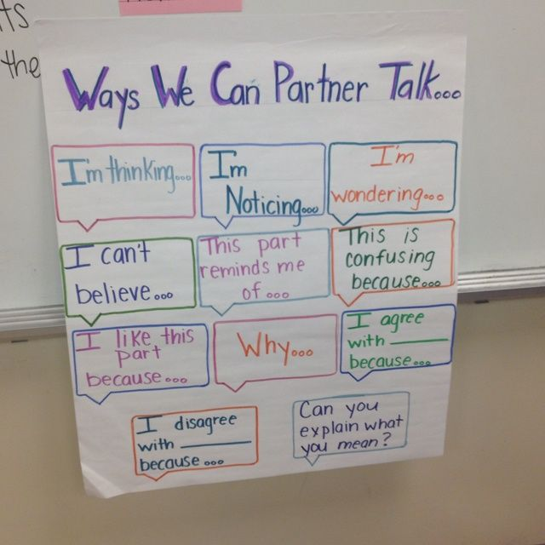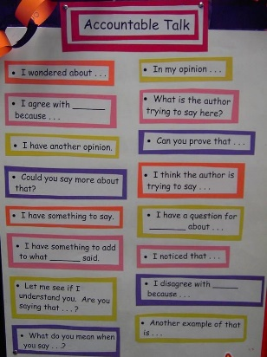

- Assigning student roles for collaborative group work ensures that all students are contributing meaningful information. Such roles might include leader, recorder, and/or monitor. Having a direction in discussion makes student collaboration time focused and worth it! Use the discussion record sheet on the next page as a guide!

DISCUSSION RECORD
DATE: | GROUP MEMBERS  1.  2.  3.  4.
LEADER
MONITER | NOTE TAKER
MAIN IDEAS GENERATED FROM OUR DISCUSSION
After reading please write a 1 sentence summary of each group member’s most significant idea and/or point of interest, opposite his/her corresponding number. The group should decide the summary sentences together (this is not the note takers job!).
1.

2.

3.
4.

TODAY’S INTERESTING QUESTIONS and INQUIRY
List a few interesting questions that came from your discussion.

*
*
*
List topics, ideas, concepts, vocabulary – anything at all – that your group wants to know more about.
*
*
*
CONNECTIONS TO OUR COURSE
List any connections to our course themes based on the novel so far.
*
*
*

Evaluate the Team Resources
The following activities are for students struggling with “Evaluate the Team”.
Part of being able to evaluate the team means being able to recognize your place in the team, lead the team to their goals, recommend areas of growth, and be a proactive member of the team. See below for activities and lessons.
- Group & Self Assessment Rubrics to open up discussion. Co-create partner assessments according to the group norms you agreed upon.
- Peer Assessment Rubric “Praise Question Polish”… this rubric invites students to give positive feedback and suggestions for improvement for peer work in three parts! See page 11 for a sample!

http://www.readwritethink.org/files/resources/printouts/Group%20and%20Self%20Evaluation.pdf
- Teach kids how to celebrate & recognize the good work others have done. Brainstorm a list of ways to celebrate and thank your team.
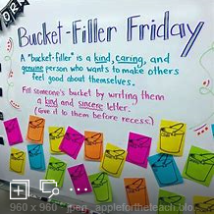

- Student Exit Slips that assess their abiltites as group members. See page 11 for a sample!

Sample Prasie Question Polish:
Praise: What do you like about the paper?
- Identify the paper’s strengths (we want to provide a balanced critique).
  - “My favorite part is…because…”
  - “You were really clear about…”
  - “I like how you explained…because…”
- You might also want to comment on word choice…
My Praise is: __________________________________________________________________________________________________________________________________________________________________________
Question: Ask the writer some questions about the paper.
- Questions might be about word choice, content, organization, clarity.
  - “Can you tell me more about…”
  - “Could you explain the part about…”
- Where can you suggest the writer KEEP, MOVE, ADD, CHANGE, and/or DELETE?
  - “Would you consider moving…”
  - “Would you consider deleting… and adding…”
My Question is: __________________________________________________________________________________________________________________________________________________________________________
Polish: What else should the writer consider before handing in their paper for grading?
- Look to the rubric for this assignment and make sure that the writer has incorporated all of the expectations.
My Polish is: __________________________________________________________________________________________________________________________________________________________________________

Sample Student Exit Slip:
How did your part in group work today compared to your part last day? What is one thing about your part in group work that you are proud of? What made you successful or unsuccessful? How could you improve next time? What did you recognize in your peers that worked for them? If you could applaud, someone is class for their growth and success in group work, who would it be and why?
Collaborative Group Rubric
Student Name:_________________________________________________________________ Date:______________________
Project Title: __________________________________________________________________ Outcome:_________________
Individual Tasks | Learning Level | Feedback
Responsibilities of individual role. Student contributed to a group as an active member
Group Tasks | Learning Level | Feedback
Research
Group included key facts, information, and criteria regarding subject area.
Literacy Skills and Strategies
Group included appropriate ideas with supporting details. Findings were summarized.

Communication of Ideas
Group communicated ideas efficiently both written and verbally and was aware of their audience.
Collaboration
Students were able to communicate ideas among each. Students demonstrated respect among each other. Students used appropriate language to diffuse disagreements and celebrate accomplishments.
KEY:  5: Wow!  4: I get it and I can show someone else  3: Got it!  2: Getting There  1: Need more practice | Overall  Learning Levels:

Find Solutions Resources
The following activities are for students struggling with “Find Solutions”.
Part of being able to find solutions means being able to identify problems and apply the best solutions, as well as seek out resources as needed to maintain unstuck. See below for activities.

- Teach Problem Solving Skills & Mindset:
  - IDEO Company- IDEO is a global design company. We create positive impact through design. https://www.ideo.com/
https://www.youtube.com/watch?time_continue=6&v=XrpAveg7ZIg
  - Design Thinking is an approach to addressing challenges in a thoughtful and fun way, where you get to apply the 4Cs -- collaboration, creativity, critical thinking, and communication –- to your own work as you develop new solutions for your classroom, school, and community. https://www.edutopia.org/what-is-design-thinking-for-educators
https://www.youtube.com/watch?time_continue=4&v=Ee4CKIPkIik
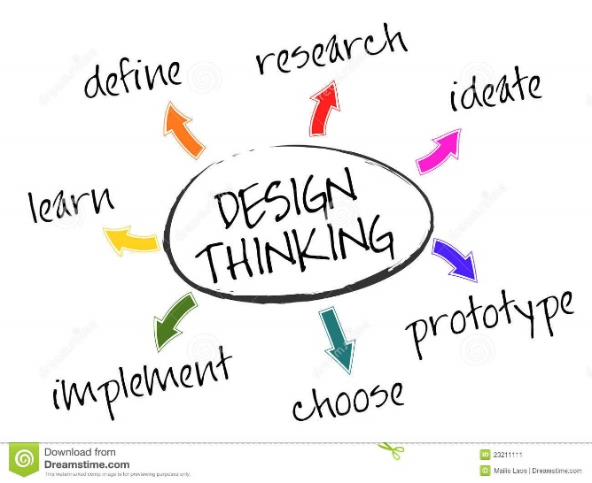

https://www.edutopia.org/blog/10-ready-borrow-project-ideas-suzie-boss

- Have students brainstorm and practice effective problem solving methods… The following site gives a student perspective on the benefits of teaching problem solving:
https://www.edutopia.org/blog/4-tips-teaching-problem-solving-from-student-anna-pelletiere

- Share with students and discuss the ideas SNOT poster. See page 14 and 15!
Stuck?
Use SNOT!
SELF – What notes do you have in your book? Have you checked the textbook glossary, index, and assigned pages?
Neighbour – Ask someone sitting close to you for help.
Other – Have you watched a video? Can you google it?
Teacher – Try this person after you have tried the other three.
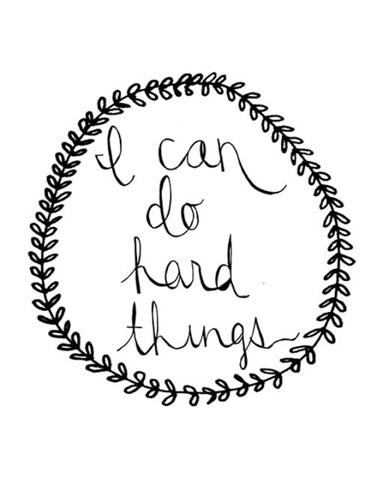
The goal is to teach you grit, perseverance, and independence.
