Character
Educator Guidebook
K-5

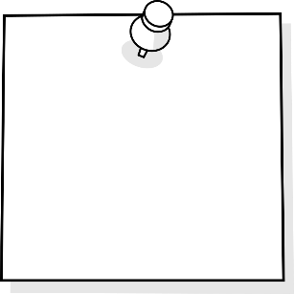
I Can
Self-Regulate
I Can Embody
GRIT/ Go For
It & Finish It
I Can Set
Challenges

I Can Be
Organized
TABLE OF CONTENTS
Purpose 3
Why is this important?
Key Steps in IMPLEMENTING.

Self Assessment Rubrics 4
I can be organized
I can embody GRIT
I can self-regulate
I can set challenges

Resources 8
I can be organized
I can embody GRIT
I can self-regulate
I can set challenges

Purpose
Why is this important?
Character is one of the 21st Century skills that students need in order to be ready to self-direct in their learning. Having the key skills that come along with strength of character allows students to be part of the planning of their instruction and assessment. In order “to use the full potential of their minds, students must learn to filter distractions and interruptions and to think deeply and critically” (Cash, 5).
Cash, Richard M. Self-Regulation in the Classroom Helping Students Learn How to Learn: Free Spirit Publishing, 2016

Key Steps in Teaching Character:
- Isolate the skill needed to be taught
- Provide students with direct teaching to learn strategies and practice self- awareness
- Provide and allow opportunities for students to practice the skills and strategies and reflect often. This takes time at first but students are rewarded for their efforts once they are able to master their practiced skill.
- Revisit strategies and skills often.

Character | 1  Not yet | 2  Getting there | 3  Yes | 4  Yes, and | 5  WOW!
I can be organized | With assistance, I still cannot organize my time and materials and do not know what is important to do first. | I need assistance to be organized with my time and materials and knowing what is important to do first. | Sometimes I need help organizing my time and materials and knowing what is important to do first. | Most of the time I can organize my time and materials and knowing what is important to do first. | I can always organise my time and materials and know what is important to do first.
I can embody grit - Go for it/finish it | I cannot begin tasks independently or with assistance. | I give up easily when something does not work the first time. | Sometimes I try again when something does not work the first time. | Usually I try again when something doesn’t work the first time. | I can try again when something does not work the first time.
I can self-regulate | I am unaware of my emotions and what appropriate actions and words are. | I am unable to control my emotions using appropriate actions and words. | With assistance I am able to control my emotions by using appropriate actions and words. | I am able to be in control of my emotions by using appropriate actions and words. | I am able to be in control of my emotions. I reflect on my positive and negative behaviours, and take pride in making good choices.
I can set challenges | I do not set challenges for myself or try new things. | I am uncomfortable trying new things and I worry about making mistakes. | With assistance I try new things, even though I am nervous to make mistakes. | I try new things, even though I am nervous to make mistakes. | I try new things, and am willing to make mistakes because I know I will learn from them.

I Am Organized
Resources
Understanding “Executive Functioning Skills”
https://www.understood.org/en/learning-attention-issues/child-learning-disabilities/executive-functioning-issues/a-day-in-the-life-of-a-child-with-executive-functioning-issues
Steps of Executive Functioning:
- Analyze a task. Figure out what needs to be done.
- Plan how to handle the task.
- Get organized. Break down the plan into a series of steps.
- Figure out how much time is needed to carry out the plan, and set aside the time.
- Make adjustments as needed
- Finish the task in the time allotted.
Executive Function Strategies include:
- Eat Way Visual Timers
- Chunking Assignments
- Writing the time on their assignment when you check in on them
- Graphic Organizers
- Color code handouts
- Pictures of organized locker (a standard for students to compare too daily)
Time Matrix - 4 quadrants of time management
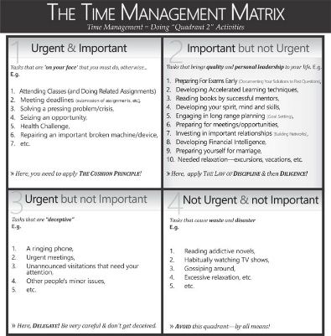

Have students use Day Planners or electronic Calendars to set appropriate timelines

Polk Elementary's ideas on why, when, how to get students organized and resources to use: http://polkdhsd7.sharpschool.com/staff_directory/p_b_s_behavior_intervention/tier_3_interventions/organizational_tools/
The why of getting organized and lesson plans for teachers https://www.yourstoragefinder.com/why-teachers-must-invest-in-teaching-kids-organizational-skills

Tedx about Life Balance and why multi tasking doesn't work: Sara Cameron https://www.youtube.com/watch?v=II_Qyf0Vw9g

Over Scheduled Andrew – Ashley Spires

I Can Embody GRIT (Go For It & Finish It)
Resources
Anchor Charts for classroom & on student desks: | Ask 3 Before Me Strategy  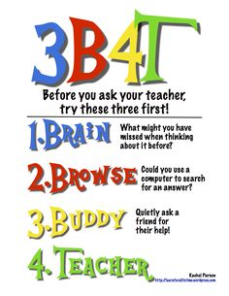
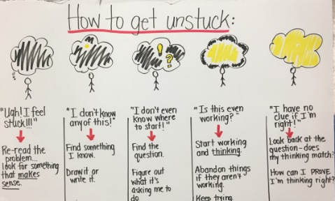
How to get Unstuck
Goal Setting Activities or Action Plans (example Appendix 2)
Direct teach students about metacognition
Self-Reflection activities
- Exam reflection sheets
- Off Task Behavior Tracking sheets

Growth Mindset Activities
Class Dojo Growth Mindset Video Series | https://www.youtube.com/watch? v=2zrtHt3bBmQ&list=PL_UD9ElfNS 8NRw01pEqDuYcg4HeU2IamD
Carol Dweck- “The Power of Yet” | https://www.youtube.com/watch?v=J-swZaKN2Ic
Link themed picture books and novels

G.R.I.T. Activities
Angela Lee Duckworth- The Key to Success- Grit | https://www.youtube.com/watch?v=J-swZaKN2Ic
Soar A Short Animated Video | https://www.youtube.com/watch?v= j0cQQOnqsq4
Pixar Short Films
Books
- I Can Be Anything – Jerry Spinnely
- The Magnificent Thing—Ashley Spires
- Same and Dave Dig a Hole – Mac Barnett

I Can Self-Regulate
Resources
Websites
http://blissfulkids.com |  | Website teaching students about Mindfulness strategies and a simple introduction to how their brain works.
https://www.understood.org/en/learning-attention-issues/child-learning-disabilities/executive-functioning-issues/5-ways-kids-use-working-memory-to-learn |  | Self-regulation is supported by a student’s working memory. Understanding our working memory can impact how we understand why some students may struggle with some parts of self-regulation. Closely working with your SST team is beneficial.
https://ed.ted.com/featured/nvJHP79R |  | “Don’t Eat The Marshmallow” Ted Talk - Joachim de Posada about delayed gratification. Lots of replicated activities developed for classrooms.
https://www.youtube.com/watch?v= HyYhoCqo58w |  | “Brain-Based Learning”- Eric Jensen
Books
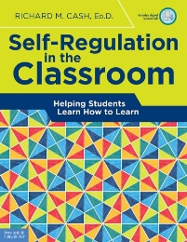
Each school should have copy of this book in their library.
- Alexander and the Horrible, Terrible, Very Bad Day – Judith Voirst
- Alexander, Who is Trying to be the Best Boy Ever – Molly Bang
- My Mouth was a Volcano – Julia Cook
- When Sophie gets Angry, really, really Angry – Molly Bang
- Frog and Toad – Arnold Lobel
- Pete the Cat – James Dean
- Scardey Squirrel – Melanie Watt
Games
Red light, green light
Play freeze game with hoops on the floor. Keep reducing the amounts of hoops on the floor that students have to be in when they freeze. You have to talk to them beforehand about how to all stand in one hoop together as more people have to cram into the hoop.
Play “Conducting an Orchestra.” Teacher will be the conductor and students will all have instruments. Use a baton with movements to indicate fast, slow, stop, start. Students need to follow along with the conductor.
I know a Chicken YouTube song | https://www.youtube.com/watch?v=9E7l0JPgclE
Move and Freeze YouTube song | https://www.youtube.com/watch?v=388Q44ReOWE
Jack Hartman Alphabet Movement YouTube video—Upper case letter workout | https://www.youtube.com/watch?v=BQB7gpDpt6o
Card-Stacking—each student has a deck of cards and are directed to build a structure using all 52 cards
Minute-to-Win-It (team activities) – 6 balloons, 3 students. They have to try to keep all the balooons from touching the floor.
Worksheets
Self-Regulation strategies (Appendix 1)
Self-Regulation Models
- The Zones of Regulation
- How Does Your Engine Run

I Can Set Challenges
Resources
Daily Reflection Checklist (Appendix 2)
Going for My Goal worksheet (Appendix 3)

Self-Regulation Strategies
Be proactive, not reactive
- Choose or modify the situation
- Change your thinking
- Control impulses

Daily Reflection Checklist:
Character
Date:

How well did I work today?

 | Always | Sometimes | Not Really
I had my stuff.

I worked hard (Go for it, finish it!)

I was calm and regulated.

I tried new things and was okay making mistakes

Next day, I need to…
__________________________________________________

Going for my Goal
Character  - I can be organized  - I can embody grit - Go for it/finish it  - I can self-regulate  - I can set challenges | My Academic Goal:
 | My Behaviour Goal:
Things I can do to reach my goals:
1
2
3
Did I achieve my goal?

