Quiz 4 April 1
Name _____________________
Circle the best answer. 1 marks each.
Questions 1-10 deal with the food web on the attached page.
1. What is the source of the original energy for this food chain?

a) the rabbit
b) the grasses
c) the hawk
d) the sun

2. Which of the following best describes the role of the grasses in this food chain?

a) animal shelter
b) source of seeds
c) a source of energy
d) place for nests

3. In this food web, which of the following pairs of organisms are capable of producing energy?

a) bacteria and lice
b) grasses and grains, and shrubs
c) shrubs and lice
d) grasses and grains, and insects

4. In this food web, which are the highest order consumers?

a) the birds and rabbits
b) the foxes and owls
c) the wolves and hawks
d) the grains and shrubs

5. If all of the snakes were wiped out, what would first happen to the population of rabbits?

a) It would increase.
b) It would decrease.
c) It would remain the same.
d) It is impossible to predict the outcome.

6. If all of the snakes were wiped out, what would happen to the population of hawks?

a) It would increase.
b) It would decrease.
c) It would remain the same.
d) It is impossible to predict the outcome.
7. In this food web, which of the following organisms could most likely be called third order consumers?

a) wolves and shrubs
b) insects and owls
c) rabbits and foxes
d) wolves and hawks

8. Which of the following best describes the lice attached to the skin and feeding on the tissue of the rabbit?

a) producer
b) first order consumer
c) second order consumer
d) third order consumer

9. If carbon dioxide disappeared from the biosphere, which of the following would be affected first?

a) first order consumers
b) producers
c) second order consumers
d) decomposers

10. In terms of the numbers of individual organisms represented in this food web, which of the following statements would be correct?

a) There are more hawks than rabbits.
b) There are more wolves than insects.
c) There are more insects than hawks.
d) There are more snakes than shrubs

- A food pyramid is represented by the diagram below. Which statement best describes one of the levels of this pyramid?
  - The organisms in level B obtain food directly from level A.
  - Level D contains the greatest number of heterotrophs in the pyramid.
  - Level C contains the largest group of consumers in the pyramid.
  - Level A contains the largest producers in the pyramid

Use the feeding pyramid below and your knowledge of the living environment to answer questions 12 through 14 which follow.
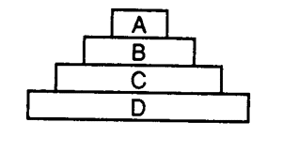
- Which level of this pyramid would contain producer organisms?
  - A
  - B
  - C
  - D

- If birds eat insects that feed on corn, which pyramid level would birds occupy?
  - A
  - B
  - C
  - D
- As one progresses from level D to level A in this pyramid, the amount of stored energy
  - Increases
  - Decreases
  - remains the same
- Which group in the food web represented below would most likely have the greatest biomass?
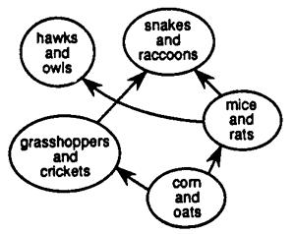
  - corn and oats
  - hawks and owls
  - mice and rats
  - snakes and raccoons

- Nutritional relationships between organisms are shown in the diagram below. Which organisms are primary consumers?
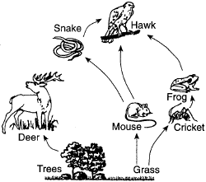
- mouse, deer, and cricket
- deer, hawk, and mouse
- snake, hawk, and frog
- cricket, frog, and deer

- For 25 years, hay was cut from the same 10 acres on a farm. During these years, shrews, grasshoppers, spiders, rabbits, and mice were seen in this hayfield. After the farmer retired, he no longer cut the hay and the field was left unattended. What will most likely occur in the former hayfield over the next few decades?
  - The plant species will change, but the animal species will remain the same.
  - The animal species will change, but the plant species will remain the same.
  - Neither the plant species nor the animal species will change.
  - Both the plant species and the animal species will change.
- As one goes up the energy pyramid, the total amount of energy on each feeding (trophic) level
  - Stays the same
  - Increases by 80-90%
  - Decreases by 80-90%
  - Increases by 10% due to heat
  - Decreases by 10% due to heat

