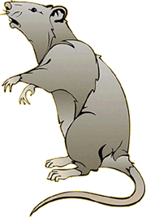
Dissection of the Rat
Introduction
In this laboratory exercise, the anatomy of the rat will be examined in some detail. You may recall that in your first year biology course you dissected a grass frog and a fetal pig. You may recognize and remember structures that you learned during that dissection. In Biology 3A, a much more detailed look at mammalian anatomy will be conducted. You will get to know and love your preserved rat over the course of this dissection.
The classification of the Rat ( Rattus norvegicus)
Kingdom Animalia
Phylum Chordata
Subphylum Vertebrata
Class Mammalia
Order Rodentia
Family Muridae
Genus Rattus
Species norvegicus
The lab books and diagrams available to you are supplemental. You are expected to follow the directions in this lab. You will be held responsible for being able to locate all the structures. You are expected to have exhausted all possibilities in attempting to located structures before asking for assistance. Using the available material, instructions and diagrams, most students will be able to locate many structures for themselves. If after an earnest effort, you cannot find a structure, ask for assistance. Remember, this is a learning experience, it is quite permissible to discuss and observe other students' specimens. Compare you dissection with others, for animals often differ, be sure to look at animals of the opposite sex, you will be responsible for both sexes on the lab practical.
The specimen you will receive is a preserved double-injected specimen. Double injected refers to the arteries being filled with a red latex, and the veins being filled with blue latex. You will notice various incisions on the external surface of the rat where the latex was injected.
The rat is a vertebrate, which means that many aspects of its structural organization are common with all other vertebrates, including man. The similarity of structures among related organisms shows evidence of common ancestry. In a way, studying the rat is like studying a human. As the leading theme of this lab, ask yourself: for every structure observed in the rat, there is an equivalent structure in your own body - what is the structure and where is it located.
As the second leading theme, pay particular attention to the relationships among organs and groups of organs. Structural parts are not "just there" in random locations. Their specific layout within the body contributes to making certain functions possible. Therefore, for every structure seen, you should determine the following:
- What organ system it belongs to
- How it is connected with other components
- Its general function
- Its specific function (if applicable)
Dissection
Dissecting tools will be used to open the body cavity of the rat and observe the structures. Keep in mind that dissecting does not mean "to cut up"; in fact, it means "to expose to view". Careful dissecting techniques will be needed to observe all the structures and their connections to other structures. You will not need to use a scalpel. Contrary to popular belief, a scalpel is not the best tool for dissection. Scissors serve better because the point of the scissors can be pointed upwards to prevent damaging organs underneath. Always raise structures to be cut with your forceps before cutting, so that you can see exactly what is underneath and where the incision should be made. Never cut more than is absolutely necessary to expose a part.
Grading
Your grade on this laboratory will be assessed according to the following criteria
- Class Participation (serious approach, proper cleanup and lab safety)
- Lab Checklist
- Quizzes throughout
- Lab Practical Exam (at the end of lab)
Glossary of Terms
Dorsal: toward the back
Ventral: toward the belly
Lateral: toward the sides
Median: near the middle
Anterior: toward the head
Posterior: toward the hind end (tail)
Superficial: on or near the surface
Deep: some distance below the surface
Sagittal: relating to the midplane with bisects the left and right sides
Transverse: relating to the plane separating anterior and posterior
Horizontal: relating to the plane separating dorsal and ventral
Proximal: near to the point of reference
Distal: far from the point of reference
Caudal: toward the tail end
Pectoral: relating to the chest and shoulder region
Pelvic: relating to the hip region
Dermal - relating to the skin
Longitudinal - lengthwise
Right & Left - refers to the specimen's right and left, not yours
Abdominal Cavity - related to the area below(posterior) the ribcage
Thoracic Cavity - related to the area above(anterior) the ribcage

Rat External Anatomy
Procedure: Obtained your rat. Rinse it off with water and place it in your dissecting pan to observe the general characteristics. Make sure you know each of the highlighted words.
The rat's body is divided into six anatomical regions:
cranial region - head
cervical region - neck
pectoral region - area where front legs attach
thoracic region - chest area
abdomen - belly
pelvic region - area where the back legs attach
1. Note the hairy coat that covers the rat and the sensory hairs (whiskers) located on the rat's face, called vibrissae.
2. The mouth has a large cleft in the upper lip which exposes large front incisors. Rats are gnawing mammals, and these incisors will continue to grow for as long as the rat lives.
3. Note the eyes with the large pupil and the nictitating membrane found at the inside corner of the eye. This membrane can be drawn across the eye for protection. The eyelids are similar to those found in humans.
4. The ears are composed of the external part, called the pinna, and the auditory meatus, the ear canal.
5. Locate the teats on the ventral surface of the rat. Check a rat of another sex and determine whether both sexes have teats.
6. Examine the tail, the tails of rats do not have hair. Though some rodents, like gerbils, have hair on their tails.
7. Locate the anus, which is ventral to the base of the tale.
8. On female rats, just posterior to the last pair of teats, you will find the urinary aperture and behind that the vaginal orifice which is in a small depression called the vulva.
9. On males, you will find a large pair of of scrotal sacs which contain testes. Just anterior to the scrotal sacs is the prepuce, which is a bulge of skin surrounding the penis. The end of the penis has a urogenital orifice, where both urine and sperm exit.

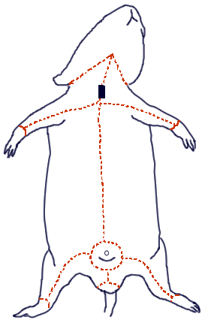
The Muscular and Skeletal System of the Rat
Procedure: Skinning the Rat
You will carefully remove the skin of the rat to expose the muscles below. This task is best accomplished with scissors and forceps where the skin is gently lifted and snipped away from the muscles. You can start at the incision point where the latex was injected and continue toward the tail. Use the lines on the diagram to cut a similar pattern, avoiding the genital area. Gently peel the skin from the muscles, using scissors and a probe to tease away muscles that stick to the skin.
Muscles are attached to bones by connective tissue called tendons that adhere to spines, knobs, and ridges on bones. You will need to refer to the rat skeleton to determine where the muscles are attached to bones. The end attached to the bone that does not move during contraction is called the origin. The end of the muscle that attaches to the bone that does move is called the insertion. The movement caused by the contraction of the muscle is called the action. Muscles can be easily identified from one another by their shape and overlap.
Identify the following muscles:
1. Biceps brachii - located on the anterior surface of the humerus. Action: flexes lower arm
2. Triceps brachii - located on the sides and back of the upper arm. Action: extends lower arm
3. Spinotrapezius - located across the dorsal thoracic region of the rat. Action: moves scapula up and backward
4. Latissimus dorsi - located posterior (and partially covered) by the spinotrapezius. | Action: moves the humerus
5. Biceps femoris - located on the side of the thigh, in two bundles. Action: flexes the lower leg
6. Tibialis Anterior - located on the front of the leg. Action: flexes foot
7. Gastrocnemius - located on lower leg, bulk of the calf muscle. Attaches to heel by the Achilles Tendon. Action: extends the foot
8. External Oblique - located on the sides of the abdomen.Action: flexes body wall.
9. Gluteus Maximus - located on the lower back and rear. Action: extends the thigh at the hip
10. Pectoralis Major/Minor - located in chest area. Action: adducts arm (draws it forward)

Procedure: Exposing the bones of the leg.
Carefully tease away the biceps femoris and gastrocnemius to expose the 3 leg bones: Tibia, Fibula, and Femur and the small patella (kneecap). You can also see the ligaments around the knee that attach the bones of the lower leg to the femur and the achilles tendon which attaches the the gastrocnemius to the ankle. .
Note that the joint of the hip is called a ball and socket joint. Examine how the bones fit into the pelvis.
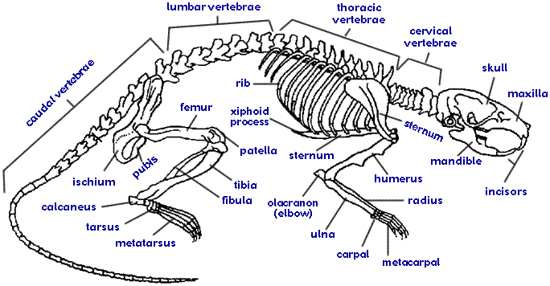

Rat Anatomy - Head, Thoracic, and Abdominal Organs

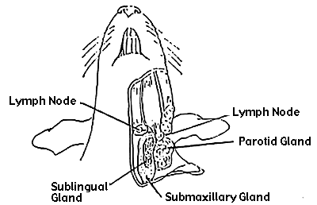
Organs of the Head and Neck
1. Locate the salivary glands, which on the sides of the neck, between muscles. Carefully remove the skin of the neck and face to reveal these glands. Salivary glands are soft spongy tissue that secrete saliva and amylase (an enzyme that helps break down food). There are three salivary glands - the sublingual, submaxillary, and parotid.
2. Find the lymph glands which lie anterior to the salivary glands. Lymph glands are circular and are pressed against the jaw muscles.
3. After you have located the submaxillary glands, remove them to find the underlying structures.
4. The thyroid gland is a gray or brown swelling on either side of the trachea. To locate the trachea you will need to carefully remove the sternohyoid muscles of the neck. The trachea is identifiable by its ringed cartilage which provides support. The esophagus lies underneath the trachea, though it is easier to locate in the abdominal cavity where it enters the stomach.
Procedure: Pin the structures of the head and neck.

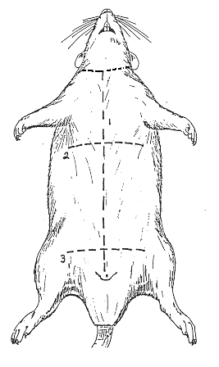
The Thoracic Organs
Procedure: Cut through the abdominal wall of the rat following the incision marks in the picture. Be careful not to cut to deeply and keep the tip of your scissors pointed upwards. Do not damage the underlying structures. Once you have opened the body cavity, you will need to rinse it in the sink.
1. Locate the diaphragm, which is a thin layer of muscle that separates the thoracic cavity from the abdominal cavity.
2. The heart is centrally located in the thoracic cavity. The two dark colored chambers at the top are the atria (single: atrium), and the bottom chambers are the ventricles. The heart is covered by a thin membrane called the pericardium. (We will come back to the heart later.)
3. Locate the thymus gland, which lies directly over the upper part of the heart. The thymus functions in the development of the immune system and is much larger in young rats than it is in older rats.
4. The bronchial tubes branch from the trachea and enter the lungs on either side. The lungs are large spongy tissue that take up a large amount of the thoracic cavity. Bronchial tubes may be difficult to locate because they are embedded in the lungs.

The Abdominal Organs
1. The coelom is the body cavity within which the viscera (internal organs) are located. The cavity is covery by a membrane called the peritoneum, which covers four region
visceral peritoneum - covers the internal organs
mesenteries - attach the internal organs to the dorsal body wall
omentia - connect organ to organ
2. Locate the liver, which is a dark colored organ suspended just under the diaphragm. The liver has many functions, one of which is to produce bile which aids in digesting fat. The liver also stores glycogen and transmforms wastes into less harmful substances. Rats do not have a gall bladder which is used for storing bile in other animals. There are four parts to the liver:
median or cystic lobe - located atop the organ, there is a central cleft
left lateral lobe - large and partially covered by the stomach
right lateral lobe - partially divided into an anterior and posterior lobule, hidden from view by the median lobe
caudate lobe - small and folds around the esophagus and the stomach, seen most easily when liver is raised
3. The esophagus pierces the diaphragm and moves food from the mouth to the stomach. Is is distinguished from the trachea by its lack of cartilage rings.
4. Locate the stomach on the left side just under the diaphragm. The functions of the stomach include food storage, physical breakdown of food, and the digestion of protein. The opening between the esophagus and the stomach is called the cardiac sphincter. The outer margin of the curved stomach is called the greater curvature, the inner margin is called the lesser curvature.
5. Slit the stomach lengthwise and notice the ridges, called rugae. The attachment between the stomach and the intestine is called the pyloric sphincter.
6. The spleen is about the same color as the liver and is attached to the greater curvature of the stomach. It is associated with the circulatory system and functions in the destruction of blood cells and blood storage. A person can live without a spleen, but they're more likely to get sick as it helps the immune system function.
7. The pancreas is a brownish, flattened gland found in the tissue between the stomach and small intestine. The pancreas produces digestive enzymes that are sent to the intestine via small ducts (the pancreatic duct). The pancreas also secretes insulin which is important in the regulation of glucose metabolism. The greater omentum is the membranous curtain of tissue that hangs from the stomach and contains lymph nodes, blood vessels, and fat. Find the pancreas by looking for a thin, almost membrane looking structure that has the consistency of cottage cheese.
8. The small intestine is a slender coiled tube that receives partially digested food from the stomach (via the pyloric sphincter). It consists of three sections: duodenum, ileum, and jejunum.
9. Use your scissors to cut the mesentery of the small intestine, but do not remove it from its attachment to the stomach and rectum. If you are careful you will be able to stretch it out and untangle it so that you can see the relative lengths of the large and the small intestine.
10. Locate the colon, which is the large greenish tube that extends from the small intestine and leads to the anus. The colon is also known as the large intestine. The colon is where the finals stages of digestion and water absorption occurs and it contains a variety of bacteria to aid in digestion. The colon consists of five sections:
11. Locate the cecum - a large sac in the lower thrid of the abdominal cavity, it is a dead-end pouch and is similar to the appendix in humans. It also is the point at which the small intestine becomes the large intestine.
12. Locate the rectum - the short, terminal section of the colon between the descending colon and the anus. The rectum temporarily stores feces before they are expelled from the body.
Procedure: Pin the organs of the digestive cavity.

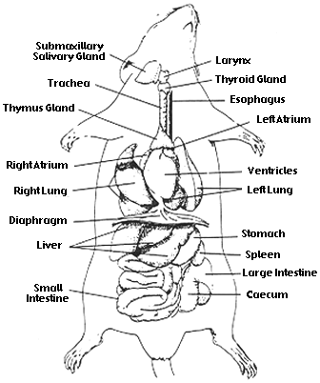

Urogenital System
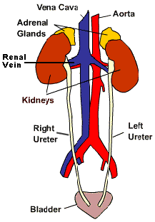
The excretory and reprodutive systems of vertebrates are closely integrated and are usually studied together as the urogenital system. However, they do have different functions: the excretory system removes wastes and the reproductive system produces gametes (sperm & eggs). The reproductive system also provides an environment for the developing embryo and regulates hormones related to sexual development.

Excretory Organs

1. The primary organs of the excretory system are the kidneys. These organs are large bean shaped structures located toward the back of the abdominal cavity on either side of the spine. Renal arteries and veins supply the kidneys with blood.
2. Locate the delicate ureters that attach to the kidney and lead to the bladder. Wiggle the kidneys to help locate these tiny tubes.
Procedure: Remove a single kidney (without damaging the other organs) and dissect it by cutting it longitudinally. Locate the cortex (the outer area) and the medulla (the inner area).
3. The urethra carries urine from the bladder to the urethral orifice (this orifice is found in different areas depending on whether you have a male or female rat).
4. The small yellowish glands embedded in the fat atop the kidneys are the adrenal glands.

The Reproductive Organs of the Male Rat
1. The major reproductive organs of the male rat are the testes (singular: testis) which are located in the scrotal sac. Cut through the sac carefully to reveal the testis. On the surface of the testis is a coiled tube called the epididymus, which collects and stores sperm cells. The tubular vas deferens moves sperm from the epididymus to the urethra, which carries sperm though the penis and out the body.
2. The lumpy brown glands located to the left and right of the urinary bladder are the seminal vesicles. The gland below the bladder is the prostate gland and it is partially wrapped around the penis. The seminal vesicles and the prostate gland secrete materials that form the seminal fluid (semen).

The Reproductive Organs of the Female Rat
1. The short gray tube lying dorsal to the urinary bladder is the vagina. The vagina divides into two uterine horns that extend toward the kidneys. This duplex uterus is common in some animals and will accomodate multiple embryos (a litter). In contrast, a simple uterus, like the kind found in humans has a single chamber for the development of a single embryo.
2. At the tips of the uterine horns are small lumpy glands called ovaries, which are connected to the uterine horns via oviducts. Oviducts are extremely tiny and may be difficult to find without a dissecting scope.
Procedure: Pin the organs of the urogenital system.
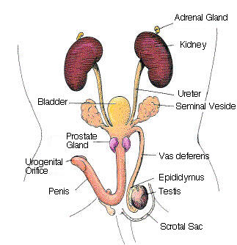 | 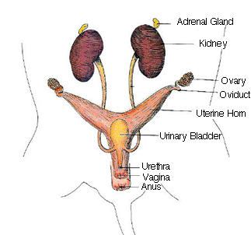

Rat - Circulatory System
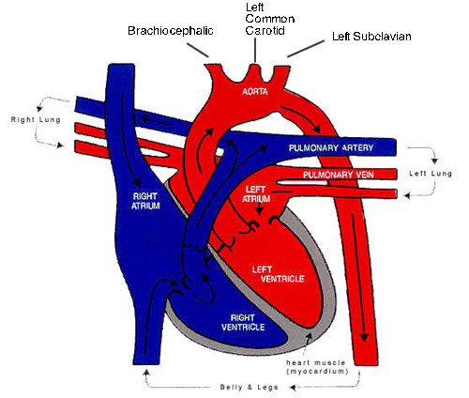
The general structure of the circulatory system of the rat is almost identical to that of humans. Pulmonary circulation carries blood through the lungs for oxygenation and then back to the heart. Systemic circulation moves blood through the body after it has left the heart. You will begin your dissection at the heart. It is important that you do not cut the vessels as you carefully remove any muscles and surrounding tissue to expose them.
Trace the flow of blood from the right atrium to the lungs and then back to the heart, you may not be able to locate all these structures due to the placement of the heart and vessels, but you should be able to find a few of them and label all of them on a diagram.

Trace the Flow of Blood Inside the Heart
1. Blood from the posterior portion of the body enters the right atrium of the heart through the inferior vena cava. The inferior vena cava is also referred to as the caudal vena cava.
2. Blood from the anterior parts of the rat enter the heart from the right and left superior vena cava, also known as the cranial vena cava.
3. Blood flows from the right atrium to the right ventricle via the tricuspid valve.
4. Blood is then pumped through the pulmonary semilunar valve and into the pulmonary trunk, which divides into the left and right pulmonary arteries - these are the only arteries in the body that carry deoxygenated blood.
5. Blood then flows through the pulmonary arteries to the lungs where it is oxygenated and then returns from the lungs to enter the left atrium via four pulmonary veins.
5. Blood goes from the left atrium to the left ventricle via the biscupid (or mitral) valve.

Trace the Flow of Blood from the Heart.
Blood leaves the left ventricle of the heart through the aortic semilunar valve and enters the aorta. The aorta has four general areas:
ascending aorta - begins at the semilunar valve of the left ventricle and passes outside and over the left and right atrial.
aortic arch - the place where the aorta bends to the left.
descending aorta - after the bend, the aorta can be traced toward the diaphragm
abdominal aorta - the aorta passes through the diaphragm and supplies blood to the lower extremities and organs

Trace the Branches of the Aortic Arch and the Descending Aorta
1. Coronary arteries are located on top of the heart and supply the heart itself with blood.
2. The first visible branch from the aorta is the brachiocephalic artery, it divides into the right common carotid artery, which supplies the right side of the neck, and the right subclavian artery, which supplies the right shoulder and arms.
3. At the most anterior part of the bend in the aortic arch is the left common carotid artery, which supplies blood up the left side of the neck.
4. Immediately to the left of the left common carotid artery is the left subclavian artery, which supplies blood to the left shoulder and arm.
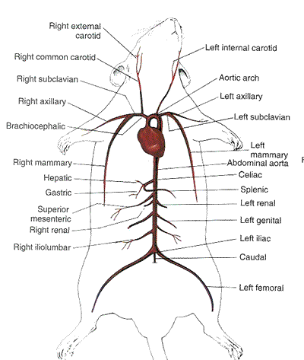
*note that the branches are not symmetrical.

Trace the Branches of the Thoracic Arteries
1. The right subclavian artery branches from the brachiocephalic artery - it then passes under the clavicle and branches into the right internal mammary artery (look alongside the the chest wall) and the right axilllary artery which leads toward the armpit.
2. The left subclavian artery branches in a similar way to form the left internal mammary and the left axillary.
3. The right common cartoid passes along the neck toward the head where it gives rise to the right external carotid artery and the right internal carotid artery.
4. Similarly, the left common carotid can be traced toward the head where it branches into the left external cartoid artery and the left internal carotid artery.
Procedure: Carefully tease away the muscles and tissue so that the right subclavian, the right axillary and the right common carotid can be seen.

Trace The Branches of the Abdominal Aorta
1. Push the abdominal organs to the left to locate the arteris. The first arterial branch from the abdominal aorta (below the diaphragm) is the celiac artery which branches to arteries that supply the stomach (gastric artery), liver (hepatic artery), spleen and pancreas (splenic artery) .
2. The second artery arising from the abdominal artery is the superior mesenteric artery, which is larger than the celiac, and delivers blood directly to the small intestine.
3. The renal arteries are short and lead directly to the kidneys.
4. Just posterior to the renal arteries are the genital arteries, which lead to the testes or the ovaries.
5. Farther along the abdominal aorta, you can find the iliolumbar arteries which lead to the dorsal muscles of the back.
6. Next, the inferior mesenteric artery leads to the intestinal mesenteries.
7. The abdominal aorta gives rise to the caudal artery, which goes on into the tail.
8. The abdominal aorta finally divides to form the iliac arteries, which deliver blood to the pelvis and hind legs.
9. The iliac arteries lead to the femoral artery in the leg.
Procedure: Carefully tease away the muscles and tissue so that the the iliac and the femoral arteries can be seen.

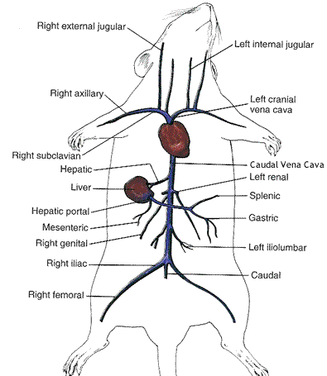
Trace the Systemic Veins
1. The left and right superior vena cava conduct blood from the upper part of the body into the right atrium. Trace these veins from the atrium until you find the small internal jugular vein and continues as the subclavian vein.
2. The subclavian vein divies into the external jugular vein and the axillary vein.
3. The inferior vena cava carries blood from the lower part of the body to the right atrium. The hepatic vein drains the liver and enters the inferior vena cava near the diaphragm.
4. Renal veins drain the kidneys.
5. Genital veins lead from the gonads and enter the inferior vena cava.
6. The iliac and femoral veins drain the legs.
7. The caudal vein drains the tail.

The Hepatic Portal System
A portal system is a system of veins that carries blood from one bed of capillaries to another bed of capillaries. The hepatic portal system carries blood from the mesenteries, small intestine, spleen, somach and pancres to the liver. Specifically, the gastic, splenic, and mesenteric veins drain the digestive system and unit to form the hepatic portal vein which carries the blood to the liver.
The liver is strategically located to receive blood after nutrients have been absorbed in the intestinal tract. The liver cells can easily modify these nutrients and remove toxins.
The vessels of the hepatic portal system may be difficult to find. 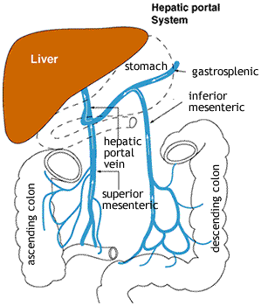

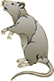
Rat Anatomy Checklist
Throughout the course of the investigation, you will be to stop and have your instructor check your progress. At each checkpoint, you should have the box initialed by your instructor to ensure adequate progress. You will turn this sheet in at the end of the investigation.
1. Rat skinned and muscles exposed. [ Instructor initials_____________ ]
2. Remove muscles from one hind leg to expose the femur, tibia, and fibula. [ Instructor initials_____________ ]
3. Pinning the structures of the head and neck. [ Instructor initials_____________ ]
4. Pinning the organs of the digestive system. [ Instructor initials_____________ ]
5. Removal and dissection of the kidney, opening of the stomach and small intestines. [ Instructor initials_____________ ]
6. Pinning the urogenital organs. [ Instructor initials_____________ ]
7. Exposing the subclavian, axillary and carotid arteries. [ Instructor initials_____________ ]
8. Exposing the iliac and femoral arteries. [ Instructor initials_____________ ]
9. Turn in the rat. [ Instructor initials_____________ ]
Lab Evalution
 | 3 | 2 | 1
FOCUS - embraces lab as a learning opportunity, uses resources to enhance understanding, stays focused and self-directed
PARTICIPATION - shared equally in responsibilities, no absences
COMPLETION - all checkpoints achieved
RESPECT - attentive, curious, does not "play" with the specimen
SAFETY & CLEANUP - always wore goggles, cleaned up station, stored specimen appropriately

