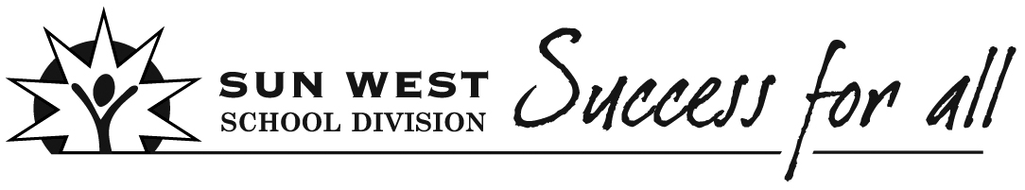 Lesson Plan Template
Teacher | Subject  Social |  | Grade  2 | Unit /Theme  Influence of Treaty |  | Topic  Treaty  promise | Date
 |  |  |  |  |  |  | Duration
Big Ideas/Key Questions

Treaties are a sacred promise. We are all treaty people.

Outcome(s)  DR 2.4 Describe the influence of Treaty and First Nations people on the local community |  |  |  |  | Student Friendly Outcome(s)  How has Treaty and FN people touched or affected our community?
Indicator(s)  b. Investigate the relationship of traditional First nations to the land.  d. Describe the reasons for Treaty from the perspective of the First Nations people and the government |  |  |  |  | Student Friendly Indicator(s)  b. How did FN people live long ago?  d. Why did FN people want to have an agreement with the government?  d. Why did the government want to have an agreement with the FN people?
Assessment Strategy  - Pre-Assessment  xFormative Assessment  - Summative Assessment |  | Formative: student representation should show elements of treaty promise.  Exit slip: What are we sharing?
Motivational Set
Have students look at and/or read lots of FN content books pulled from library showing traditional ways. Could also include books about promises.

Instructional Strategies/Activities (Before/During/After)
Before:
1. Read the story “A Promise is a Promise” (optional)
2. Talking circle: how are promises sealed?
During:
1. Role play – FN way of life, first arrival of newcomers, later relationships, need for treaty
2. Role play – signing a legal document; handshake
3. Role play – pipe ceremony; sacred agreement
After:
1. Student handout activities: “Treaty: a Promise”, “How do we feel?”, “Reasons for Treaty”, Treaty medal
2. Representation: treaty medal–“as long as the sun shines, the grass grows and the river flows” with treaty medal (Teaching Treaties Gr. 2 appendix)
3. Exit slips

Differentiated Strategies

Allow students to answer written work in words or pictorially.

Materials/Resources

“A Treaty Story” by Maxine Hadubiak (2011) smartstartlearning.com Harris School library has this book This book could be used in place of the role play.

1. A Promise is a Promise – story book (optional)
2. Talking stick
3. Paper that looks like a legal document – to sign
4. pipe ceremony images (file)
5. materials to create a representation for sun, grass, river, treaty promise, medal (OTC treaty kit Gr. 2)
6. student handouts: “Treaty: a promise”, “How do we feel?”, “Exit Slip”, copy of the treaty medal from OTC treaty kit Gr. 2
7. Role play guide
8. FN content library books
9. Treaty Kit “Treaty Resource guide for grade 2” topic 3: “Reasons for Treaty” pages 28 to 31 and appendix D page 69

Reflection

Section 2 of this document contains the lesson in detail.

Section 3 contains all the student handouts.

Section 2 Social 2 Lesson in Detail (this lesson may take several classes to complete)
DR2.4 Describe the influence of Treaty and First Nations people on the local community.
b. Investigate the relationship of traditional First Nations to the land.
d. Describe the reasons for Treaty from the perspective of the First nations and the government.
Introductory lesson:
Before:
1. Discuss the concept of a “promise”. Read “A Promise is a Promise” (optional)
2. Sit in a talking circle, pass around the talking stick and have students demonstrate ways that promises are sealed (pinky swear, cross my heart, scouts’ honour, swear on a bible, handshake, more…..)
During:
(the book “A Treaty Story” by Maxine Hadubiak could be used in place of role play)
1. Role play #1: Have all students assemble on the carpet or other defined area. Have 3 students move to the side and be the newcomers with the teacher. Have the other students pretend to be FN living off the land. Prompt them to show (act out) all the ways FN used the land to survive: hunting buffalo, deer, other animals; picking berries, plants, roots; skinning animals for fur, blankets, clothing, tipis, pots; moving from place to place to follow food sources; fishing; other ideas….. (DR2.4 b)
Have the 3 students pretend to meet the FN for the first time. Language is a barrier. FN are happy to teach the newcomers how to survive in this new land: hunt, fish, forage, etc. Students show mutual respect, willingness to share, learning from one another, moving about freely.
Newcomers leave. Now take about 2/3 of FN actors and have them join the 3 students and become newcomers. Newcomers return and far outnumber the FN people. They take over, shooting all the buffalo, taking the land, pushing the FN people further away off the carpet so they have more room for settlement.
Freeze frame: To develop an understanding of the need for treaties, ask students questions at this point….
How did the FN and the newcomers get along at the beginning? (welcoming, sharing, learning from one another, ….)
What has changed now? (many more newcomers; taking land and hunting/fishing away from FN)
How would the FN feel about how the newcomers are behaving? (angry, confused, sad)
What might they want to do? (fight, cry, run away, chase newcomers away)
How will this problem be solved? (sit down and talk and figure something out, war, fight)
Use OTC Treaty Kit as a resource for reasons for treaty from both perspectives. See Treaty Resource guide for Grade 2. Pages 28 to 31 and appendix D. Material is NOT at a grade 2 level. Teacher would have to rework this resource to create suitable material for grade 2.
“A Treaty Story” by Maxine Hadubiak (2011) smartstartlearning.com page 13 reasons for treaty – the author refers to First Nations people as “Aboriginals” so you may have to explain this term to students
Continue role play #1. Have representatives from both sides is in a large circle. Have the others sit closely behind. Start to negotiate through hand gestures and simple words. Come up with a list of problems and solutions: students will mention land taken away, illness, no buffalo any more, need for food, hunting, fishing, land. Come up with an agreement – FN will pick land that is good for hunting & fishing, but not for farming; very little land is given to FN; try to include major treaty items
Role play #2: treaty signing: have 3 or 4 students from each side “sign” the treaty document (make up some sort of legal-looking document). FN must place an X because they cannot read or write English. Point out that because of the language barrier, there would be misunderstandings in written treaty agreements.
Role play #3: pipe ceremony: use some prop as a pipe. Pass it around the circle. Have students pretend to wave the smoke towards their bodies as a sign of cleansing and sacredness. Explain that the pipe ceremony made the treaty agreements a sacred, solemn undertaking. The intent in the treaties was unwritten as well as written. Show images of pipe ceremony from image file.

Act out the treaty agreement: FN try to hunt and fish freely, but newcomers say they can only hunt on a little bit of land (reserve) ; FN try to move freely, but made to go back to their land by an Indian Agent; point out that what each side intended was not understood by the other side; many misunderstandings; much hardship, anger, resentment, FN feeling cheated; more….
This leads to an understanding of the current issues with treaty: students will come up with land issues, hunting and fishing issues, and maybe schooling issues, language rights, retaining culture etc.

After
1. Handout “Treaty: a Promise” and have students discuss the symbolism of the images for treaty.
Handout “Treaty Medal” – discuss that treaties were to last “as long as the sun shines, the grass grows and the river flows”
Handout: “How do we feel?” students fill in the responses in words or pictures
Handout: “Reason for Treaty” DR 2.4 d
2. Represent: Student create a treaty medal. They must incorporate sun, grass, river, handshake, pipe and any other images they feel symbolize treaty. Can be any shape. Use the example of the real treaty medal as inspiration.
3. Exit slips: students respond with what they have learned in the role play (formative assessment) or from “A Treaty Story”

Section 3
Student handouts:

- A Treaty Promise

- Pipe Ceremony Images

- How Do We Feel?

- Reasons for Treaty

- Exit Slips

Name: _______________
Treaty: a promise
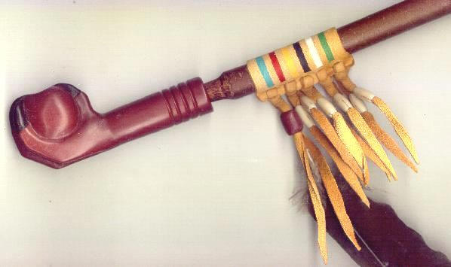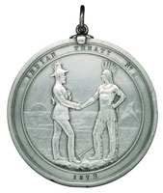

Pipe Ceremony
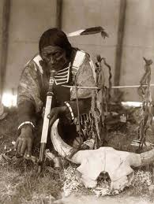

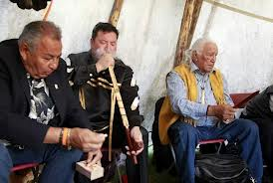

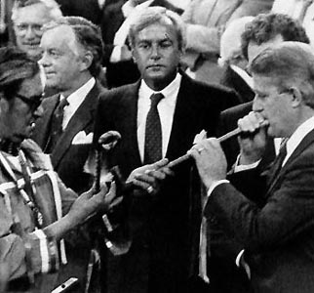

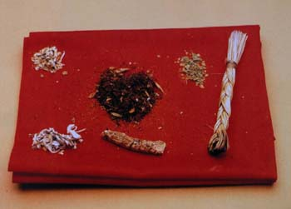
Sacred Plants: Red Willow Bark, Sage, Calamus Root, Sweetgrass braid, Poplar leaves and Tobacco

Treaties Name: __________
How do we feel when we make a great promise?
Words: Pictures:

How do we feel when a promise is broken?
Words: Pictures:

Reasons for Treaty Name: __________________
(adapted from “A Treaty Story” by Maxine Hadubiak (2011)

Canada’s government wanted to sign treaties with the First Nations for one very important reason: they wanted the land. The government wanted land for:
(1) a railway to be built across the country
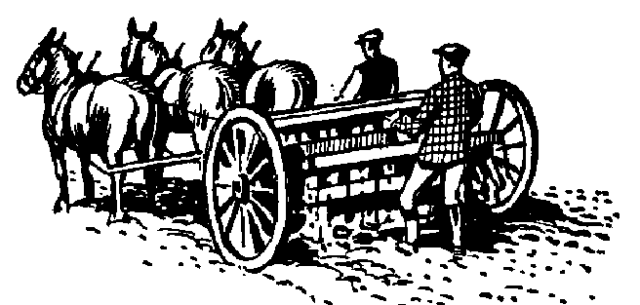
(2) the thousands of settlers who planned to farm and develop the land.

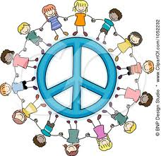
The government also wanted to keep peaceful relations between the settlers and the First Nations.

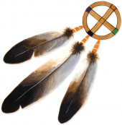
The First Nations had their reasons for signing the treaties. The First Nations saw the treaties as agreements or sacred promises to live together in peace and harmony.
The First Nations also saw the treaties as a way to protect their way of life. The treaties would allow their people to make their own living and they would allow their people to be independent and free.
The First Nations signed Treaty 6 so that their children and grandchildren could have a good future .
Exit slip Name: __________________
Treaties: (answer in words and / or pictures)
What are we sharing? Who are treaty people?

Why did the government want to make treaty?

Why did the First Nations want to make treaty?

How long will treaties last?

