Grade 3 Social Studies

Community Comparisons

In social studies, Grade 3 students begin to expand their focus from the local environment to the global environment, and begin to explore the relationships between their local communities and the broader world community in which they live. Students of Grade 3 social studies begin to examine their responsibilities as citizens of interdependent local and global communities. They explore how needs and wants are met in communities other than their own, how decisions are made in various settings, and how location affects lifestyles and worldviews of inhabitants.

Treaty education at Grade 3 should include comparisons of the Treaty relationship in Canada with indigenous communities elsewhere in the world. The study of social studies in Grade 3 should include one Saskatchewan community different from the local community, at least one First Nations or Métis community, at least one Canadian community, and at least one international community.

Social Studies 3 Aim & Goals
﻿
Aim and Goals of Social Studies and the Social Sciences
The four goals of K-12 Social Studies and Social Sciences education are to:
- examine the local, indigenous, and global interactions and interdependence of individuals, societies, cultures, and nations (IN).
- analyze the dynamic relationships of people with the land, environments, events, and ideas as they have affected the past, shape the present, and influence the future (DR).
- investigate the processes and structures of power and authority, and the implications for individuals, communities, and nations (PA)
- examine various worldviews about the use and distribution of resources and wealth in relation to the needs of individuals, communities, nations, and the natural environment, and contribute to sustainable development (RW).
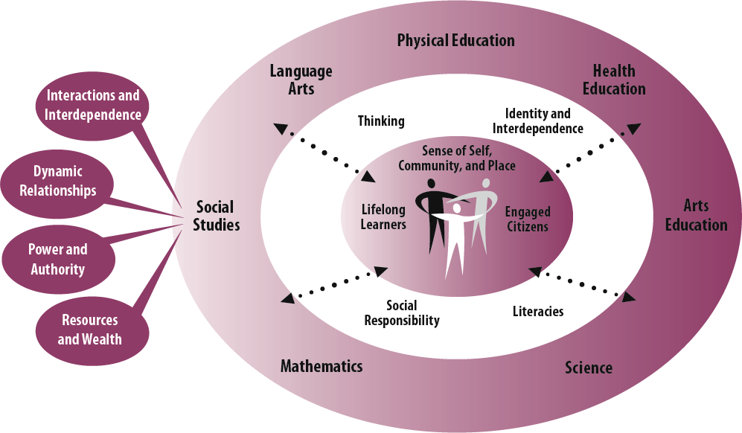

NOTE: This unit is developed in order to give our students a background and a framework in FNMI. We are going to divide the unit into Pre-Newcomers and Newcomers. This way we can have a better understanding of the FNIM understandings.
Outcome: DR3.3

Compare the beliefs of various communities around the world regarding living on and with the land.

Indicator: | Assignment/Assessment/Materials | F or S | 5 4 3 2 1
a)Research the view of land as held by indigenous peoples in communities studied.

Outcome: IN3.1
Analyze daily life in a diversity of communities.
Indicator: | Assignment/Assessment/Materials | F or S | 5 4 3 2 1
a) Describe characteristics of daily life in communities studied, and compare the ways in which the needs are met by individuals in diverse communities (e.g., housing, tools, work, use of the land, games, education).

b)Give examples of how culture is reflected in daily life in various communities, and examine why these cultural elements are important (e.g., language, stories, cultural traditions, religious traditions, recreation, art, architecture, clothing).

c)Compare life of a child in the local community to life of a child in one of the communities studied (e.g., family, housing, education, recreation).

Outcome: IN3.2
Analyze the cultures and traditions in communities studied
Indicator: | Assignment/Assessment/Materials | F or S | 5 4 3 2 1
a)Hypothesize about the interactions students may have with people and communities elsewhere in the world.

b)Give examples of traditions and practices that have endured over time in communities studied, and discuss why these are important.

c)Make inferences about how the culture of the local community is reflected by its customs and celebrations.

Outcome: DR3.2
Assess the degree to which the geography and related environmental and climatic factors influence ways of living on and with the land.

Indicator: | Assignment/Assessment/Materials | F or S | 5 4 3 2 1
a)Identify the influences that geography has on societies (e.g., location of settlements, transportation of goods and people, types of industry such as farming, ranching, forestry, mining, tourism, and manufacturing).

b)Recognize how environmental and climatic factors are influenced by location (e.g., proximity to water bodies influences precipitation and temperature; mountainous terrain influences soil formation, precipitation, and temperature).

c)Describe the impact of environmental factors and events on ways of life in communities studied (e.g., climate, vegetation, natural resources, landforms, floods, droughts, storms).

Outcome: DR3.3
Compare the beliefs of various communities around the world regarding living on and with the land.
Indicator: | Assignment/Assessment/Materials | F or S |  | 5 4 3 2 1
a)Research the view of land as held by indigenous peoples in communities studied.

Outcome: PA3.1
Compare how decisions are made in the local community and communities studied.

Indicator: | Assignment/Assessment/Materials | F or S |  |  | 5 4 3 2 1
a)Identify formal and informal types of leadership.

c)Give examples of ways in which groups and communities make decisions
d)Investigate decision-making processes in communities studied
Outcome: PA3.2
Demonstrate awareness that divergent viewpoints may lead to conflict as part of group interactions, and assess various means of conflict resolution.

Indicator: | Assignment/Assessment/Materials | F or S | 5 4 3 2 1
a)Inventory situations in which divergent viewpoints exist within the classroom and school.

h)Research different laws and rules in communities studied, and speculate upon the reasons for such laws and rules.

d)Construct a list of reasons why groups and communities may experience conflict, and identify ways in which conflict is resolved and harmony is restored.

h)Research different laws and rules in communities studied, and speculate upon the reasons for such laws and rules
Outcome: RW3.1
Appraise the ways communities meet their members’ needs and wants.
Indicator: | Assignment/Assessment/Materials | F or S | 5 4 3 2 1
b)Identify how individuals and communities meet needs and wants.

c)Describe ways in which communities help ensure basic human needs are met (e.g., food and water, shelter, clothing, education, safety).

d)Describe how and why communities exchange goods with other communities.

