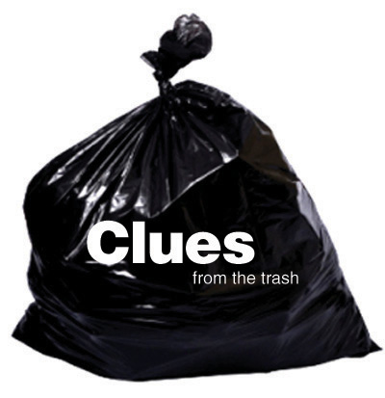
Clues from the Trash: Who's in the family?
Fill a clean empty trash bag with "clean garbage" and encourage kids to use their inference skills to make guesses about "the family."

Trash Examples (all emptied):
Dog food - they have a dog
Shaving cream - someone hairy, dad
Baby food jar - baby in the family
Carry out menu - they like to eat out
Lipstick tube - mom or teen girl
Picture of Justin Bieber - kid / teen with a crush, likes music
Box of crayons - someone likes to color, kid
Popcorn bag - they watched a movie
Get creative! You can put some crazy things in the bag to get kids to think out of the box!

Questions to Ask:
How many people in the family? - Maybe six: dad, mom, baby, kid, teen, dog
What are their interests? - Music, art, movies, eating out

