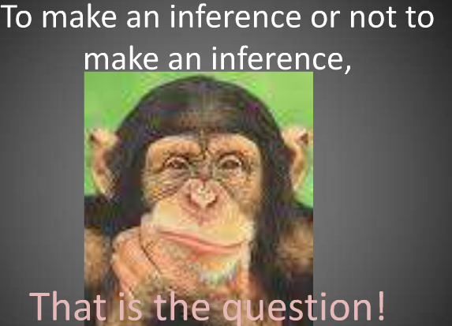
Infer from Pictures
Select a picture, possibly from a newspaper or magazine that has a caption. The picture should show people interacting or reacting to something. Cover the caption, and show the picture to the students. Ask them to look at it carefully for a few minutes and try to mentally compose an explanation for what is happening in the picture. Ask them to look at all areas of the picture for details and helpful information. Then ask students to write as much as possible to explain what is happening in the picture. Read the caption to the students and ask them to compare it with their ideas. (Captions are intended to be short explanations for pictures, so the student work will probably be much more comprehensive.)
Try this same strategy with other illustrations, posters, diagrams, graphs, etc.
Something else to try: Using Cartoons to Teach Inferencing – see zipped folder on this wiki!

