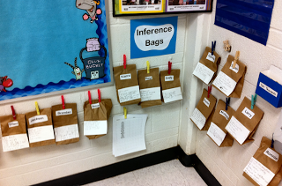
Step One: Hand out paper sandwich bags to each student
Step Two: Glue name tag on their bags
Step Three: Let the students place anything that would fit in their bag. Examples - rubber animals, stuffed animals, unit cubes, paper decorations, anything they could find that wasn't actually living they could put in their bag. It was their job to make sure they put it in their bag secretly.
Step Four: Staple the bags closed.
Step Five: Hand out one index card to each student.
Step Six: Have students write out 6 clues about their mystery object in the bag. They don't want to make the clues obvious, but they do have to be factual.
Step Seven: Place the bags in a corner of the room with their clues and a sheets of paper with all of the students’ names on them. When the students go to the corner or center, they read the clues and work together to determine what they think is in each student's inference bag. After all station rotations are over whether it be two days or a week, the children can reveal their items and the other students can check and see if they were correct.

Whole School Inferencing Practice
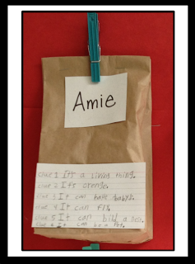
You can take the inference activity above a little bit farther and do the same activity for the school.
- The students place any item of their choice in a brown paper bag. Place their name on it, give them an index card, and they write their clues.
- Using hot glue, glue clothespins to the bulletin board and hang the bags.
- Glue a small box to the bulletin board and label it "Take a Slip." Place blank inferencing slips in the box. When teachers brought their class to the board, they would pass out the inferencing slips. The students would write their name, room number, the name on the bag, and a guess as to what was in the bag based on the clues.
- Glue another box (larger in size) to the board. The students would fold up their slips and place them in the box. The box opened so the host students could periodically remove the slips and check them for accuracy.
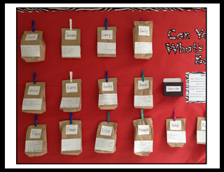
- The host students would have the job of checking the slips. If a student from another classroom made a good inference, one of host students would cut out a "Congratulations Slip", write their name and room number on it, and tape a Starburst onto the slip. Then, they would deliver the slip and treat to their classroom teacher so he/she could hand them out.
Click on the PDF icon below to find some printable inference congratulations cards that you could use.

