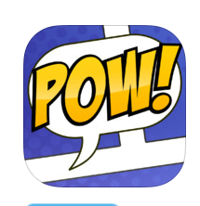
Inferencing App
Strip Designer - $3.99
This iPad app could be used for inferencing, as well as many other things in which the students could “show what they know”.
Features:
- A variety of templates
- Speech balloons
- Stickers
- Use photos from photo album/stream on your iPad or iPhone or ones that you download from elsewhere
- Add text
One teacher gave her students pictures to make inferences from. They exported them to PDFs and she then uploaded their ideas to FlipSnack to create a class inference book.
http://borchardtlibrary.edublogs.org/2012/11/06/2nd-grade-inferences-books/

