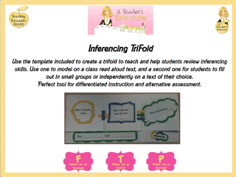
You can see the foldable is color coded. It help the kids see the relationship and helps them think of it as an addition problem.

Printout the template for the kids & they colored theirs in. Click on the PDF icon to get the foldable.
Next, have the students write down the title of the text & the topic of it.
Have the students flip up the What I already know fold and write down 3-5 facts they already knew about the topic and illustrate the first image that came to their mind.
Next, have students read the story in pairs and add 5 NEW facts that they learned about the topic from the text in the second fold. They also had to create a new illustration based on an image that they now formed in their head.
Lastly, they had to add up the two and draw new conclusions and
write them in the third fold & add an illustration.
Discuss and have the students share their inferences.
Here are pics of some examples.