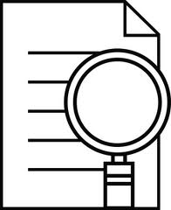

INFER

Something good readers do to figure out what the author is saying, even though she may not have actually written it down. Good readers look for CLUES in the text (words/pictures) to help.

**Opinions or conclusions** based on observations from facts - what you see, hear, read or what you know.

Inferences

Infer =

to form an opinion based on facts

What you **think** will happen next; based on your observations and inferences.

Predictions

**Clues**, either in a picture or in a paragraph or story. They are **factual** and can be proven.

Observations

What do I know?

What do I need to

**fill in**

because the author didn’t include it?

versus

FACT

What you know because the author wrote it. It can be proven.

INFERENCE

**Opinions or conclusions** based on observations from facts - what you see, hear, read or what you know.