Get your students really interested in the strategy of inferring by packing a “ME” purse or backpack with items in it that would invite them to infer things about you that they may not already know. Have the students take turns selecting things from your purse or backpack and then discussing what they are able to infer about you, based on that item.
Examples of things that you might include would be:
- Passport – you like to travel
- Chocolate bar – you love chocolate
- Tim Horton’s gift card – you like coffee and/or donuts
- Family pictures – you love your family
- Cell phone – you like to stay connected with family and friends
- Cookbook – you like to cook
- Ear buds – you like to listen to music
- Dog leash – you have a dog
- Pocket calendar – you are forgetful/very busy and have to write down things
- the list is endless here
Once you have shared your purse or backpack, invite the students to prepare a backpack (see next two pages) of their own. Encourage them to be a creative as they can with the list they create. Sharing their backpacks is lots of fun and is a great way for the students to get to know one another. Be sure to have them talk about why they are able to infer things about their classmates based on what’s in their backpack.

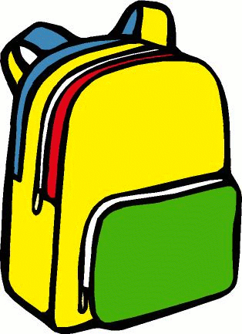

Imagine that you are packing a “ME” Backpack. What would you put in it to have others infer things about you? Complete the chart below and then list or draw your items on the picture of the backpack on the next page. Share with your classmates to see if they can “infer” things about you that they may not already know
Item | What it tells about me
