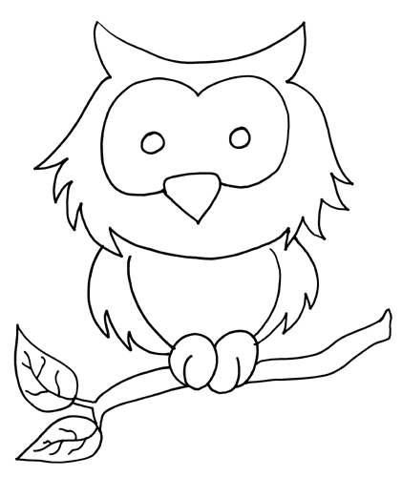

**Link it to your life**

**Observe or notice**

**What do you wonder?**