Picture Book Detectives
Encourage students to make inferences from picture books or illustrations in textbooks.
Begin by telling students that good readers use illustration clues along with their prior knowledge and experiences to make inferences during reading. Model with a picture book or textbook how you look at illustrations and make inferences by thinking aloud. Repeat the thinking aloud multiple times, showing how to be a “detective” hunting for clues about character feelings and actions. Be on the lookout for picture clues that were NOT included in the text that tell you more about the setting, characters, problem, solutions, or events. List inferences and clues on a chart (attached).
After modeling, invite students to work in pairs or small groups to study an illustration and tell what clues they used to make an inference. Allow each group to share with the class. Then encourage students to do the same as they read independently. They may complete their own inference chart during independent reading.
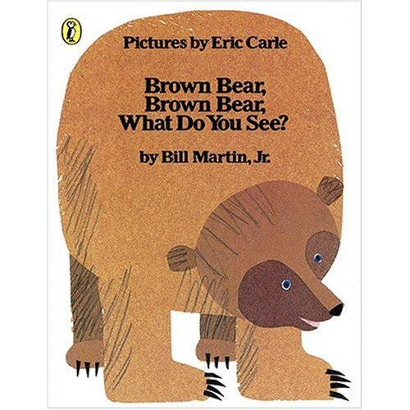
Discuss with students how making picture inferences helps them to understand the text.

Picture Book Detectives
The book + your experiences, knowledge = an inference
1. After reading a picture book with a partner, study all of the illustrations again. Which illustrations show examples of inferences? Watch for clues that are in the illustrations but were NOT in the words.
Some examples might include:
• character feelings
• action clues
• clues about the problem in the story
2. Use the chart below to record the page number, what you see, the clues from the book or your experience, and your inference.
3. Choose your favorite illustration from the selection that shows an inference.
On a separate sheet of paper sketch the illustration. Act out the inference with a partner for the class.

Picture Detective Inference Chart
Page ___ | Describe the picture. | Clues from the picture.  Our experiences | Inference
Page ___ | Describe the picture. | Clues from the picture.  Our experiences | Inference
Page ___ | Describe the picture. | Clues from the picture.  Our experiences | Inference
Page ___ | Describe the picture. | Clues from the picture.  Our experiences | Inference

