Picture of the Day
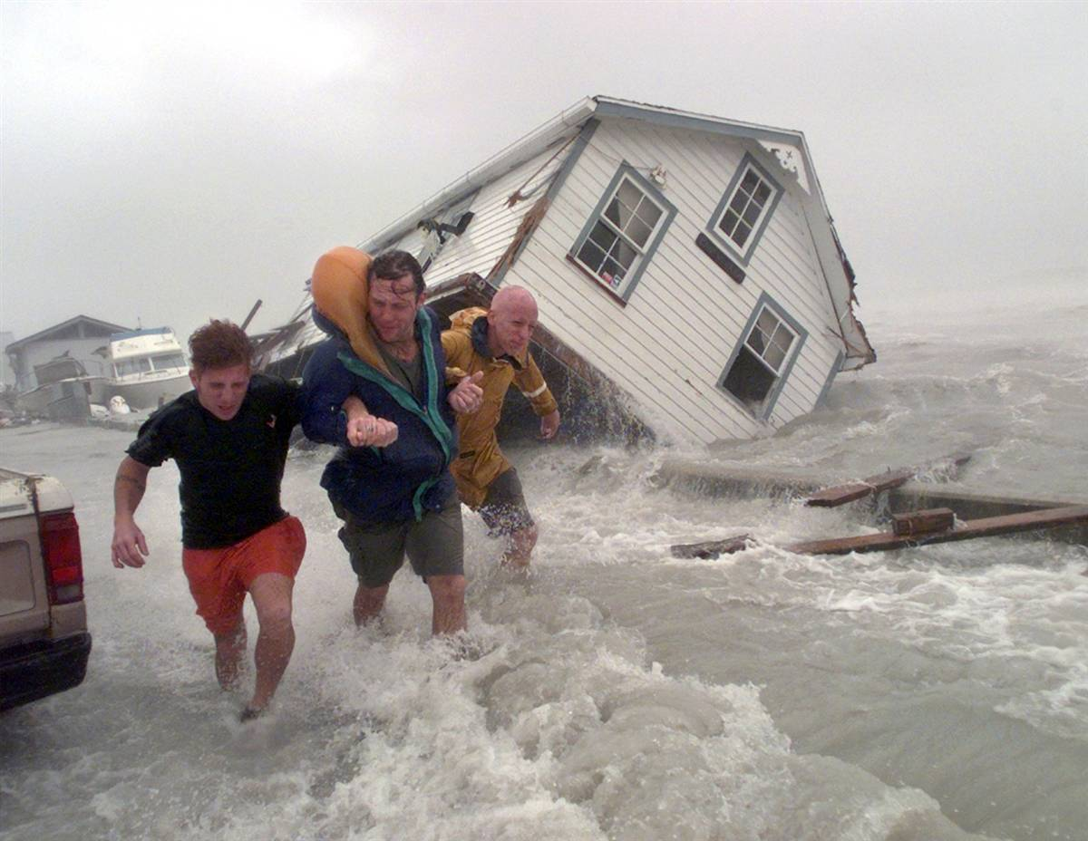

This activity helps students differentiate between observations, inferences, and predictions.
Put a picture on the interactive white board (or print out and show the picture) as a warm up activity.
You can get the pictures from a variety of sources but National Geographic's Picture of the Day @ http://photography.nationalgeographic.com/photography/photo-of-the-day/ is a great place to get pictures. The picture above is from the National Geographic site.
Have the students make five observations. Then have them make five inferences. Finally, ask them to make five predictions. You can use the graphic organizer on the next page if you wish.
Discuss what the differences between the three terms is. The discussions that you have will soon help the students realize the differences between the three.
Students will love the daily practice. It is also a great way to use those “teachable” moments to discuss lots of different topics, depending on the picture you use.

Picture of the Day

My OBSERVATIONS:
- ______________________________________________________________________________
- ______________________________________________________________________________
- ______________________________________________________________________________
- ______________________________________________________________________________
- ______________________________________________________________________________

My INFERENCES:
- ______________________________________________________________________________
- ______________________________________________________________________________
- ______________________________________________________________________________
- ______________________________________________________________________________
- ______________________________________________________________________________

My PREDICTIONS:
- ______________________________________________________________________________
- ______________________________________________________________________________
- ______________________________________________________________________________
- ______________________________________________________________________________
- ______________________________________________________________________________

