Pull a Passage
Explain to students that when good readers read they often use inferences to help them understand what they are reading. While reading aloud to students, stop and “pull a passage” out of the text that you used to make an inference. Write this passage on a chart or the overhead. Give two or three inferences that you made when you read the text. Tell what you visualized, remembered, and inferred. Say something like “The author didn’t say this, but I know that _____ because the clues from the text were _____ and my experience is _____.”
After modeling several passages, “pull a passage” for students and have them determine what the author meant but didn’t come out and actually say it. Provide them with the following framework: The author didn’t say this, but I know that _____ because the clues from the text were _____ and my experience is _____ . Allow students to share their inferences.
Provide additional modeling if necessary. Ask, “How did you know?” to encourage use of evidence from the text and experiences. The worksheet on the next page can be used to help students with this strategy.
Reflect with students on some of the following:
• How does inferring help you understand what you read?
• How does inferring make reading enjoyable?

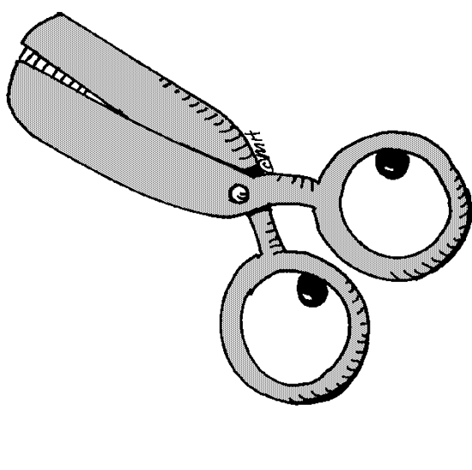

Pull a Passage
Sentence or passage is from (title) _________________________________________________
Author ________________________________________ Page number ___________________
Sentence or passage from the reading is _____________________________________________
____________________________________________________________________________________________________________________________________________________________

Inference #1 Inference #2
The author didn’t say _________________ The author didn’t say __________________
___________________________________ ____________________________________
But I know that ______________________ But I know that _______________________
___________________________________ ____________________________________
___________________________________ ____________________________________
because the clues from the text were because the clues from the text were
___________________________________ ____________________________________
___________________________________ ____________________________________
___________________________________ ____________________________________
___________________________________ ____________________________________
My own experiences that helped me infer My own experiences that helped me infer
___________________________________ ____________________________________
___________________________________ ____________________________________
___________________________________ ____________________________________
___________________________________ ____________________________________

