Who Wears These Shoes?

Ages: 7-12
Grade Range: 3-6

Making Inferences to Promote Comprehension
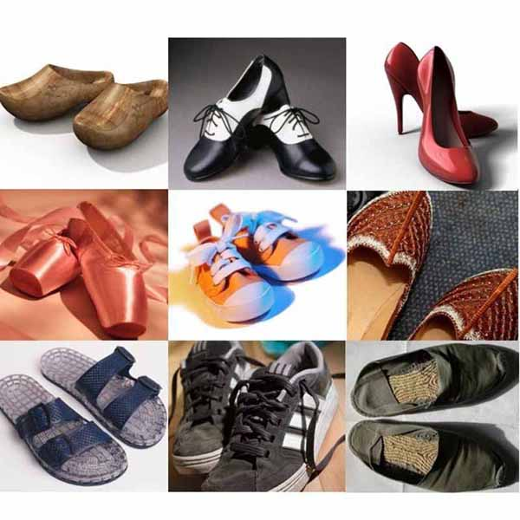

Activity Objective
The goal of Who Wears These Shoes?: Making Inferences to Promote Comprehension is to improve students' comprehension skills by providing practice in making inferences orally and in writing.

Activity Description

Preparation:
- Take/gather photos of several pairs of shoes
  - You may wish to use the actual pairs of shoes
- Select one photo to use as a model
- Gather chart paper and markers
- Prepare reference chart – see attached
  - Write the heading “Inferring”
  - Below the heading use a different color marker and write “Schema + Evidence = Inference”
  - Write the subheading “Thinking Stems” and include a list of possible sentence starters students can use when making inferences. For example: I predict... It could be that... My guess is... I infer... Perhaps...

Implementation:
- Invite students to view a photo of a shoe
  - Ask “Who do you think wears this pair of shoes?”
  - Encourage students to support their ideas by asking “What makes you say that?”
  - Encourage students to point out specific details from the photo to help them support their ideas
  - Move the discussion along by saying “Is there anyone else who can wear this pair of shoes?”
- Share the thinking stems chart with the students
  - Explain the term “schema” as prior knowledge or background information
  - Explain the term “evidence” as clues or details from the text or photo
  - Explain how using schema and evidence together helps to make inferences about what might be happening
    - Point out the equation schema + evidence = inference
    - Use the term “prediction” and discuss drawing conclusions and “reading between the lines” when describing inference
  - Provide an example of a schema and evidence that lead to an inference. For example: “My inference is that I think these shoes belong to a man. My evidence is that that the shoes are big. I know from my background knowledge that men usually have bigger feet than women.”
- Read the thinking stems to the students and have the students share ideas for completing each sentence
- Model the activity of making an inference chart
  - Divide another piece of chart paper in half and write “Evidence” and “Inference” as headings for each column – see attached
  - Invite students to share their ideas about what they see in the photo and record their ideas under the heading “Evidence”
  - For each piece of evidence that students share have them make an inference based on this piece of evidence and record it under the heading “Inference”
- Invite students to work in groups and make their own inference chart
  - Distribute a photo, a piece of chart paper and markers to each group
    - Each group should receive a different photo
  - Have students create 2 columns and copy “Evidence” and “Inference” as headings for each column
    - Encourage students to refer to the thinking stems during their group discussions
- Invite groups to share their photos and inference charts

Adaptations for:

English Language Learners/ESL:
- Prior to whole class discussion provide thinking stems to students and allow time to practice speaking aloud
- review terms schema, evidence and inference
LD/Reading & Writing Difficulties:
- Include picture cues or symbols for the terms schema, evidence and inference on the thinking stems chart
- Review and rephrase instructions to each group during activity

Differentiated Instruction:
- Use flexible and mixed ability groupings
- Encourage varied responses during whole class discussion
- Provide a variety of thinking stems as examples from which students can choose

Assessment Ideas:
- Use a checklist during the whole class discussion and group activity as a way to track participation, speaking and listening skills and cooperation skills
- Check for understanding during the group activity and sharing time by using a checklist to determine appropriateness of students' inferences

Activity Extensions:
- Have students independently write an inference in a short paragraph or story
- Infer and make predictions about other familiar objects. Examples could be:
- Who owns this toy?
- Who drives this car?
- Who has this hairdo?
- Who owns this backpack?
- Who would read this book?
- Who lives in this house?
- Who owns this pet?
- Whose handwriting is this?
- the sky’s the limit? - Get kids thinking critically!!!!!!
- Present comics or wordless picture books to the students and have them infer about what is happening
- Create an inference center with photos, pictures, wordless picture books and writing materials

Why Infer?
- Making inferences and drawing conclusions are necessary for readers to develop deeper understandings. Giving students an opportunity to infer about real objects provides a context for learning.
- Facilitate the discussion by keeping the questions open-ended rather than leading the students to a correct response.
- Encourage students to extend their thinking by including evidence from the photos to support their inferences.
Adapted from:
http://www.oise.utoronto.ca/balancedliteracydiet/Recipe/00084/

Inferring

SCHEMA + EVIDENCE = INFERENCE

What you know (your background knowledge) +
What you see/read/hear = What you infer
Thinking stems:
- I predict...
- It could be that...
- My guess is...
- I infer...
- Perhaps...
Give the Evidence! Relate it to your background knowledge!
“My inference is _______. My evidence is that _______. I know from my background knowledge that _______.”

evidence | inference

