Inside/Outside Circles
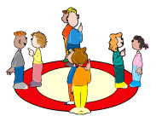

1’s are the inside circle and 2’s are the outside circle. Students face each other and take turns:
- responding to questions posed by teacher
- sharing writing they have done
- responding to a section of the text
- the sky’s the limit here!
After each opportunity for sharing, one circle moves counter clockwise based on the number provided by the teacher.

