**Think- Puzzle- Explore**

Consider the subject or topic just presented.

* What do you think you know about this topic?
* What questions or puzzles do you have about this topic?
* How might you explore the puzzles we have around this topic?

This strategy is similar to KWL, RAN chart as it invites students to connect to their prior knowledge. However the piece about what you think you know invites students to take risks about they know for sure.

To continue to puzzle throughout the unit of study is important as well. This sets the stage for further and deeper inquiry. It is important to incorporate at the end of the unit as well as a reflective tool. Revisit the Puzzle section as a reminder that learning is an ongoing process.

Set up:

1. This piece help to shape further inquiry and is used at beginning of unit.
2. What do you *think you know* about…..
3. Ask, “*What questions of puzzles do you have?”* What wonderings do you have? Place onto sticky notes, or puzzle pieces to display.
4. How can we explore this puzzles?
5. Share the thinking.

Variations:

1. Use when looking at art works. What do you think you know about this? What puzzles you and what are wondering?
2. Use large paper, label it as TPE, either place on table, floor or wall to jot down ideas of thinking on the ‘thinking’ section. Then list the wonderings, in the “puzzle” section. This could be done in large group, small groups.

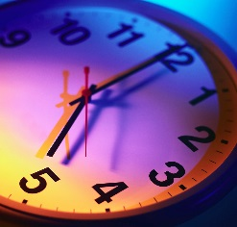**Sample: Thoughts and Puzzles about Time**

|  |  |
| --- | --- |
| **What do you think you know about time?** | **What puzzles do you have about time?** |
| Time is day and night. Time is also morning and afternoon, You can see time on a clock. There are twenty-four hours in a day. Time can also be timetables. The time when the sun comes up in the morning. The time when the moon comes up is night.  There is digital and analogue. There is bedtime, lunchtime, breakfast time. Day and Night, sunset, seconds and minutes.  The time it takes for a tree to grow.  When I think of a time I think of how grow up. | Who invented time?  How was time created?  Can you go backwards in time?  What if there was no time?  When was the first clock invented?  Why is time called time?  How does the clock know when to strike?  Why is time so important? |

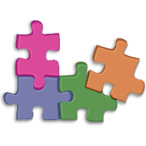**Think- Puzzle- Explore**

Consider the subject or topic just presented.

|  |  |
| --- | --- |
| * What do you think you know about this topic? |  |
| * What questions or puzzles do you have about this topic? |  |
| * How might you explore the puzzles we have around this topic? |  |