SOCIAL 4 Name: ______________
PA 4.3Demonstrate an understanding of the First Nations system of governance.
Thank you to Susan Beaudin, Office of the Treaty Commissioner, for reviewing this lesson for appropriate language and content.

Instructions:

1. Use the information given on the handouts “Local Government” and “First Nations Government” to fill in the chart. (To the teacher: handouts are attached at the end of this document.)

2. Use what you have learned to identify things that are the same and things that are different between the 3 kinds of local government.
Lightly shade the boxes that are similar blue.
Lightly shade the boxes that are different green.

Name: ______________
Gr. 4 Social  PA 4.3 | Local Government  Urban | Local Government  Rural | First Nations  Government
Type of community | Cities, towns, villages | Rural Municipalities  (R.M.) | First Nation reserve
Head of local
government is called……
Members are called…
Headquarters is called …..
Examples of types of services provided

Suggested answers:  Gr. 4 Social  PA 4.3 | Local Government  Urban | Local Government  Rural | First Nations  Government
Type of community | Cities, towns, villages | Rural Municipalities  (R.M.) | First Nation reserve
Head of local  government is called…… | Mayor | Reeve | chief
Members are called… | Councilors | Councilors | Councilors or headman or headwoman
Headquarters is called ….. | Town office  City hall | RM office | Band office
Examples of types of services provided | Fire protection  Streets and roads  Water and sewer  Parks  Libraries  Town bylaws about pets, fire pits, garbage, snow removal | Grid roads  Gravel  Country roads  Snow plough  Grader patrol | Fire protection  Gravel and country roads  Water and sewer  Snow plough  Grader patrol  Education  Bylaws about animals, garbage, pets  Housing

Local Government Student Handout

Local governments make decisions about the community where you live. Local governments provide services that affect people’s daily lives. These services include fire protection, police services, water and sewer, local parks and sports facilities, streets and roads, and libraries.

If you live in a city, town or village, the head of the local government is called the mayor. The members of the local government are called councillors or aldermen. The mayor and councillors together are called the city, town or village council. People who live in the city, town or village vote to elect the mayor and councillors.

In cities, the headquarters of the local government is called city hall. In towns and villages, it is called the town or village office.

Rural areas outside of cities, towns and villages are divided into rural municipalities (RMs). The head of the rural municipality is called the reeve. The members of the local government are called councillors. Together the reeve and councillors are called the municipal council. People who live in the rural municipality vote to elect the reeve and councillors.

The headquarters of a municipal council is called the RM office.
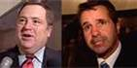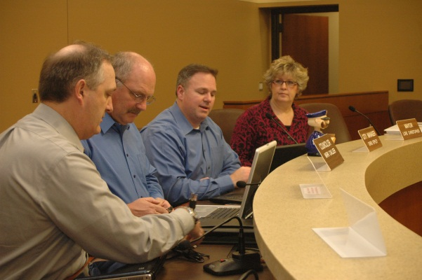
First Nations Government Student handout

If you are a member of a First Nation, the head of your government is called the chief. The members of First Nations governments are called councillors (or sometimes headmen or headwomen). People who are members of the First Nation vote to elect the chief and council.

The headquarters of a First Nation government is called the band office.

The government of a First Nation is responsible for all aspects of First Nations’ life. They oversee housing and education, and other services like fire protection, water and sewer, gravel roads, snow ploughs, road grader patrol, and bylaws about animals, garbage, pets.

First Nations governments also talk with federal and provincial governments about how governments work together.

Sometimes Elders or other people with lots of knowledge advise the chief and council about issues that affect the community.
