Chem 20 – Unit 5 Exam – Gases - Rewrite Name____________
January 18th, 2011

Part A. Matching. Place the letter of the correct ending in the blank provided using either A or B. You can re-use A and B. The completed statements on the left must be matched with one of the laws on the right. The laws cannot be reused.

_____ The combination of the simple gas laws.

_____ As pressure increases, volume _____.

_____ States that the total pressure of a mixture of
gases equals the sum of the partial pressures of
each gas.
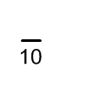
_____ States that pressure and volume are related
when the amount of gas and temperature are
fixed.

_____ As temperature increases, volume _____.

_____ As the amount of gas decreases, volume _____.

_____ Law that involves constant temperature and
pressure.

_____ As the amount of gas increases, pressure _____.

_____ Explains if the volume of a gas is doubled, the
temperature is doubled if the amount of gas and
pressure are constant.

_____ As the pressure decreases, temperature _____.
- Increases
- Decreases
- Boyle’s Law
- Charles’s Law
- Avagadro’s Law
- Ideal Gas Law
- Dalton’s Law

Part B. Problems. Answer the following questions. Each question is worth a differing amount of marks. Show all necessary equations, units, and use significant figures.
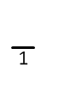
- The volume of 3.00 g of CO_{(g)} and 10.0 g of F₂ in identical 1.0 L containers are identical at the same temperature. Use the characteristics of gases to answer the following questions:
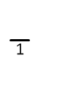
- What is the volume of each gas?

- Explain your answer for part a.

- Which gas has the greater pressure? Why?

- Explain the distribution of the particles for the two gases. Why is the distribution like this?

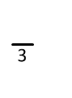
- The pressure a gas exert at a given temperature is 233 kPa. If the pressure of the gas decreases to 125 kPa and the volume is measured at 455 mL, what is the original volume? Pressure and amount of gas is constant.

- 5.00 moles of O₂ are contained in a 3.45 L container. What is the pressure exerted by the gas if the temperature is 60.0°C?
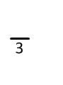

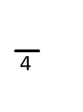
- 20.0 g of chlorine gas exerts a pressure of 101.0 kPa at -28.0°C. What is the volume of the gas?

- On a hot summer day, 35.0°C, Batman’s tires on his batmobile contain 5.00 L of air. 6 months later, he measures the volume in his tires to be 3.78 L. What is the temperature, in degrees Celsius on this winter day?

- What is the mass of 608 mL of HCl_{(g)} if it exerts a pressure of 635 000 Pa at 32.6°C?

- 2.50 moles of hydrogen gas and 4.50 moles of sulfur dioxide gas exist in the same 5.00 L container at 35.0°C. What is each partial pressure and the total pressure?

- Pure oxygen gas is collected over water. If the temperature is 90.0°C, and the total pressure exerted is 100.0 kPa, what is the pressure of the oxygen gas?
