Being Creative with Evidence
- Compare and contrast the drastic differences in society between the ‘Roaring Twenties’ and the ‘Dirty Thirties’.
- Learn the skill of using primary sources to construct a historical narrative.
- Help students learn that taking a historical perspective means attempting to see through the eyes of people who levied in time and circumstances sometimes far removed from our present-day lives. It means considering the different “things” that made up their everyday living – …” (p. 138, Sexias and Morton)
- Practice creative thinking and enhance kinesthetic learning both in the presentation of what they have learned and in the development of the artifacts.

LESSON PLAN
Historical Thinking Concept:
- Evidence: Guidepost 1: History is interpretation based on inferences made from primary sources. Primarily sources can be accounts, but they can also be traces, relics, or records.
economic Guidepost 2: A source should be analyzed in relation to the context of its historical setting: the conditions and worldviews prevalent at the time in question.
- Historical Perspectives: Guidepost 3: The perspectives of historical actors are best understood by considering their historical context.
Curriculum Objectives/Outcomes:
- Know that the early decades of the 20th century witnessed a confluence of forces that produced events and conditions, such as a world war, which seriously challenged the traditional institutions and political status quo in many nations.
- Learn and practice the basic research skills of: (all of the following)
- Learn and practice the following analytical skills: describing how the parts of the whole are related to each other.
- Know that and political instability can engender a climate conducive to the rise of radical/extreme political movements.
- Know that traditional political institutions and political processes are questioned/challenged during periods of social, economic and political instability.
- Know that within each society, an interplay exists between individual needs and rights and collective needs and rights.

Materials:
The students have to develop or collect their own artifacts.

Prior Knowledge:
A series of lessons about significant events, developments and people of the 1920s and 30s (worldwide) with several videos if possible will help them to have background knowledge but they could just be turned loose to learn as this may be an introductory assignment rather than a summative assessment.

Instructions:
The students will put together a trunk full of artifacts or ‘keepsakes’ from the perspective anyone who would have lived through the 1920s and 30s. The truck has to demonstrate the change the occurred over that 20 year span. The artifacts must be tangible (not only a picture of an artifact but a picture could be an artifact); could be original or replica (made by them).

Opportunity for Creativity Provided:
- By constructing or determining the artifacts that will be used
- By developing a historical narrative from a specific perspective of a historical actor
- In possibilities of the presentation of the final product

Student Handout/Package:

History 20: A Journey in Time
Task: You will showcase a trunk of artifacts representing the journey of people from the 1920’s to the 1930’s.
Phases | Criteria | Assessment:
Phase 1: Generating Ideas  “Anything Goes” | Think about:  - Different perspectives  - Different people  - Different groups  - Significant events of the time  - Setting or location  - What could artifacts (traces of the past) be? | Formative:  Complete Part 1 of Project Guide
Phase 2: Gather Knowledge  “Just Learn!” | Ask Questions:  - What made the news?  - Who were leaders and what was their impact?  - What was the pop culture then?  - What were famous inventions?  - Who were the famous people?  - What was everyday life like?  - How was art represented during this time period?  - What were the new laws or laws with significant impact?  Evidence Collected from: (other than online)  - Interviews with family members  - Photographs  - The Prairie Tapestry  - Antiques collections/ collectors  - Videos (documentaries, YouTube, Canadian Archives)  - Books from libraries ( School and Palliser)  Record Sources:  - Display clearly during presentation  - Use of a wide variety (consider the list above)  - Accurately document (use either APA, MLA or Chicago Style) | Formative:  Complete Part 2 of Project Guide
Phase 3: Artifact Representation  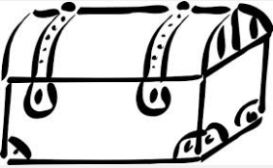  “What’s in your trunk?” | Choose a perspective (theme) that your artifacts will represent:  - Minimum of 10 artifacts that are representation of both eras  - Artifacts have to be tangible and could be authentic or recreated  (handmade)  - Artifacts are to be “from” a specific person or group of people (theme such as a specific worldview or social class or lifestyle/job or nationality or location of the focus character(s))  - Artifacts must represent the change over time (from 1920’s to 1930’s) | Formative:  Complete Part 3 of Project Guide
Phase 4: Explanation of Artifacts  “Why have these items been placed in your trunk?” | Think about the historical significance:  - What is the story behind the artifact? (tell us about the artifact)  - What historical understanding/significance of the decades do the artifacts represent? (give us historical context*)  - Why did you choose this artifact?  - What can we learn from this artifact? (inferences** made from this primary source)  - How is this artifact demonstrating a part of person’s or group’s journey (history)? | Formative:  Complete Part 4 of Project Guide  Check in with your teacher before moving onto Phase 5.
Phase 5: Putting the Pieces Together  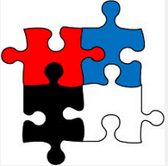  “It’s ok to be creative…think beyond the trunk!” | Things to consider:  - Start with a trunk  - Materials needed to create artifact  - Where to get authentic artifacts  - Who is your audience? Who are you inviting?  - Visual appeal  - Presentation style | Formative:  Do I have what I need?  Am I making good use of my time?  Have I set goals?  What problems might be an obstacle to completion? How can I get around them?
Phase 6: Showcase  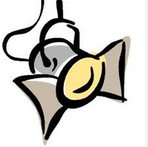  “It’s Showtime!” | Presentation must include:  - Prepared and practiced presentation/performance  - Explanation of artifacts; clearly from a specific perspective (theme)  - Demonstration of knowledge and understanding of the 1920’s and 1930’s (historical context)  - A blend of knowledge and personal touches (critical or creative thinking skills) | See Summative Assessment Rubric  Attached

*context: the circumstances/situations at the time of the creation of a source (artifact); the society and belief system in which the source (artifact) was created as well as the historical events taking place at the time. A broader understanding of the history.
** inference: conclusion based on “reading between the lines” of a source (artifact).

Source: Sexias, Dr. Peter and Tom Morton. The Big Six; Historical Thinking Concepts. Toronto: Nelson Education. 2013.

Co-created by Karielle Willner and Arlene Low (2014)

History 20: A Journey through Time

Project Guide
Name:__________________________________
PART 1: Generating Ideas:

PART 2: Gathering Knowledge:
Questions to Think About: | Ideas for Evidence/ Artifacts:
PART 3: Artifact Representation:
Artifacts: Minimum of 10 | Create or Find | Era

PART 4: Explanation of Artifacts:
1920’s Artifacts & Explanation | 1930’s Artifacts & Explanation

Created by Arlene Low (2014)

Assessment Checklist/Rubric:
1920’s-30’s Artifact Presentation Rubric
** Partial marks can be earned for each category Total: /24

Criteria  Potential Points | Presentation/  Performance | Choice and Explanation  of Artifacts – Revealing a Historical Narrative  (x2) | Demonstrating Analysis of  Learning through Artifacts (understanding 1920’s and 30’s historical context) (x2) | Demonstrating Critical or Creative Thinking Skills
4  Sources:  - used a large number of credible sources  -- accessed a wide variety of print, digital, visual and human sources  --- all sources (information and artifacts) are accurately documented  Note: assuming there are at least 10 artifacts; if not automatically drop to 3-3.9 | - Maintained eye contact/spoke looking towards the audience almost all of the time: referred to notes or screen occasionally; spoke from memory  -- Attention-grabbing when speaking: was interactive with the audience, spoke clearly/loud enough for everyone to hear, paced slowly enough to be easily understood, expressive/interesting pitch and tone  --- Obviously prepared/Organized: proper enunciation, language was fluid, presentation had good flow/was planned in advance | - Minimum of 10 artifacts which are tangible (either authentic or recreated) which represent both decades  -- Artifacts are “from” a specific person or group of people where one of the following themes is clearly evident in the artifacts (worldview or social class or lifestyle/job or nationality or location of the focus character(s))  --- Artifacts clearly demonstrate the change between the 2 decades; tell a historical narrative  Note: a picture is only an artifact if it is a realistic picture that would be found in a trunk; a picture of an artifact does not count as an artifact | Has at least 3 talking points for each artifact; which could include but are not limited to:  - describe why this primary source (artifact) was chosen; how it relates to the historical narrative/story behind the artifact  -- identify/explain what historical knowledge/event the artifact is a representation of (give us historical context*)  --- infer** how this artifact might be associated with/link to other facts/events/understandings in the history of this period.  ---- give some detailed information/facts about the artifact  As result of the above:  Revealed a clear demonstration of extensive/sophisticated understanding of the history of the period | - has a unique (not previously thought of) way to engage the audience during the whole length of the presentation  -- took a risk(s) and tried something different from the ordinary/  conventional  (“outside the box”)
3  Sources:  - used a small selection of credible sources  -- accessed print &/or digital, visual &/or human sources  --- all sources (information and artifacts) are listed with some additional bibliographical info. | - has a total of 3 errors in the level 4 criteria | - 1 or 2 less than 10 artifacts included but one decade is mainly focused; does not explicitly demonstrate the change over the 20 years; but shows a solid understanding of that decade  -- some of the artifacts don’t seem to fit the theme | - Has only 2 talking points for each artifact (assuming there are at least 10)  As result of the above:  There are some gaps or missing information in understanding of this period of history. | - has a thoughtful/diligent  /detailed way to engage the audience during the presentation  -- tried something new to you that you’ve seen done but by others but never tried yourself (there by still taking a risk)  Note: please identify this plan ahead of time with me
2  Sources:  - used a very limited selection of credible sources  -- accessed only print or digital or visual, or human sources  --- all sources (information and artifacts) are listed by name or URL only | - has a total of 4+ errors in all of the level 4 criteria | - the theme (perspective) is clear and a change in the times is evident but there are only 5 artifacts (give or take 1) therefore a limited demonstration of learning during the inquiry (Phase 2-4) | - could talk about 1/3 points from level 4 for each artifact (assuming there are at least 10)  As result of the above:  There is partial/limited understanding of the period in history. | - has not really engaged the audience because the presentation is unoriginal/typical/  uninspired/bland  -- used a presentation-style or technique which is familiar/safe
1  Sources:  - used only 2 sources  -- sources (information and artifacts) listed with incorrect info. (i.e. | - has only 1 criteria done well or satisfactorily; everything else needs work  listing “Google as a source) | - there are no artifacts gathered, but can briefly speak about what they learned during the inquiry (Phase 2-4) | - included random facts the regarding the decades | - has a partially complete presentation to engage the audience  -- did not even consider the presentation-style and made it up on the spot

Differentiation/Extension Plan:
- Reducing the number of artifacts to only a few from each period of time will help in differentiation.
- Students do this assignment in groups of 2-3 and the group work could be a differentiation.
- Extension would be to encourage students to pick a perspective that is not from North America, perhaps from a person who lived in what would become a totalitarian state.

Exemplar:
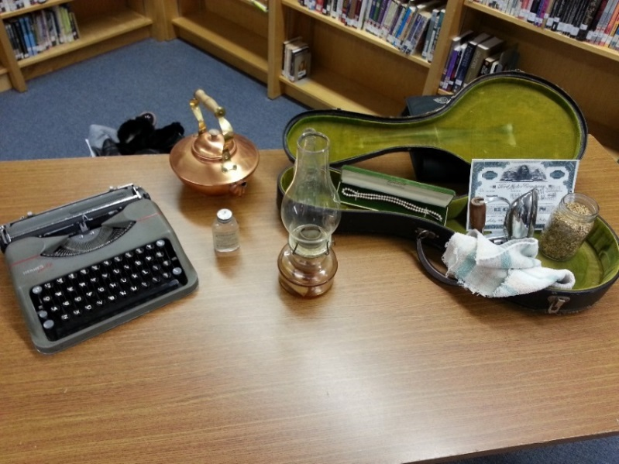
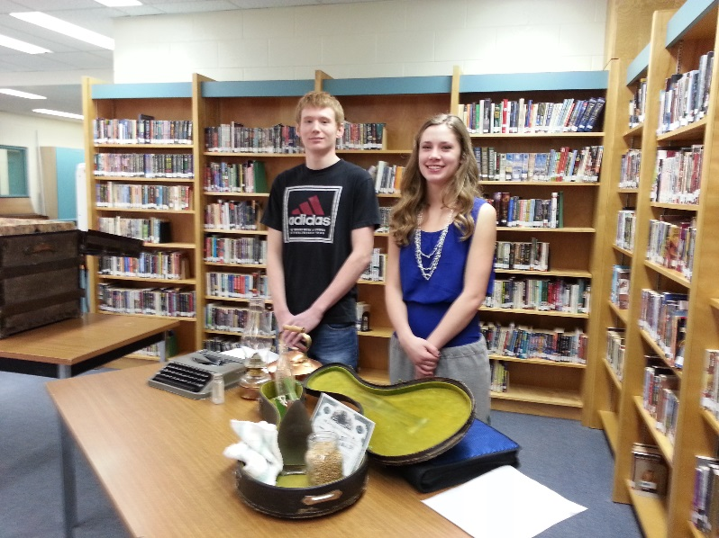

The following is an example of student notes for the presentation pictured above (from one of the partners); the highlighted ones particularly lend well to the “Demonstrating Analysis of Learning through Artifacts (understanding 1920’s and 30’s historical context)” part of the rubric:
Coca- Cola Bottle: 1920
This artifact was chosen because it was one of the luxuries that I could afford when I was living in New York during the 1920’s. After the Great War people wanted to buy these treats that were available because we had spent our teenage years with access only to the food that was rationed. Coca cola boomed during the 20s because of the prohibition on alcohol, it was the next best thing. Coke advertised itself in a very carefree fun way; this appealed to me because I didn’t have any worries. The economy was prosperous and the stocks were great I was having the time of my life. It is a small treasure that I lost the privilege to during the 30’s.
Jar of Wheat: 1931
This symbolizes the great crop we had in 1931. This was around the time that my family moved to Oklahoma for good because we had lost everything in the city after the stock crash in 1929. We were still very prosperous even though the price of wheat was declining. The government wanted us to grow smaller crops so that the price of wheat could go back up but we decided to plant more in order to make up for the price going down. We had the best crop yet and were very excited for the fortune it would bring. Unfortunately there was no one to buy our goods and we had to leave our beautiful wheat in the streets. It was heartbreaking to see our money go to waste.
Ford Motor Company Common stock Bond: 1929
This was one of the many stock bonds I got during the 1920’s. This particular one is for the Ford Motor Company and is worth Forty Two dollars, this was a rather small bond and could be increased tenfold in a couple days. I paid for this bond on October 20th 1920, 9 days before black Tuesday when the stock market crashed. It was cancelled and not issued because the banks didn’t have any money to give me and I never saw a penny of that forty two dollars again. I kept this certificate as a reminder that stocks are not a reliable business to be in and I swore if they were ever prosperous again I would have nothing to do with them.
Type writer: 1924- 1939
I bought my typewriter in 1924 because for the first time in my life I had more money then I knew what to do with. I would buy anything my family wanted and when my friends bought something new I would too. It was wonderful not having to be concerned about money after that’s all our life was about during the war. This typewriter became useful in the late 1930s when there was no employment and everyone desperately needed money. After my farm went under I got a job for a local newspaper making obituaries because I had my own typewriter so they wouldn’t have to spend additional money. I got paid very little but the amount of obituaries being made were so high.

