

READING STRATEGIES HANDBOOK

READING STRATEGIES HANDBOOK
READING IN THE CONTENT AREAS

Acknowledgements

Shirley Barclay
Cheryl Bashutski
Terry Gasior
Michael Hoult
Karen Jeffries
Ryan Johnson
Dave Luukkonen

With special acknowledgment of
Kim Hobbs
For facilitating the handbook development

With contributions from Secondary Level Reading Team:

Eugene Buchko
Kelly Christopherson
Natalie Chupik
Kim Johnson
Melissa Mah
Blair Nesbitt
Brenda Park
Carol Rychlo
Elwood Torgunrud
Reading Strategies Handbook

Reading in the Content Areas

“Reading is a constructive meaning-based act which, depending upon purpose, background knowledge, and reading task, requires readers to use a variety of skills and strategies before, during, and after reading. It is a process that develops over a long period of time and through extensive practice.”

Teaching reading is a shared responsibility for teachers in all areas of the curriculum. The purpose of this handbook is to provide teachers with a quick reference guide to reading strategies in the content areas. These reading strategies are research based and address the Before, During and After Strategies for content reading.

The strategies in this document are only a starting point to which you are invited to add
additional strategies that you have found to be successful with your students. Any activities
or strategies that you find useful but are missing from this document may be submitted for consideration to the Reading Strategies Handbook Team.
Table of Contents

Page #
Characteristics of Proficient Readers |  |  |  | 5
Keys to Success |  |  |  | 6
Determining the Readability Level of a Text |  |  |  | 7
Fry Graphs |  |  |  | 8
Teacher Toolkit 9 | Before | During | After | 9
A Textbook Tour.10 | √ |  |  | 10
KWLS 13 | √ | √ | √ | 13
Reading Rates 16 | √ |  | √ | 16
Word Study: Brainstorming | √ |  |  | 18
Word Study; CATEGORIZING 19 | √ |  |  | 19
Word Study: Retelling 20 |  |  | √ | 20
Signal Words 25 | √ | √ | √ | 25
Think Alouds 26 | √ | √ | √ | 26
Sentence Chunking 27 | √ | √ |  | 27
Anticipation Guide 28 | √ | √ |  | 28
Walk About 30 | √ | √ | √ | 30
Coding for Comprehension 31 |  | √ | √ | 31
Directed Reading Thinking Activity (DRTA) 32 | √ | √ | √ | 32
Read Aloud 33 |  | √ | √ | 33
W5 Chart 34 | √ | √ | √ | 34
Venn Diagrams 37 | √ | √ | √ | 37
Frayer Model 41 | √ | √ | √ | 41
T-Notes 44 |  | √ | √ | 44
Exit Slips 47 |  |  | √ | 47
Making Judgment 49 | √ | √ | √ | 49
Critical Literacy 52 | √ | √ | √ | 52
K-12 Reading Continuum |  |  |  | 53
Before, During and After Reading Posters |  |  |  | 54
Ten Critical Skills & Strategies for Reading Proficiency Checklist |  |  |  | 57
Notes |  |  |  | 58
Resources |  |  |  | 59

CHARACTERISTICS OF PROFICIENT READERS

The Saskatchewan English Language Arts Curriculum Guide for the Middle Level outlines the following characteristics of proficient readers:

Before Reading

- Understand that reading is a sense-making process
- Use prior topical and linguistic knowledge as they read
- Build background knowledge on the subject before beginning to read
- Know the purpose for reading

During Reading

- Give complete attention to the reading task
- Keep a constant check on own understanding
- Adjust reading rate to match purpose and reading material
- Monitor reading comprehension and do it so often it becomes automatic
- Can match own reading strategies to a variety of reading materials
- Stop only to use a fix-up strategy when text is not understood

After Reading

- Decide if they have achieved own goal for reading
- Respond personally and critically to what is read
- Evaluate own comprehension of what was read
- Summarize the major ideas
- Seek additional information from outside source
Keys to Success

To help develop proficient readers in your content area you should:

- Evaluate Student Reading Ability

  - Past student performance is an indicator.
  - Gather information informally.
  - Access information provided by formal tools that have been used to assess students.

- Match Students and Texts

  - Use a suitable readability chart or tool to determine the reading level of the text or document you are using.
  - Match student reading level to texts and make adaptations, as necessary, to help make the text more meaningful to them or provide them with the skills and strategies necessary to engage in all levels of text.

- Develop the Ten Critical Skills & Strategies for Reading Proficiency

- Set Purpose for Reading
- Tap & Use Prior Knowledge
- Make Connections
- Predict, Confirm & Adjust Predictions
- Use Text and Vocabulary (Language Cues) to Construct & Confirm Meanings
- Create Visual Images
- Recognize Key Ideas & Supporting Details
- Monitor Understanding & Use a Variety of “Fix-Up” (Self Correcting) Strategies
- Make & Confirm Inferences & Conclusions
- Recall, Reflect, Evaluate & Apply
Determining THE READABILITY LEVEL OF A TEXT

Directions for using the Fry Readability Graph to determine the reading level of a text:

- Count 100 words of text in three different places (a word is any combination of letters and numbers with a space at either end, therefore “1812” is a word)
- Count the total number of syllables in the 100 word passage (usually there is a syllable with each vowel or vowel combination, for numerals and initials like “1812” or “N.B.A.” count one syllable for each symbol. 1812 counts as four syllables)
- An easy way to count syllables is to put a mark above every syllable over one in each word, then, when you get to the end of the passage, count the number of marks and add 100.
- OR use a calculator set to 1+1= works well to tally the number of syllables. Hit the = button for each additional syllable.
- Count the number of sentences to the nearest half.
- Enter graph with average number of sentences and number of syllables; plot a dot where the two lines intersect. The area where the dot is plotted will give you the approximate grade level.

Directions for using Microsoft Word to determine the reading level of a text:

- Open Microsoft Word
- Type a selection of text (minimum of 100 words)
- On the Tools menu, click Options, and then click the Spelling &Grammar tab.
- Select the Check grammar with spelling check box.
- Select the Show readability statistics check box, and then click OK
- On the Standard toolbar, click Spelling and Grammar icon
- The last screen will display “statistics” including readability (Flesch Kincaid)

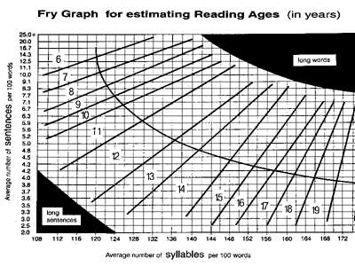

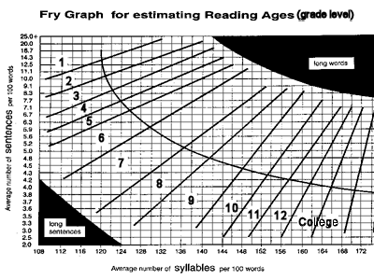

Teacher Toolkit
A Textbook Tour

 |  | √ |  | BEFORE |  | during |  | after
a textbook Tour helps students to identify text features and use them efficiently to gain greater understanding as they read.

√ | 1. |  | Set Purpose for Reading
√ | 2. |  | Tap & Use Prior Knowledge
√ | 3. |  | Make Connections
 | 4. |  | Predict, Confirm & Adjust Predictions
 | 5. |  | Use Text & Vocabulary ( Language Cues) to Construct & Confirm Meaning
 | 6. |  | Create Visual Images
 | 7. |  | Recognize Key Ideas & Supporting Details
 | 8. |  | Monitor Understanding & use a Variety of “Fix Up” Strategies
 | 9. |  | Make & Confirm Inferences & Conclusions
 | 10. |  | Recall, Reflect, Evaluate & Apply
how to use:
- Encourage students to analyze the features of a text before they read the content.

- Use the following worksheets to help students identify and analyze the features of the textbook they have been presented with.

- Students complete the Scavenger Hunt Checklist as they preview the text

- Students analyze the features of their textbook as they complete the “Thinking about the Features of My Text” activity sheet.

Textbook Scavenger Hunt
Textbook Title _________________________________
Author or Publisher: _________________________________

Place a check mark beside each text feature that you find in your textbook.

 | CONTENT ORGANIZATION |  | VISUALS
 | Table of Contents |  | Illustrations
 | Index |  | Photographs
 | Glossary |  | Diagrams
 | Appendix |  | Charts
 | Units |  | Graphs
 | Chapters |  | Maps
 | Questions |  | Timelines
 | Answer Key |  | Flowcharts
 | Review Sections |  | Cartoons
 | Suggested Activites |  | Captions
 | FORMAT |  | REFERENCES
 | Headings |  | Preface
 | Sub Headings |  | Acknowledgement
 | Font Changes (Italicized, Bold, Colour) |  | Footnotes or Endnotes
 | Coloured Sections |  | Bibliography
 | Paragraphs separated by spacing |  | Reference List
 | Paragraphs identified by indentations |  | Credit List
 | Bulleted or Numbered Lists |  | Web Resources
 | Sidebars
 |  |  | OTHER
Thinking about the Features of My Text

Textbook Title: __________________________________
Author or Publisher: __________________________________

List the Text Features that you located during the “Textbook Scavenger Hunt” in the left-hand column of the table. Give a brief Description of the feature in the right-hand column of the table.
Text Feature | Description

KWLS

 |  | √ |  | BEFORE | √ | during | √ | after
Before Reading:  K-What we already know  W-What we want to find out |  |  |  |  |  | After Reading:  L-What we learned  S-What we still want to find out
√ | 1. |  | Set Purpose for Reading
√ | 2. |  | Tap & Use Prior Knowledge
√ | 3. |  | Make Connections
√ | 4. |  | Predict, Confirm & Adjust Predictions
 | 5. |  | Use Text & Vocabulary ( Language Cues) to Construct & Confirm Meaning
 | 6. |  | Create Visual Images
 | 7. |  | Recognize Key Ideas & Supporting Details
√ | 8. |  | Monitor Understanding & use a Variety of “Fix Up” Strategies
 | 9. |  | Make & Confirm Inferences & Conclusions
√ | 10. |  | Recall, Reflect, Evaluate & Apply
how to use:

- Introduce the KWLS and model how to use it with a new topic or assignment
- Individually, in pairs, or in small groups, students brainstorm what they already know about the topic. Record this information in the “K” section of the chart. Record information so the whole class may respond to it.
- Have students generate lists of what else they want to learn or what questions they would like answered. Record ideas in the “W” section of the chart.
- Students read with a purpose of discovering information to answer these questions and note the strategies they want to try under the questions in the “W” category.
- Students read with a purpose of discovering information to answer their questions or to verify knowledge.
- Record and display information gained after reading in the “L” section of the chart.
- Student should then review what they have learned, and compare their current understandings to their initial knowledge. They are not encouraged to keep looking for answers to questions they have yet to answer. Record these questions in the “s” section of the chart.
Option: Use the KNWS chart to aid students with solving problems.

Name: ____________________ Date: ____________________

K | W | L | S
Topic:

Things I Read That | What I want to know | New Things I Learned | Questions I Still Have
I Already Know

Name: ____________________ Date: ____________________

K | N | W | S
Problem:
What facts do I KNOW from the information in the problem? | Which information, if any, do I NOT need? | WHAT does the problem ask me to find? | What STRATEGY, operations, or tools will I use to solve the problem?

Reading Rates

 |  | √ |  | BEFORE |  | during | √ | after
Skim- read quickly to get the main idea or a general sense of the text
Scan- moving quickly down a page to look for a specific detail.
Rapid-reading quickly for general understanding
Slow & Careful- reading to get an in-depth understanding of the text..
√ | 1. |  | Set Purpose for Reading
√ | 2. |  | Tap & Use Prior Knowledge
√ | 3. |  | Make Connections
√ | 4. |  | Predict, Confirm & Adjust Predictions
 | 5. |  | Use Text & Vocabulary ( Language Cues) to Construct & Confirm Meaning
 | 6. |  | Create Visual Images
 | 7. |  | Recognize Key Ideas & Supporting Details
√ | 8. |  | Monitor Understanding & use a Variety of “Fix Up” Strategies
 | 9. |  | Make & Confirm Inferences & Conclusions
√ | 10. |  | Recall, Reflect, Evaluate & Apply
how to use:
Teachers can help students recognize the need for adapting their reading rates according to the purpose by:

- Sharing the information in the chart that follows with students as needed so that they become aware of the various rates and can practice matching reading abilities and purposes with reading rates.

- Posting an enlarged version of the chart for student reference.

- Modeling the various rates for students by demonstrating with the types of materials and purposes that require different rates.

- Encouraging students to add this knowledge to their repertoire of metacognitive abilities.

Reading Rate | Use this rate:
Skimming  Readers conduct a quick overview to get the overall gist of the text. | - To get an overview of the material  - To determine if more careful reading is necessary
Scanning  Readers glance over text in search of a specific detail. | - To search for a single piece of specific information (e.g., date, name, term)
Rapid  Readers read quickly for general understanding. | - To read for entertainment or enjoyment (e.g., light, fast-moving fiction)
Slow and Careful  Readers wish to get an in-depth understanding of a passage or text. | - To understand texts that contain difficult concepts and vocabulary (e.g., technical material)  - To retain detail (e.g., studying, summarizing)  - To judge or evaluate ideas and issues

Word study: brainstorming

 |  | √ |  | BEFORE |  | during |  | after
Brainstorming allows pupils to hear and learn a range of ideas from several sources. Brainstorming encourages pupils to activate prior word and language skills.
 | 1. |  | Set Purpose for Reading
√ | 2. |  | Tap & Use Prior Knowledge
√ | 3. |  | Make Connections
 | 4. |  | Predict, Confirm & Adjust Predictions
√ | 5. |  | Use Text & Vocabulary ( Language Cues) to Construct & Confirm Meaning
 | 6. |  | Create Visual Images
 | 7. |  | Recognize Key Ideas & Supporting Details
 | 8. |  | Monitor Understanding & use a Variety of “Fix Up” Strategies
 | 9. |  | Make & Confirm Inferences & Conclusions
 | 10. |  | Recall, Reflect, Evaluate & Apply
how to use:
- Begin simply: teacher writes a commonly used word on the board.

- Have pupils call out synonyms or antonyms to write on the board.

- Option: Students may work in pairs or teams to see how many words they can list on the given topic within a period of time.

- Teacher selects a word from the list that my be problematic for pupils.

- If the word is not understood by pupils the teacher can offer the initial synonym.

Example:
Common Word  Small-  - tiny  - wee |  |  |  |  |  | Text Word  Economics  -wants  -capital
- After new words are identified have pupils practice usage so as to become part of daily lexicon.

Word Study: Categories

 |  | √ |  | BEFORE |  | during |  | after
Words often fall within categories of meaning which can be sub-categorized to provide nuance and enhance the quality of understanding.

√ | 1. |  | Set Purpose for Reading
√ | 2. |  | Tap & Use Prior Knowledge
√ | 3. |  | Make Connections
 | 4. |  | Predict, Confirm & Adjust Predictions
√ | 5. |  | Use Text & Vocabulary ( Language Cues) to Construct & Confirm Meaning
√ | 6. |  | Create Visual Images
 | 7. |  | Recognize Key Ideas & Supporting Details
 | 8. |  | Monitor Understanding & use a Variety of “Fix Up” Strategies
 | 9. |  | Make & Confirm Inferences & Conclusions
 | 10. |  | Recall, Reflect, Evaluate & Apply
how to use:
- Categorizing may be used in conjunction with brainstorming.

- The teacher identifies the key concept words. Students sort words from the brainstormed list to fall within these categories.

- Discussion follows.

- In an Open Word Sort, students decide on the categories and then explain the reasons for their decisions

Demonstrate word usage for your students!
Teachers should use a range of words that offer nuances in meaning. They have to encourage pupils to use newly learned words in their written and oral work.

Encourage pupils to learn that the finest writers and speakers use a variety of words, many of which accentuate slight variety in context which could be significant to the intention or speaker.

word study: retelling

 |  |  |  | BEFORE |  | during | √ | after
Use Retelling to practice the acquisition of new vocabulary.
Encourage students to use newly acquired words in a context similar but identical to the text from which the word was taken.

 | 1. |  | Set Purpose for Reading
√ | 2. |  | Tap & Use Prior Knowledge
√ | 3. |  | Make Connections
 | 4. |  | Predict, Confirm & Adjust Predictions
√ | 5. |  | Use Text & Vocabulary ( Language Cues) to Construct & Confirm Meaning
√ | 6. |  | Create Visual Images
 | 7. |  | Recognize Key Ideas & Supporting Details
 | 8. |  | Monitor Understanding & use a Variety of “Fix Up” Strategies
 | 9. |  | Make & Confirm Inferences & Conclusions
√ | 10. |  | Recall, Reflect, Evaluate & Apply
how to use
- Retelling provides an opportunity for readers to process what they have read by organizing and explaining it to others.

- Identify new vocabulary and practice understanding the meaning of new words ( use Brainstorming and Categorizing)

  - Have students construct short paragraphs using the newly acquired words from the original text and words that are synonymous ( what teachers often refer to as “say in your own words”)
or
  - Have students prepare an oral presentation retelling the original text with synonyms in place of original words.

- Use the enclosed rubrics as a benchmark to measure student progress.

- Look for increased fluency in student presentations.

Used with permission from Regina Public School Division
mathematics retelling rubric

 |  | 0 | 1 | 2 | 3 | 4 | 5
 |  | Attempt | Needs  Improvement | Average | Good | Excellent | Exemplary
1. | Predict when to use this procedure?
2. | Define the concept or procedure?
3. | Identify the main steps in this concept?
4. | Make sense to the learner?
5. | Keep the sequence of the procedure?
6. | Describe how this could be applied to real world situations?
7. | Answer the question presented by the problem?
Does the retelling:

Total Points: __________

Student Name: ______________________________

Retelling of: ______________________________

Date: ______________________________

Comments: ______________________________________________________

Literary retelling rubric

 |  | 0 | 1 | 2 | 3 | 4 | 5
 |  | Attempt | Needs  Improvement | Average | Good | Excellent | Exemplary
1. | Have a good beginning explaining when and where the story took place?
2. | Name the characters?
3. | Express the main points of the story?
4. | Add some supporting details?
5. | Make sense to the reader?
6. | Keep the sequence of the story?
7. | Identify the main problem in the story?
8. | Explain how the problem was solved in the story?

Does the retelling:

Total Points: __________

Student Name: _____________________________

Retelling of: _____________________________

Date: _____________________________

Comments: ______________________________________________________

historical retelling rubric

Does the retelling:

 |  | 0 | 1 | 2 | 3 | 4 | 5
 |  | Attempt | Needs  Improvement | Average | Good | Excellent | Exemplary
1. | Have a good introduction, explaining when and where the situation takes place?
2. | Name the person(s) involved?
3. | Explain the main points of the situation?
4. | Add some supporting details?
5. | Make sense to the reader?
6. | Keep the sequence of the situation?
7. | Identify what the main problem was in the situation?
8. | Describe the resolution of the situation?

Total Points: __________

Student Name: ______________________________

Retelling of: ______________________________

Date: ______________________________

Comments: __________________________________________________

_____________________________________________________________________________________________

 |  | 0 | 1 | 2 | 3 | 4 | 5
 |  | Attempt | Needs  Improvement | Average | Good | Excellent | Exemplary
1. | State the problem presented?
2. | Predict what outcome is expected?
3. | Identify the main points of the concept or procedure?
4. | Identify some variables of the concept or procedure?
5. | Follow the process or steps?
6. | Keep the sequence of the procedure?
7. | Relate the problem and outcomes to real-world situations?
8. | Explain whether the prediction is as expected?
Science retelling rubric

Does the retelling:

Total Points: __________

Student Name: ______________________________

Retelling of: ______________________________

Date: ______________________________

Comments: ______________________________________________________

Signal words

 |  |  | √ | BEFORE | √ | during | √ | after
Signal Words are words or phrases that cue the reader to link ideas and help them follow the flow of information.

√ | 1. | Set Purpose for Reading
 | 2. | Tap & Use Prior Knowledge
√ | 3. | Make Connections
√ | 4. | Predict, Confirm & Adjust Predictions
√ | 5. | Use Text & Vocabulary ( Language Cues) to Construct & Confirm Meaning
 | 6. | Create Visual Images
√ | 7. | Recognize Key Ideas & Supporting Details
 | 8. | Monitor Understanding & use a Variety of “Fix Up” Strategies
 | 9. | Make & Confirm Inferences & Conclusions
 | 10. | Recall, Reflect, Evaluate & Apply
how to use:
- Show a text passage that has signal words.

- Identify all signal words.

- Use the signal words as clues to find the meaning of the text.

- Reread the text and use the signal words to identify the main idea.

- Write a brief summary of the text using only the signal words to organize the summary.

- Encourage students to scan passages to identify signal words and to preview the passage before they read.

- Create a class vocabulary chart that highlights important signal words that can be posted for future reference.

Think aloud

 |  | √ |  | BEFORE | √ | during | √ | after
Think Alouds help students understand what they are reading by making them think about what they read as they are reading it.

√ | 1. |  | Set Purpose for Reading
 | 2. |  | Tap & Use Prior Knowledge
√ | 3. |  | Make Connections
√ | 4. |  | Predict, Confirm & Adjust Predictions
√ | 5. |  | Use Text & Vocabulary ( Language Cues) to Construct & Confirm Meaning
 | 6. |  | Create Visual Images
 | 7. |  | Recognize Key Ideas & Supporting Details
 | 8. |  | Monitor Understanding & use a Variety of “Fix Up” Strategies
√ | 9. |  | Make & Confirm Inferences & Conclusions
 | 10. |  | Recall, Reflect, Evaluate & Apply
how to use:
- There are a variety of situations in which to use “Think Alouds”
  - Teacher to Student
  - Student to Teacher
  - Student to Student

- To use this technique you need to demonstrate to the student how to:
predict, question, describe, make connections and clarify what is being said.

- While modeling, the teacher can show how he or she pauses while reading and does the above.

- Then the students can try to use these methods while reading aloud to the teacher and or a partner.
*It is important to keep in mind that think-aloud strategies are not a sequence of events but a set of tools that can be used by the reader to further understand the text.

sentence chunking
 |  |  |  | BEFORE | √ | during |  | after
Sentence Chunking helps Students understand complex ideas by breaking text down to smaller chunks that describe or represent core concepts.

 | 1. |  | Set Purpose for Reading
 | 2. |  | Tap & Use Prior Knowledge
√ | 3. |  | Make Connections
 | 4. |  | Predict, Confirm & Adjust Predictions
√ | 5. |  | Use Text & Vocabulary ( Language Cues) to Construct & Confirm Meaning
 | 6. |  | Create Visual Images
√ | 7. |  | Recognize Key Ideas & Supporting Details
 | 8. |  | Monitor Understanding & use a Variety of “Fix Up” Strategies
 | 9. |  | Make & Confirm Inferences & Conclusions
 | 10. |  | Recall, Reflect, Evaluate & Apply
how to use:
- Teacher must pre-read text.

- Chunk important ideas and model with the think aloud.

Example:
By definition tornados are rotating columns of air that extend from swelling cumulonimbus clouds to the ground. No one fully understands tornado dynamics but certain ingredients seem essential to the witches’ brew from which twisters emerge: warm, humid air near the ground, colder air aloft, and shearing winds that change direction and speed with height.
(National Geographic, Chasing Tornadoes, pg. 9, April 2004.)

- The underlined text is “chunked”.

anticipation guide

 |  | √ |  | BEFORE | √ | during | √ | after
An Anticipation Guide helps students to activate their prior knowledge before reading and acts as a guide to student reflection and self assessment during reading. It also helps the teacher gauge the beginning understanding level of the class.
√ | 1. |  | Set Purpose for Reading
√ | 2. |  | Tap & Use Prior Knowledge
√ | 3. |  | Make Connections
√ | 4. |  | Predict, Confirm & Adjust Predictions
√ | 5. |  | Use Text & Vocabulary ( Language Cues) to Construct & Confirm Meaning
√ | 6. |  | Create Visual Images
√ | 7. |  | Recognize Key Ideas & Supporting Details
√ | 8. |  | Monitor Understanding & use a Variety of “Fix Up” Strategies
 | 9. |  | Make & Confirm Inferences & Conclusions
√ | 10. |  | Recall, Reflect, Evaluate & Apply
how to use:
- The teacher must first identify the major concepts in the selected reading.

- The teacher creates a number of statements 3-8 depending on the class size) about the material. These statements should be designed so that students have enough knowledge to discuss them, but not enough to understand and discuss them without reading the text.

- The teacher gives the students the Anticipation Guide (an example of one is on the next page) before giving them the selection to be read. Students need the opportunity to discuss their responses to the questions and explain their reasoning in advance of their reading.

- Students read the selection.

- After reading, the students review their responses and discuss whether the reading has provoked a change in their thinking.

The teacher leads the students to understand that changing your opinion as you gather more and better information is normal- and is part of ‘good’ thinking processes.
Anticipation Guide

Student Name: ________________________________

Date: ________________________________

Title of Selection: ________________________________

Statements | True | False

Comments:
Walkabout

 |  | √ |  | BEFORE | √ |  | √ | after
The Walkabout helps to engage students in a learning task by activating their prior knowledge and evoking discussion on an issue before they read the selected text.

√ | 1. |  | Set Purpose for Reading
√ | 2. |  | Tap & Use Prior Knowledge
√ | 3. |  | Make Connections
√ | 4. |  | Predict, Confirm & Adjust Predictions
 | 5. |  | Use Text & Vocabulary ( Language Cues) to Construct & Confirm Meaning
 | 6. |  | Create Visual Images
 | 7. |  | Recognize Key Ideas & Supporting Details
 | 8. |  | Monitor Understanding & use a Variety of “Fix Up” Strategies
√ | 9. |  | Make & Confirm Inferences & Conclusions
√ | 10. |  | Recall, Reflect, Evaluate & Apply
how to use:
- The teacher reads the selection and notes between 3 and 6 questions which address the main concepts of the reading, and which can be phrased in a ‘true/false’ format.
- The teacher gathers a poster (paper quality not important) for each question, and writes one true false question at the top of each.
- Before class, the teacher affixes these to the walls of the classroom to make ‘learning stations’ an appropriate distance apart. The questions should be concealed somehow, in a manner of the teacher’s choosing.
- The teacher divides the class into a number of learning groups that equal the number of posters.
- The teacher briefs the students on how the activity will work;
  - Each group will begin at a different station. At each station they will have 3-5 minutes to discuss the question, decide whether they agree or disagree and mark their decision as true or false on the poster.
  - They should also briefly explain their decision and concisely note any differences of opinions within the group.
  - At the end of the allotted time, they move to the next poster and repeat the process. This continues until each group has examined each poster.
  - While remaining at the last poster they examined, each group discusses what has been written on the posters and shares what is on the poster with the entire group.
- The teacher leaves the posters on the wall for the duration of the learning activity- as the students read the passage, they may refer to the posters and compare what they are learning to both the questions posed on the posters, and the class’s responses to them.
- In post reading discussion, the students share how their ideas have changed. The activity may then be connected to a larger project or assignment within the unit.

Coding for comprehension

 |  |  |  | BEFORE | √ | during | √ | after
Coding for Comprehension allows students to self monitor comprehension, ask questions, word solve, make connections, make inferences and read critically.

√ | 1. |  | Set Purpose for Reading
√ | 2. |  | Tap & Use Prior Knowledge
√ | 3. |  | Make Connections
 | 4. |  | Predict, Confirm & Adjust Predictions
 | 5. |  | Use Text & Vocabulary ( Language Cues) to Construct & Confirm Meaning
 | 6. |  | Create Visual Images
 | 7. |  | Recognize Key Ideas & Supporting Details
√ | 8. |  | Monitor Understanding & use a Variety of “Fix Up” Strategies
 | 9. |  | Make & Confirm Inferences & Conclusions
√ | 10. |  | Recall, Reflect, Evaluate & Apply
how to use:
- Coding for Comprehension works with fiction or non-fiction, about 5-10 pages of text.

- Give each student four Sticky Notes, each marked with 1 of 4 symbols
(√ * ? !).

- Students read the given text and stick the notes in the places that they identify as:
√ I already knew this.
* This is new to me
? Is this really true
! Wow! This is really interesting!

- Follow up by having students justify their choices with a partner or small group.

Directed reading thinking activity
(DRTA)

 |  | √ |  | BEFORE | √ | during | √ | after
The Directed Reading Thinking Activity (DRTA) leads students through a process involving prediction, verification, judgment and extension of thought. Students can also self-access their level of understanding.
√ | 1. |  | Set Purpose for Reading
 | 2. |  | Tap & Use Prior Knowledge
√ | 3. |  | Make Connections
√ | 4. |  | Predict, Confirm & Adjust Predictions
√ | 5. |  | Use Text & Vocabulary ( Language Cues) to Construct & Confirm Meaning
 | 6. |  | Create Visual Images
 | 7. |  | Recognize Key Ideas & Supporting Details
√ | 8. |  | Monitor Understanding & use a Variety of “Fix Up” Strategies
√ | 9. |  | Make & Confirm Inferences & Conclusions
√ | 10. |  | Recall, Reflect, Evaluate & Apply
how to use:
- Skim or preview the text with the students by looking at pictures, titles, headings, beginning and concluding paragraphs and other cues.
- Have students make predictions about the content of the selection. They should support these predictions with reasons and evidence.
Sample Questions:
  - What do you think a reading with this title will be about?
  - What do you expect will happen?
  - Why do you expect this to happen?
  - Could it happen any other way?
  - Which predictions do you agree or disagree with? Why?
- Have the students read a part of the selection thoroughly keeping predictions and purpose in mind.
- Students need to confirm or reject predictions by finding proof or confirming statements. (it may be useful to mark them with post it notes). Then they make new predictions, modify predictions or reaffirm predictions.
- Continue the “read-predict” approach until the selection is completed. Have students read the chunked text, stop as directed. Interact with them in order to model the behavior of good reading.
- You might want to have students reflect on the process and the usefulness to them in understanding the text.
Read Aloud

 |  |  |  | BEFORE | √ | during | √ | after
Reading aloud is a helpful technique for improving reading skills and engaging readers. Hearing the text while looking at it on the page helps many readers process the information more effectively and helps them understand how it should be read.

√ | 1. |  | Set Purpose for Reading
 | 2. |  | Tap & Use Prior Knowledge
√ | 3. |  | Make Connections
√ | 4. |  | Predict, Confirm & Adjust Predictions
√ | 5. |  | Use Text & Vocabulary ( Language Cues) to Construct & Confirm Meaning
 | 6. |  | Create Visual Images
 | 7. |  | Recognize Key Ideas & Supporting Details
√ | 8. |  | Monitor Understanding & use a Variety of “Fix Up” Strategies
√ | 9. |  | Make & Confirm Inferences & Conclusions
 | 10. |  | Recall, Reflect, Evaluate & Apply
how to use:
Always allow students the opportunity to preview and read silently prior to reading aloud so they are able to focus on comprehension rather than decoding. Never force students to read aloud, invite them.

- Hearing the text will help students enjoy it or process it in a more effective way.
- Give students options for various read aloud configurations:
  - Students to small group
  - Students to class
  - Teacher to students
- Provide a safe, supportive environment to ensure successful read alouds.
- Use read aloud across the subject areas 9 e.g. reading story problems aloud in math class helps to emphasize their narrative structure.)
- Before, during and after read alouds have students:
  - Make predictions
  - Follow along on the page while the text is being read
  - Take notes using graphic organizers ( T Charts, Venn Diagrams etc)

W5 CHART

 |  | √ |  | BEFORE | √ | during | √ | after
A W5 Chart will add meaning to the text by having students identify the Who? What? When? Where? Why? And How? of an event.
√ | 1. |  | Set Purpose for Reading
√ | 2. |  | Tap & Use Prior Knowledge
√ | 3. |  | Make Connections
 | 4. |  | Predict, Confirm & Adjust Predictions
 | 5. |  | Use Text & Vocabulary ( Language Cues) to Construct & Confirm Meaning
 | 6. |  | Create Visual Images
√ | 7. |  | Recognize Key Ideas & Supporting Details
 | 8. |  | Monitor Understanding & use a Variety of “Fix Up” Strategies
√ | 9. |  | Make & Confirm Inferences & Conclusions
√ | 10. |  | Recall, Reflect, Evaluate & Apply
how to use:
- Review the 5W’s (Who, What, Where, When, Why) and H (How) with the students if they are not familiar with them.
- Who: List the main characters or “key players” identified
- What: Note the important things they did in regard to this event or issue
- When: Identify when they did what they did
- Where: Note where the issued or event happened, if applicable.
- Why; Try to identify why they did what they did
- How: List how it was accomplished

- Ask students to identify any answers they can before reading, to help them connect with their prior knowledge of the subject.

- Have students fill in a W5 Chart (samples attached) as they read the text.

- After reading, discuss with the students the content of their W5 Charts.

- Focus on the Why as much as possible. It is important to help students see relevance and the connections of individuals and events.

W5 Chart

Title: ________________________

Name: _____________________________ Date: _________________

Who? | What? | When? | Where? | Why? | How?
Name: _____________________________ Date: _________________
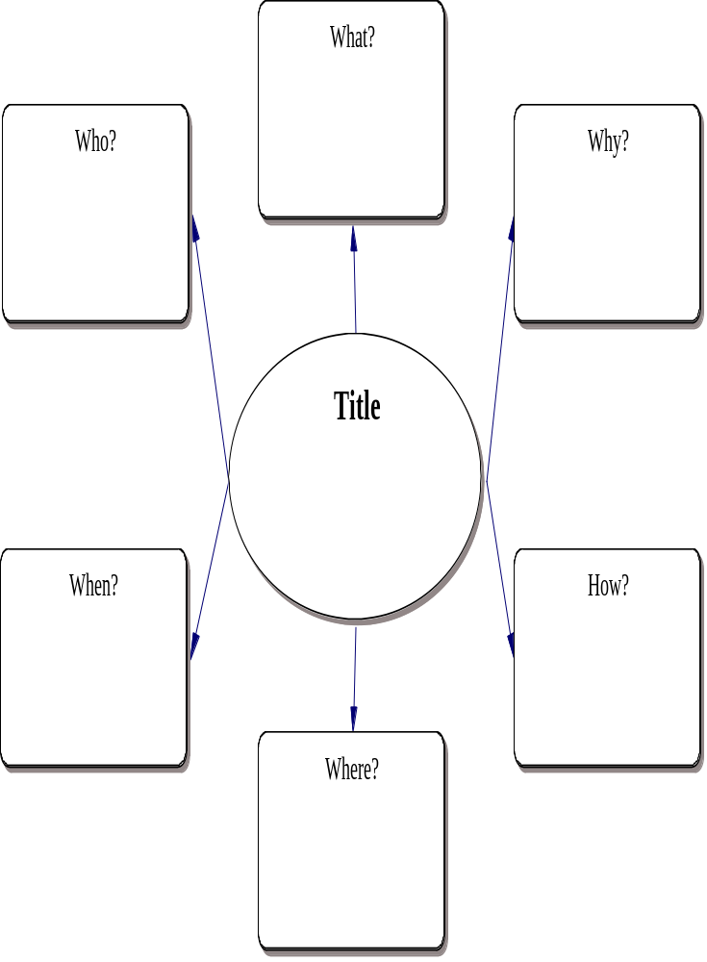
Venn Diagram

 |  | √ |  | BEFORE | √ | during | √ | after
A Venn Diagram allows you to compare two items that have similarities but are also unique in some way.

√ | 1. |  | Set Purpose for Reading
√ | 2. |  | Tap & Use Prior Knowledge
√ | 3. |  | Make Connections
 | 4. |  | Predict, Confirm & Adjust Predictions
 | 5. |  | Use Text & Vocabulary ( Language Cues) to Construct & Confirm Meaning
√ | 6. |  | Create Visual Images
√ | 7. |  | Recognize Key Ideas & Supporting Details
 | 8. |  | Monitor Understanding & use a Variety of “Fix Up” Strategies
 | 9. |  | Make & Confirm Inferences & Conclusions
√ | 10. |  | Recall, Reflect, Evaluate & Apply
how to use:
- Identify the items or articles to be compared.

- Prior to reading discuss what prior knowledge the students have about the items to be compared.

- As students read the text or after they have completed reading the assignment, have those record similarities in the intersecting areas of the diagrams or in the “knot” of the bow tie and place unique characteristics of each item in the separate areas of the diagram (samples attached).

- Discuss with students the contents of their diagrams and talk about how concepts have both similarities and differences and the value of comparing and contrasting.

Name: _____________________________ Date: _________________
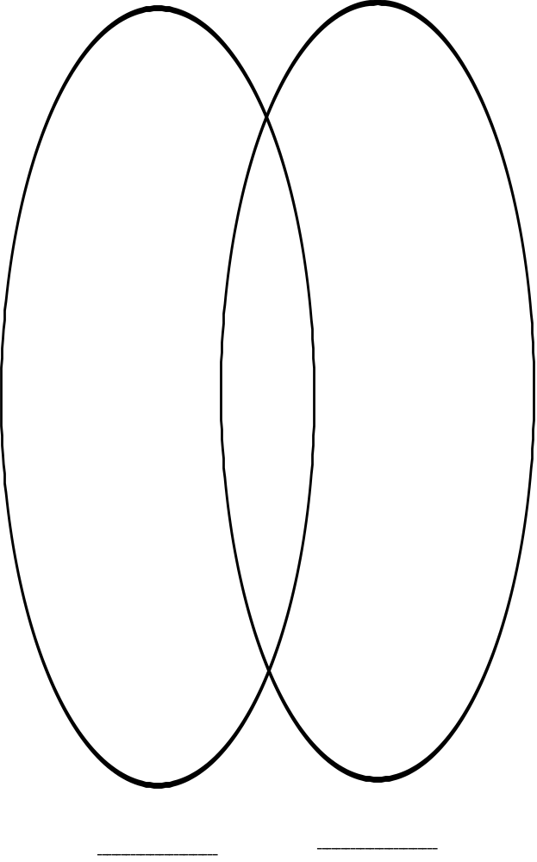

Name: _____________________________ Date: _________________

Name: __________________Date: ___________________

Name: __________________Date: ___________________

Name: _____________________________ Date: _________________

Frayer modeL

 |  | √ |  | BEFORE | √ | during | √ | after
The Frayer Model is a way to categorize terms or concepts. Students analyze a concept’s attributes by listing examples and non-examples of the concept
√ | 1. |  | Set Purpose for Reading
√ | 2. |  | Tap & Use Prior Knowledge
√ | 3. |  | Make Connections
 | 4. |  | Predict, Confirm & Adjust Predictions
 | 5. |  | Use Text & Vocabulary ( Language Cues) to Construct & Confirm Meaning
√ | 6. |  | Create Visual Images
√ | 7. |  | Recognize Key Ideas & Supporting Details
√ | 8. |  | Monitor Understanding & use a Variety of “Fix Up” Strategies
 | 9. |  | Make & Confirm Inferences & Conclusions
 | 10. |  | Recall, Reflect, Evaluate & Apply
how to use:
- Identify a concept that is essential for students to understand in a topic they are going to read or have read to them.
- Place the concept in the centre box of the model.
- Define the term in the “Definition” box. Write the definition as simple as possible so that others can understand it.
- List the words or phrases that further describe what the word means in the “Characteristics” Box.
- In the “Examples” box list several examples that show the word in action.
- In the “Non-Examples” box list several examples of actions or ideas that are the opposite of this word.
- Work individually or in pairs to complete the chart.
- Share the work as a class on chart paper and display. Students should feel free to refer to and modify these charts throughout the topic being studied.

Used with permission. The Association for Supervision and Curriculum Development is a worldwide community of educators advocating sound policies and sharing best practices to achieve the success of each learner. To learn more, visit ASCD
at www.ascd.org

Frayer Model
Example

Name: _____________________________ Date: _________________

Definition  A part of a whole | Characteristics  - A fraction can be part of a whole number or object  - A fraction can be part of a group  - There are three parts of a fraction: numerator, denominator, and fractions bar.  - We can find equivalent fractions  - Fractions can be part of a mixed number.  Fractions can be added, subtracted, multiplied or divided.  - Fractions can be changed to decimals or percentages.
Examples  5/10  1 ½  ½ = 5/10  ½ = 0.5  ½ = 50% | Non-Examples  25  5  10  2000  8+10

Fraction
Frayer Model

Name: _____________________________ Date: _________________

Definition | Characteristics

Examples | Non-Examples

T Notes

 |  | √ |  | BEFORE | √ | during | √ | after
Students record notes and/or visuals in a T-Note format.

√ | 1. |  | Set Purpose for Reading
 | 2. |  | Tap & Use Prior Knowledge
√ | 3. |  | Make Connections
 | 4. |  | Predict, Confirm & Adjust Predictions
 | 5. |  | Use Text & Vocabulary ( Language Cues) to Construct & Confirm Meaning
√ | 6. |  | Create Visual Images
√ | 7. |  | Recognize Key Ideas & Supporting Details
√ | 8. |  | Monitor Understanding & use a Variety of “Fix Up” Strategies
 | 9. |  | Make & Confirm Inferences & Conclusions
√ | 10. |  | Recall, Reflect, Evaluate & Apply
how to use:
OPTION 1
- While reading, student record words or key points on one side of the chart.
- On the other side of the T. have them record definitions or explanations of key points or add visual cues (pictures, drawing, chart or graph) or important words to help them organize and remember information.

OPTION 2
- Include a Summary section where students record one or two sentences about the most important idea.from the notes on the page.

OPTION 3
- While reading students record main ideas on one side and supporting ideas on the other side.
- When finished they record the main idea of the passage.

Have students share their visuals and remind them to be prepared to explain their meaning.
This form of note taking is beneficial for review of content.

T-Notes
Topic: ________________________________

Name: ________________________________ Date: _______________

_______________ | _______________

T-Notes
Topic: ________________________________

Name: ________________________________ Date: _______________

____________________ | ____________________
Summary
Exit Slips

 |  | √ |  |  | √ |  | √
 |  |  |  | BEFORE |  | during |  | after
Exit Slips are written student responses to questions you pose at the end of class.

 | 1. |  | Set Purpose for Reading
 | 2. |  | Tap & Use Prior Knowledge
 | 3. |  | Make Connections
 | 4. |  | Predict, Confirm & Adjust Predictions
 | 5. |  | Use Text & Vocabulary ( Language Cues) to Construct & Confirm Meaning
 | 6. |  | Create Visual Images
√ | 7. |  | Recognize Key Ideas & Supporting Details
 | 8. |  | Monitor Understanding & use a Variety of “Fix Up” Strategies
√ | 9. |  | Make & Confirm Inferences & Conclusions
√ | 10. |  | Recall, Reflect, Evaluate & Apply
how to use:
- Excellent to use at the end of the school day, or at the end of an important learning activity.
- Distribute an index card to each student.
- Pose a question for the students to respond to.
- The question must be short and should take the students a maximum time of 5 minutes to complete.
- As the students leave the classroom they are to drop their exit slip into some sort of container. This is their ticket to be done the class.
- Assess the responses on the exit slips to better prepare the instructions for the next class.

Examples:
  - Write one thing you learned today.
  - Write one question you have about today’s lesson.
  - Draw a quick diagram that shows…
  - or Ask a specific question related to the content of the lesson.

Used with the permission from Regina Public School Division

Assessment of Exit Slips

1 | 2 | 3
- Exit slip is blank or is  impossible to understand. | - Exit slip is difficult to read or understand | - Exit slip is organized and easy to understand
- Student makes no  effort to answer the question. Simply writes “I don’t know”. | - Exit slip makes very  little attempt to answer the question that was asked. | - Student has made a serious attempt to answer the question posed by the teacher
- No effort has gone  into exit slip. | - Minimal effort has gone into exit slip | - Evident that effort has gone into exit slip.

Used with permission from Regina Public School Division
Making JudgEments

 |  | √ |  | BEFORE | √ | during | √ | after
Most reference materials offer only one view point or side.
Making Judgments uses several short selections so students carefully consider both sides of an issue before making judgments.
√ | 1. |  | Set Purpose for Reading
 | 2. |  | Tap & Use Prior Knowledge
√ | 3. |  | Make Connections
√ | 4. |  | Predict, Confirm & Adjust Predictions
 | 5. |  | Use Text & Vocabulary ( Language Cues) to Construct & Confirm Meaning
√ | 6. |  | Create Visual Images
√ | 7. |  | Recognize Key Ideas & Supporting Details
 | 8. |  | Monitor Understanding & use a Variety of “Fix Up” Strategies
√ | 9. |  | Make & Confirm Inferences & Conclusions
√ | 10. |  | Recall, Reflect, Evaluate & Apply
how to use:
Before Reading:
- Select course material that presents two points of view on a topic or issue.
- Prepare a statement about the text and present to the class.
- Make sure the students know the difference between information and opinion.
- Ask the students to record one supporting idea and one opposing idea on a sample T Chart on board or overhead. Inquire as to where the idea came from ( i.e. previous knowledge)
During Reading:
- Have the students preview the material and make predictions.
- Students should read the information and find evidence that both supports and opposes the view point. This might be indicted with coloured stickies.
After Reading:
- Record the supporting and opposing arguments onto the T-Charts.
- Students may review and discuss with a partner and draw conclusions.
- An option would be share and discuss decisions and reasons in groups or as a class.
- There are two sample templates for making judgments or drawing conclusions.

Think Literacy: Cross-Curricular Approaches, Grades 7—12, (c) Queen’s Printer for Ontario,2005. Reproduced with
permission.
Making Judgments

Name: _____________________________ Date: _________________

Both Sides Now
Evidence that Supports | Question  Or  Statement | Evidence that Opposes
Decision

Reasons

Think Literacy: Cross Curricular Approaches, Grades 7-12. (c) Queen’s Printer for Ontario, 2005. Reproduced with permission.
Drawing Conclusions

Name: _____________________________ Date: _________________

I Read | I think
Therefore

Think Literacy: Cross Curricular Approaches, Grades 7-12. (c) Queen’s Printer for Ontario, 2005. Reproduced with permission.

CRITICAL LITERACY

 |  | √ |  | BEFORE |  | √ |  | √ | after
Critical Literacy is a way of reading that encourages the reader to question the text.

 | 1. |  | Set Purpose for Reading
√ | 2. |  | Tap & Use Prior Knowledge
√ | 3. |  | Make Connections
 | 4. |  | Predict, Confirm & Adjust Predictions
√ | 5. |  | Use Text & Vocabulary ( Language Cues) to Construct & Confirm Meaning
√ | 6. |  | Create Visual Images
 | 7. |  | Recognize Key Ideas & Supporting Details
 | 8. |  | Monitor Understanding & use a Variety of “Fix Up” Strategies
 | 9. |  | Make & Confirm Inferences & Conclusions
√ | 10. |  | Recall, Reflect, Evaluate & Apply
how to use:
- Read the article

- Summarize or challenge the article based on different perspectives

Example:
DeBono’s “Thinking Hats” approach:
Perspective 1: Louise Riel  - Patriot  - Mission  - My People  - Justice |  |  |  |  | Perspective 2: Métis Man  - He is a hero  - Created Manitoba  - Fought for our rights  - Scott was a traitor to us. |  |  | Perspective 3: Prosecutor  - Rebel  - Murdered Thomas Scott  - Led uprising  - Actions led to killing
Important questions for critical reading:
- What is the author’s bias?
- Whose voices are missing?
- Are the facts skewed?
- How do we know this?
- Does this mesh with the world that I know?

Think Literacy: Cross Curricular Approaches, Grades 7-12. (c) Queen’s Printer for Ontario, 2005. Reproduced with permission.

Reading Continuum
Emerging  K-1 | Early Developing  Grade 1 | Developing  Grades-2-5
-builds upon children’s emerging interests and abilities in listening, speaking, reading, writing, viewing, and representing. | -focuses on expanding student’s language, increasing their fluency and confidence  in language use and providing varied purposes for using language in the learning contexts of the classroom.
Student know:  - Illustrations carry a message that can be “read”.  - Print carries a message.  - Print in the environment carries messages in signs, labels, and logos.  - Stories can be remembered and retold. | Students know:  - What can be said can be written and read  - Print is read from top to bottom, left to right.  - Words such as “letter”, “word”, and “sentence” are used to describe print features.  - Texts are written in a variety of formats. | Students know:  - Reading is a process of constructing meaning.  - Reading can be done for different  - reasons or purposes.  - Readers use a variety of strategies.

Extending  Grades 6-9 | Specializing  Grades 10-12
-includes the reinforcement and refinement of language processes for learning and for public use, as well as increased language study. | -focuses on analysis and evaluation of language and literature structures, as well as use and application of specific language and structures for particular audiences and purposes.
Students know:  - Reading is a means of learning and enjoyment.  - Reading requires different strategies and rates depending on purpose and difficulty of the text. | Students know:  - Effective readers use a range of reading strategies before, during, and after interacting with texts to comprehend, interpret, evaluate, and appreciate what is aid.  - Reading a range of text – prose fiction and nonfiction, drama and poetry – extends one’s understanding of self and of the world.  - Different texts share our view of the world and shape us personally.

Before Reading Poster
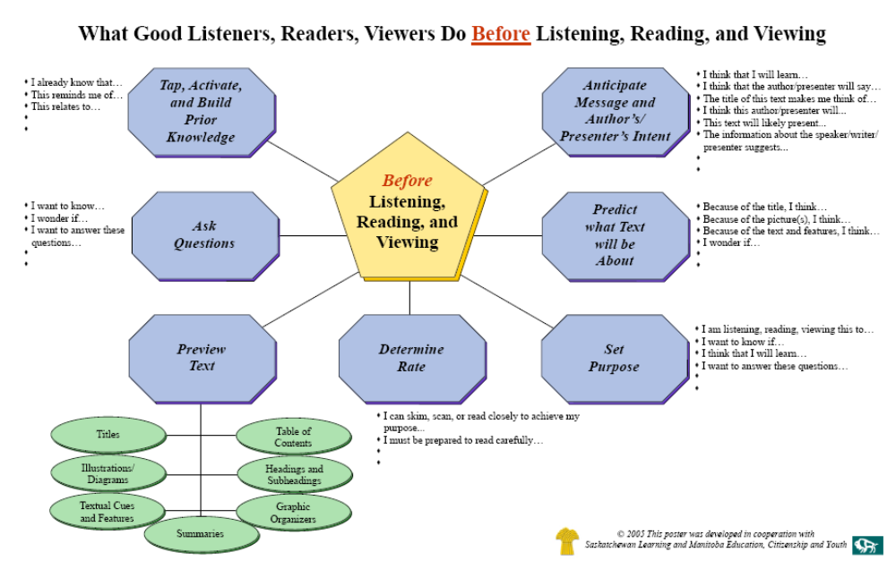

During Reading Poster
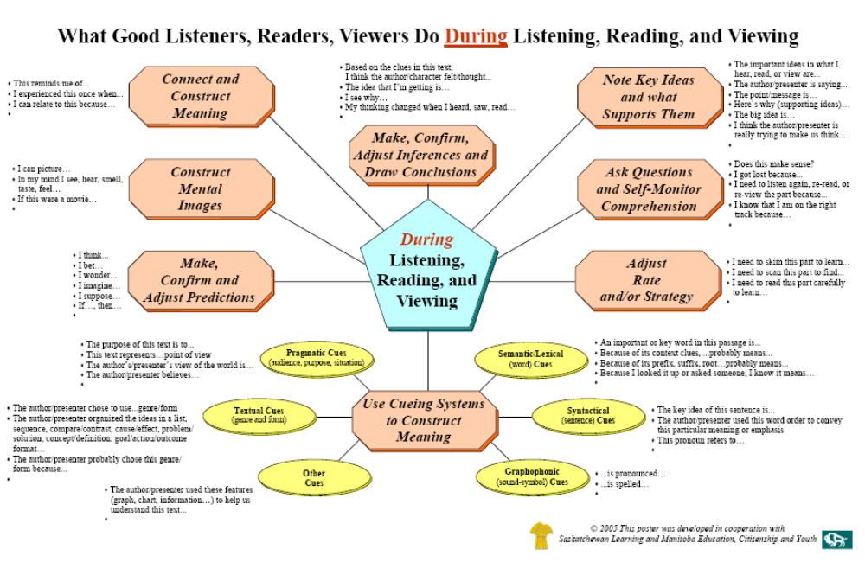
After Reading Poster

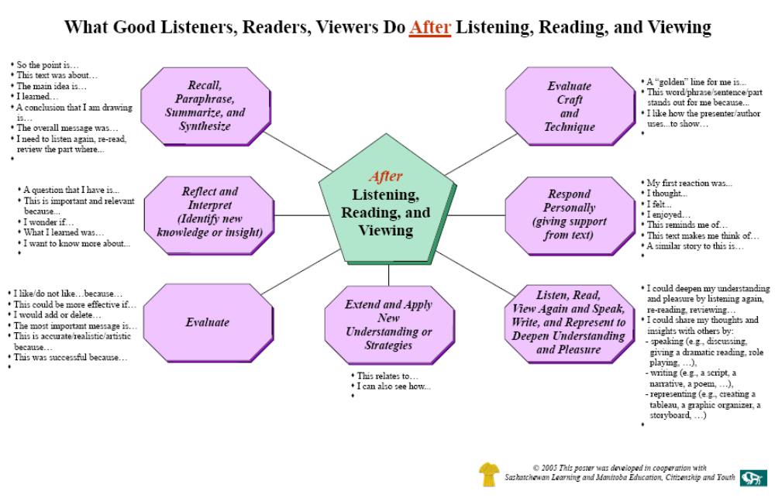
Ten Critical Skills & Strategies for Reading Proficiency Checklist
 | 1. Set Purpose for Reading | 2. Tap & Use Prior Knowledge | 3. Make Connections | 4. Predict, Confirm & Adjust Predictions | 5. Use Text & Vocabulary (Language Cues) to Construct & Confirm Meaning | 6. Create Visual Images | 7. Recognize Key Ideas & Supporting Details. | 8. Monitor Understanding & Use a Variety of “Fix Up Strategies. | 9. Make & Confirm Inferences & Conclusions | 10. Recall, Reflect, Evaluate & Apply
A Textbook Tour | √ | √ | √
KWLS | √ | √ | √ | √ |  |  |  | √ |  | √
Reading Rates | √ |  |  |  |  |  | √ |  |  | √
Word Study: Brainstorming |  | √ | √ |  | √
Word Study: Categorizing | √ | √ | √ |  | √
Word Study: Retelling |  | √ | √ |  | √ |  |  |  |  | √
Signal Words | √ |  | √ |  | √ |  | √
Think Alouds | √ |  | √ | √ | √ |  |  |  | √
Sentence Chunking |  |  | √ |  | √ |  | √
Anticipation Guide | √ | √ | √ | √ | √ | √ | √ | √ |  | √
Walk About | √ | √ | √ | √ |  |  | √ |  | √ | √
Coding for Comprehension | √ | √ | √ |  |  |  |  | √ |  | √
Directed Reading Thinking Activity (DRTA) | √ |  | √ | √ | √ |  |  | √ | √ | √
Read Aloud | √ |  | √ | √ | √ |  |  | √ | √
W5 Chart | √ | √ | √ |  |  | √ | √ | √ | √ | √
Venn Diagrams | √ | √ | √ |  |  | √ | √ |  |  | √
Frayer Model | √ | √ | √ |  |  |  | √ | √
T-Notes | √ |  | √ |  |  | √ | √ | √ |  | √
Exit Slips |  | √ |  |  |  |  | √ |  | √ | √
Making Judgment | √ |  | √ | √ |  | √ | √ |  | √ | √
Critical Literacy | √ | √ | √ |  |  |  | √ |  | √ | √

Notes

Saskatchewan Learning: English Language Arts – A Curriculum Guide for the Elementary Level, 2002.
Adapted from, Kropp, Paul, Content Area Reading, Grades 6-8, November, 2006.
Adapted from: Pass, Holly, Reading in the Content Areas: Student Strategies for Improving Reading Comprehension, Regina, Saskatchewan, 2006.
Saskatchewan Learning, English Language Arts: A Curriculum Guide for the Middle Level (Grades 6-9), p.134, June 2006
Pass, Holly, Reading in the Content Areas: Student Strategies for Improving Reading Comprehension, p 29, Regina, Saskatchewan, 2006.
Pass, Holly, Reading in the Content Areas: Student Strategies for Improving Reading Comprehension, p 29, Regina, Saskatchewan, 2006.
?Pass, Holly, Reading in the Content Areas: Student Strategies for Improving Reading Comprehension, p 30, Regina, Saskatchewan, 2006.
Pass, Holly, Reading in the Content Areas: Student Strategies for Improving Reading Comprehension, p 31, Regina, Saskatchewan, 2006.
, Holly, Reading in the Content Areas: Student Strategies for Improving Reading Comprehension, p 32, Regina, Saskatchewan, 2006.
Kropp, Paul, Content Area Reading, November 2006.
Pass, Holly, Reading in the Content Areas: Student Strategies for Improving Reading Comprehension, p. 78 Regina, Saskatchewan, 2006
Saskatchewan Learning, Social Studies: A Curriculum Guide fo rhte Middle Level (Grade 9), Instructional Philosophy and Strategies, p. 400, August 1999.
Kropp, Paul, Content Area Reading, November 2006
Pass, Holly, Reading in the Content Areas: Student Strategies for Improving Reading Comprehension. Regina, Saskatchewan, 2006
Pass, Holly, Reading in the Content Areas: Student Strategies for Improving Reading Comprehension, p. 23, Regina, Saskatchewan, 2006
Beers, Sue and Howell, Lou, Reading Strategies for the Content Areas: an ASCD Action Tool, Association for Supervision and Curriculum, Alexandria, Virginia, p. 274, 2003
Beers, Sue and Howell, Lou, Reading Strategies for the Content Areas: an ASCD Action Tool, Association for Supervision and Curriculum, Alexandria, Virginia, p. 274, 2003
Adapted from Regina Public Schools, Best Practices: Pieces of the Puzzle, Regina Public Schools and Saskatchewan Learning, 2003
Regina Public Schools, Best Practices: Pieces of the Puzzle, Regina Public Schools and Saskatchewan Learning, 2003
Ontario Ministry of Education, Think Literacy: Cross Curricular Approaches, Grades 7-12, Queen’s Printer for Ontario, p. 74, 2005
Ontario Ministry of Education, Think Literacy: Cross Curricular Approaches, Grades 7-12, Queen’s Printer for Ontario, p. 77, 2005
Ontario Ministry of Education, Think Literacy: Cross-Curricular Approaches, Grades 7-12, Queen’s Printer for Ontario, p. 73, 2005.
Ontario Ministry of Education, Think Literacy: Cross-Curricular Approaches, Grades 7-12, Queen’s Printer for Ontario, p. 73, 2005. Resources Allen, J. (2004). Tools for Teaching Content Literacy, Stenhouse Publishers, 2004. Beers, S. and L.Howell. (2003). Reading Strategies for the Content Areas: an ASCD Action Tool, Association for Supervision and Curriculum, Alexandria, Virginia. Beers,S. and L.Howell.(2005). Reading Strategies for the Content Areas Volume 2: an ASCD Action Tool, Association for Supervision and Curriculum Development, Alexandria, Virginia. Creating a Culture of Literacy: A Guide for Middle and High School Principals. (2005). National Association of Secondary School Principals, Reston, Virginia. Kenney, J.(2005). Literacy Strategies for Improving Mathematics Instruction, Association for Supervision and Curriculum Development, Alexandria, Virginia. Miller, W.(1999). Ready-to-Use Activities and Materials for Improving Content Reading Skills. The Center for Applied Research in Education. Ontario Ministry of Education.(2005). Think Literacy: Cross Curricular Approaches, Grades 7-12,Ontario: Author. Saskatchewan Learning.(2002). English Language Arts: A Curriculum Guide for the Elementary Level, Regina, SK: Author. Saskatchewan Learning.(2006).English Language Arts: A Curriculum Guide for the Middle Level, Regina, SK: Author. Saskatchewan Learning.(1999).English Language Arts: A Curriculum Guide for the Secondary Level, Regina, SK: Author. Tankersley, K.(2003). The Threads of Reading: Strategies for Literacy Development, Association for Supervision and Curriculum Development, Alexandria, Virginia. Tovani, C.(2004). Do I Really Have to Teach Reading? Content Comprehension, Grades 6-12. Stenhouse Publishers, Portland, Maine. Vaugh, S. and S. Linan-Thompson.(2004).Research-Based Methods of Reading Instruction: Grades K-3, Association for Supervision and Curriculum Development, Alexandria, Virginia.

