Quiz:
Do you have an Organizational Problem?

Take this assessment to determine if you are as organized as you’d like to be.

1. True False I can find anything I need in two minutes or less.

2. True False I feel in control of my space, time, and papers.

3. True False Cleanup is quick because I know where everything
goes.

4. True False I am rarely late.

5. True False I rarely lose things.

6. True False Getting ready to go out is a smooth process.

7. True False Procrastination is rarely a problem for me.

8. True False I get my homework done on time and am pleased
with the results.

9. True False I feel happy with what I accomplish every day.

10. True False I rarely hear myself apologizing for how my room
looks.

11. True False I am comfortable in my space.

12. True False I don’t think being disorganized is an obstacle to
my success.


If you answered “False” to 3 or more of the above questions, you have room for improvement when it comes to your organizational skills. Continuing to work on these skills will prove to be very helpful in increasing your level of achievement and reducing your stress.

Organizing Your Life From the Inside Out

Step 1: Analyze
First, pick a part of your life where you feel organization could be improved (i.e. your bedroom, your locker, your math binder, etc.)

Your area for improvement:______________________________________________________________

Question 1: What’s working and what’s not?

What’s working:

- I can always find my ________________________________________________________________
- I always have a place to put my ______________________________________________________
- I like the current set-up of my ________________________________________________________
- No matter how busy I get, I always find time for ________________________________________
- My goals are well defined when it comes to_____________________________________________

What’s not working:

- I can never find my __________________________________________________________________
- I have no place to put my ____________________________________________________________
- I don’t have enough time for __________________________________________________________
- I procrastinate whenever I have to _____________________________________________________
- I have a hard time finishing ___________________________________________________________

Question 2: What’s your essential 7?

What are the 7 most important items in the area you are about to organize?
(i.e. what are the objects you are constantly looking for and need most often?)

- _____________________________________ 5.____________________________________
- _____________________________________ 6.____________________________________
- _____________________________________ 7.____________________________________
- _____________________________________

Question 3: What’s the pay-off?

What are the reasons why it will be worthwhile to get organized in this area?

1._____________________________________________________________________________________
2._____________________________________________________________________________________
3. ____________________________________________________________________________________

Question 4: What’s the problem?

Tick off every reason that applies to why you feel you are unorganized in this area.

___ “homeless” items and tasks ___ fear of losing your individuality
___ inconvenient storage ___ believe organizing is boring
___ overly complex organizational systems ___ unclear goals and priorities
___ having more stuff than space available
___ “out of sight, out of mind” mindset
Organizing Your Life From the Inside Out

Step 2: Strategize

There are two important considerations to make when strategizing how you will organize an area. Both are explained below.

Your area for improvement: ______________________________________________________________

Step 1: The Kindergarten Model of Organization
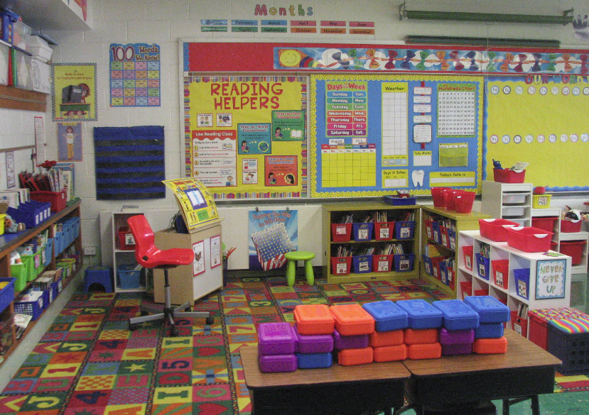
Does this remind you of your kindergarten classroom?

Why was it that the room seemed to be so “easily” organized, even after 25 5-year olds had been playing at the same time? Here are the key features listed below. Now consider the area you are going to organize. How can you ensure that each of the above are considered in your organizational plan?

- Clearly defined activity zones ________________________________________________________
- Self contained spaces ________________________________________________________________
- Easy to access storage________________________________________________________________
- Fun, tactile storage __________________________________________________________________
- A visual map of what’s important in that space _________________________________________

Step 2: Estimate your time

Most people greatly under or overestimate the time it will take to organize various areas of their life, which can sometimes get everything started off on the wrong foot. For each of the following, provide an average range for how long you think it would take to organize the following unorganized spaces or items:

________ a bedroom
________ a closet
________ school papers
________ locker
________ backpack
________ collections of items (baseball cards, photos)
________ a week-long schedule of activities

Now consider how long it will take you to organize your area for improvement. ______________
Does it seem to be worth your time to organize this area? _______
Studies show that people lose an average of 1-2 hours per day due to disorganization. What would you do with an extra 1-2 hours each day? _____________________________________________________________________________________

Organizing Your Life From the Inside Out

Step 3: Attack

Attack Plan 1: Organizing A Space

Select a space in your life that you know needs to be organized: __________________________________

Use the SPACE formula to help you decide your attack plan:

SORT: What types of items or possessions will need to be sorted in your space?
____________________________________________________________________________________________
____________________________________________________________________________________________

PURGE: What items do you know will likely need to be thrown away because they are duplicates,
excess, undesirable or irrelevant?
_____________________________________________________________________________________________
_____________________________________________________________________________________________

ASSIGN A HOME: Where in the space can you put each item to make it easy to find?

_____________________________________________________________________________________________
_____________________________________________________________________________________________

CONTAINERIZE: What kinds of containers will you need to organize the space?
_____________________________________________________________________________________________
_____________________________________________________________________________________________

EQUALIZE: How do you think your organizational system may have to change over time?

Remember these rules to effectively organizing a space:

Rule 1: Attack what’s visible first- rather than sorting through drawers, cabinets, closets first and creating more chaos, first organize what you clearly see each and every time you use that space.

Rule 2: Use the quick-sort plan- begin by grouping items into categories and worry about purging items afterwards.

Rule 3: Don’t play catch-up- don’t spend your time looking through books or photo albums, unfinished
projects etc. Set them aside in a “Future Projects” pile.

Rule 4: Avoid ZigZag organizing – pick one place to start your organizing and stick with it until it’s organized to your satisfaction.

Rule 5: Play Beat-the-Clock – Challenge yourself to sort each section by a particular time – it will help to keep you on task.

Organizing Your Life From the Inside Out

Step 3: Attack

Attack Plan 2: Organizing an Assignment or Task
Whatever you are organizing needs to fit what works for YOU! Your organizational system may be different from someone else’s, and that is okay, as long as it is working!

The assignment or task that I want to organize is: _________________________________________

This assignment is due on: ________________________________

The expectations of this assignment are:

The process I need to follow to meet those expectations is (in point form):

Beside each point above, realistically determine approximately how much time it will take to complete each step. Calculate the total time, and look at how that can be broken up and completed before the assigned due date.

Attack Plan 3: Organizing Your Time

There are three basic tools to effective time management. They include:

- Use a planner or datebook
- Create a time map
- Use the WADE formula

Each step is explained for you below:

1. Use a Planner: All students are given a planner at the beginning of the school year. Do you still have yours? If not, it is worthwhile to invest in one – no one can remember everything they have to do without writing it down. If you’re not interested in using a planner that you write in, do you have an effective app on your phone to use as a planner? Do you use your calendar and reminder apps to help you manage your time?

- Creating a Time Map: this is an important step to any time management plan. You need to work on mapping your time out over critical time periods – a day, a week, or a month. A blank weekly time map is provided on the next page. Your time map should always reflect your priorities, it should represent an accurate reflection of how your time is spent, and should be evaluated frequently to ensure it’s working for you.

After completing your own time map, ask yourself these questions…

- My biggest surprise was ___________________________________________________________________
- I’m proud of the way I _____________________________________________________________________
- Something I’d like to change is ______________________________________________________________
- My biggest time wasters are ________________________________________________________________
- One thing I wish I had more time for is ______________________________________________________
- One thing I want to spend less time on is ____________________________________________________

- Using the WADE formula:
Any time an activity must be completed, be sure to Write it down in your planner, Estimate how long each task will take, Decide exactly when you will do the task and Execute your time management plan!

My Weekly Time Map

Time | Monday | Tuesday | Wednesday | Thursday | Friday | Saturday | Sunday

6:30 a.m.

7:00 a.m.

7:30 a.m.

8:00 a.m.

8:30 a.m.

9:00 a.m.

9:30 a.m.

10:00 a.m.

10:30 a.m.

11:00 a.m.

11:30 a.m.

12:00 p.m.

12:30 p.m.

1:00 p.m.

1:30 p.m.

2:00 p.m.

2:30 p.m.

3:00 p.m.

3:30 p.m.

4:00 p.m.

4:30 p.m.

5:00 p.m.

5:30 p.m.

6:00 p.m.

6:30 p.m.

7:00 p.m.

7:30 p.m.

8:00 p.m.

8:30 p.m.

9:00 p.m.

9:30 p.m.

10:00 p.m.

10:30 p.m.

Student Organization…In A Nutshell


Organizing Your Binders 101

- Designate one binder for each of your courses – a different colour for each
- Decide what sections are logical based on the course you are organizing (i.e. Notes, Quizzes, Assignments, Tests)
- Create a labelled divider for each section of your binder
- Organize your paperwork in order by date in each of the appropriate sections
- Date each note and handout you receive, and place them in the appropriate section in your binder
- Keep your binders in a set place in your locker, and label the spine of each

Organizing Your Assignments 101

- When an assignment is given out in class, read the instructions carefully the same day you receive the assignment.
- Ask your teacher for any clarification that is required around expectations, format, or the due date(s).
- Break the task down into manageable chunks that you feel you can realistically tackle.
- Predict the amount of time that each of these tasks will take you.
- Working back from a couple of days BEFORE the assignment due date, plan out on what days and exactly when you will tackle each part of the assignment. Give yourself more time than you think it will take you to complete each part.
- When you have completed the assignment, review the assignment expectations again and proof-read the assignment to your satisfaction.
- Ask the teacher if they may be able to check your assignment and provide you with feedback before the due date.

Note: Remember to always review feedback from previous assignments to
make sure you don’t make the same mistakes in future assignments.

Organizing Your Time 101

- Acquire an agenda or daily calendar on which you record your commitments, hour by hour
- Block off all hours in which you are in class or have other non-flexible commitments (i.e. team practice, work, family event, meals, sleep)
- Record all of the school-related commitments you need to fit into your schedule on a separate sheet for each subject (homework completion, studying, assignment research etc.)
- Begin to block off the time (hour by hour) in which you will complete each of these tasks. Be realistic and give yourself more time than you think you will need. Work backwards from due dates.
- Stick to your schedule as much as possible, adjusting when required.
- Be sure to leave time for activities you enjoy and “down time.” A completely scheduled student is often a miserable one!

