Clothing Textiles and Fashion
SunWest School Division has purchased a garment printer.
Full Curriculum Documents available at Saskatchewan Curriculum
Brother GT 341GT Garment Printer
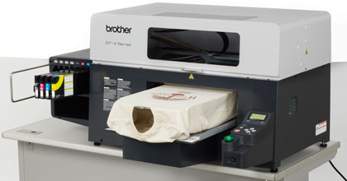

- Sewing Basics – refer to document “Grade 7 Sewing Basics” to find I Can" Statements
- Link to the Clothing, Textile, and Fashion Curriculum Document
Full Curriculum Documents available at Saskatchewan Curriculum

ROVER (Recommended Online Video Education Resources) is the video streaming site for Saskatchewan teachers and students in the PreK-12 education system. It is managed and maintained by the Saskatchewan Ministry of Education.

ROVER Resources Available:
all available in September, 2012
Design: All About Textiles
Flattering Fashions
Jobs in Clothing, Textiles, and Fashion
Sew Cool
Sew Green: recycle, Repurpose, Restyle

