**Angle Grinder**

**Standard Operating Procedure (SOP)**

|  |
| --- |
| **All students must have a signed and dated Standard Operating Procedure form before they use any machine in the welding shop**. |

|  |  |
| --- | --- |
| Safety glasses must be worn at all times in work areas. | Hair Protection circleLong and loose hair must be contained. |
| Foot Protection circleSturdy footwear must be worn at all times in work areas. | ApronClose fitting/protective clothing must be worn. |
| **Prohibition circleProhibition circle**Rings and jewellery must not be worn. | Hearing protection may be required for some operations.Hearing Protection circle |

### **INITIAL SAFETY CHECKS**

|  |  |
| --- | --- |
|  | Before that work commences ensure that the work area is safe by clearing debris and flammable material from the work area. |
|  | Ensure that the angle grinder disc, guards & handle are secure. |
|  | Check that the grinder safety guard covers half of the grinding/cutting disc. |
|  | Examine the power lead and plug for obvious damage. |
|  | Do not lift or carry the angle grinder by the power cord. |
|  | Use the grinder only in a designated work area – preferably behind a portable screen. You are legally and ethically obligated to protect others from injury. |
|  | Wear appropriate eye, ear and face protection. Use other personal protective equipment or clothing, as required under the circumstances. |

|  |
| --- |
| Do not use a grinding disc that has been cracked, dropped, damaged or has been soaked in water.  If a grinder disk has been cracked or damaged, the disk may disintegrate while in use, causing severe injury. |

#### OPERATIONAL PROCEDURE

|  |  |
| --- | --- |
|  | Do not plug in the grinder until all adjustments have been made. |
|  | Ensure your work piece is firmly secured & supported. |
|  | Keep fingers, hands and power cord clear of the disc. |
|  | Be aware of flying hot sparks. Hold the grinder so that any sparks fly away from you and anyone nearby, and away from all flammable materials. Shielding may be required in order to protect others and to protect property from damage. |
|  | Allow the grinder to reach operating speed, then apply load gradually. Maintain a constant pace to avoid uneven surfaces. |
|  | Maintain complete control. Always operate using a firm grip, with both hands. Maintain a proper & steady footing at all times. |
|  | Do not apply excessive force – this could cause the disc to shatter. |
|  | Avoid prolonged use & high pressures. This could overheat the disk and the motor. |
|  | Turn off after use. |
|  | Do not place the grinder down until the disc has stopped rotating. |

|  |
| --- |
| Violent kick-back can occur, particularly when using the grinder for cutting.  Kick-back occurs when the blade gets caught between two pieces of metal and the energy from the grinder causes the grinder disc to be thrust back violently towards the operator. For this reason cutting metal with a grinder is more dangerous than using an angle grinder for grinding. If the operator wishes to use an angle grinder to cut steel, extra precautions must be taken. Appropriate training and the use of additional PPE will be required. The use of a face shield, leather gloves and leather sleeves on the arms will reduce the risk of injury. |

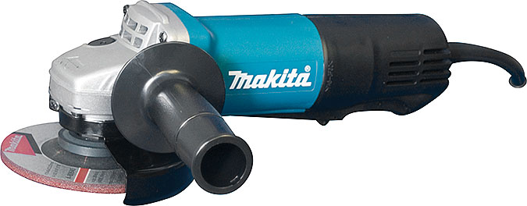**This Standard Operating Procedure does not necessarily cover all possible hazards associated with the machine. The operator of any machinery should be committed to operating this and all machinery in a safe manner. In addition this SOP has been designed to be used as part of an education program which was designed to teaching Safety Procedures and to act as a reminder to users prior to machine use.**

**Date ________________________**

**Instructor’s Signature _____________________________**

**Student Signature __________________________**