**Bench Grinder**

**Standard Operating Procedure (SOP)**

|  |
| --- |
| **All students must have a signed and dated Standard Operating Procedure form before they use any machine in the welding shop**. |

|  |  |
| --- | --- |
| Safety glasses must be worn at all times in work areas. | Hair Protection circleLong and loose hair must be contained. |
| Foot Protection circleSturdy footwear must be worn at all times in work areas. | ApronClose fitting/protective clothing must be worn. |
| **Prohibition circleProhibition circle**Rings and jewellery must not be worn. | Hearing protection may be required for some operations.Hearing Protection circle |

### **INITIAL SAFETY CHECKS**

|  |  |
| --- | --- |
|  | Before that work commences, ensure that the work area is safe by clearing debris and flammable material from the work area. |
|  | Ensure that the grinder guards and guides are secure. |
|  | Examine the power supply cord and plug for obvious damage. |
|  | Do not operate a grinder until you are sure it is safe to do so. You are legally and ethically obligated to protect others from injury. |
|  | Wear appropriate eye, ear and face protection. Use other personal protective equipment, as required under the circumstances. |
|  | Check that the grinding wheels are running true (no excessive vibration) and are not glazed or loaded with non-ferrous metals or other substances |
|  | As the grinding wheel wears down, tool rests and safety guards must be regularly adjusted. Safety guidelines state that the gap between the grinding wheel and the spark arrestor and the wheel and the distance between the tool rest and the stone should be adjusted to 1.6mm (1/16”). Basically this means that the guides and guards should be adjusted as close to the wheel as possible, without touching the wheel. This prevents objects from being jammed between tool rest and the wheel |
|  | Never use the bench grinder to grind non-ferrous metals. Metals such as aluminium and brass may cause glazing on the grinding surface, which may cause a failure of the stone. |
|  | Faulty equipment must not be used. Immediately report any suspect machinery. |

|  |
| --- |
| Do not use a grinding stone that has been cracked, dropped, damaged or has been soaked in water.  If a grinder stone has been cracked or damaged, the stone may disintegrate while in use. The resulting debris may cause severe injury. |

**OPERATIONAL SAFETY CHECKS**

|  |  |
| --- | --- |
|  | Stand to the side of the grinder stone when starting the machine up. |
|  | Let the machine attain maximum speed before starting to grind. |
|  | Do not grind on the side of the wheel. |
|  | Never leave the machine running unattended. |
|  | Never force the work piece against a grinder stone. |
|  | Slowly move the work piece across the face of the grinder stone in a uniform manner. |
|  | If you need to grind a small object, use a pair of locking pliers to hold the object. This will keep your fingers away from grinding wheel. |
|  | Turn off the power switch to pedestal grinders and lockout the electrical switch before doing any repairs. |

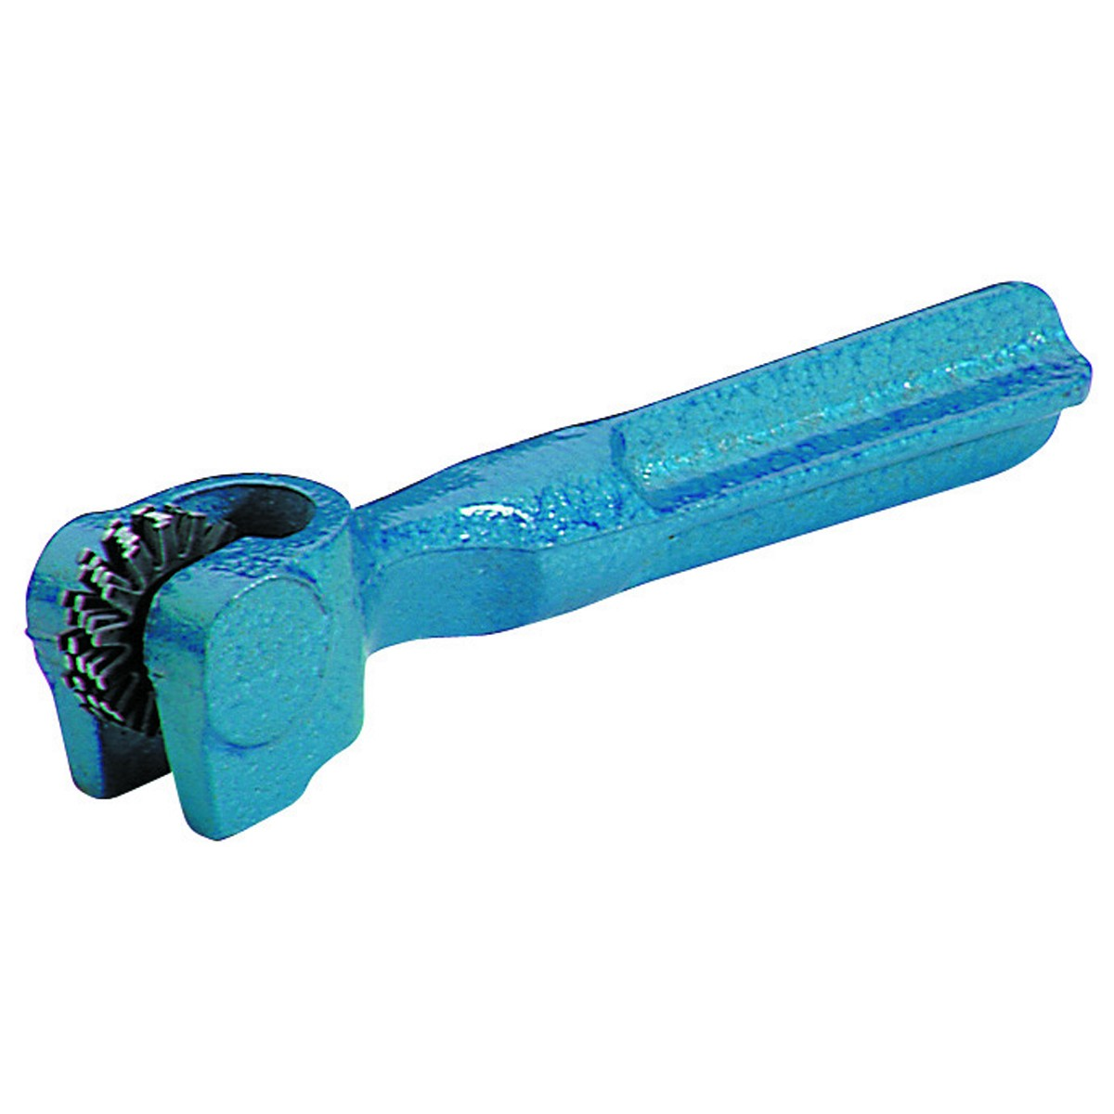**Wheel Dressing Procedure**

Normal Bench Grinder usage may cause uneven wear on the grinding face this may be corrected using a grindstone-dressing tool. The tool is applied to a grindstone while it is rotating at full speed.

|  |  |
| --- | --- |
|  | Wear a face shield over your safety glasses for protection against heavy particles. |
|  | Use a dressing tool approved for the job. |
|  | Inspect star dressers for loose shaft and worn disks. |
|  | Round off the wheel edges with a hand stone before and after dressing to prevent the edges from chipping. |
|  | Use the work rest to support and guide the tool. |
|  | Apply moderate pressure slowly and evenly. |

|  |
| --- |
| Be aware that a large bench grinder wheel takes a long time to come to stop spinning.  NEVER LEAVE THIS MACHINE ON AND STEP AWAY |

**This Standard Operating Procedure does not necessarily cover all possible hazards associated with the machine. The operator of any machinery should be committed to operating this and all machinery in a safe manner. In addition this SOP has been designed to be used as part of an education program which was designed to teaching Safety Procedures and to act as a reminder to users prior to machine use.**

**Date ________________________**

**Instructor’s Signature _____________________________**

**Student Signature ____________________________**