Drill Press is a upright fixed type of drill that is generally mounted on a worktable or stands on the floor. It consists of a base, column, table, spindle, and the drill head. The drill press head contain handles (usually three) when rotated they move the drill bit down into the object being bored. This head is usually spring loaded so that when the drilling operation is complete the head will return to its upward position.
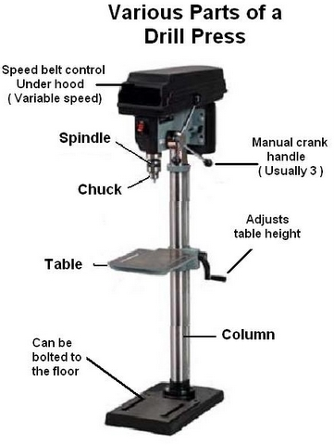
Refer to document “Drill Press Standard Operating Procedure (SOP)”

