ALWAYS WEAR APPROPRIATE PPE WHEN USING THIS MACHINE
SAFETY FOR THIS MACHINE:
- DO NOT operate while under the influence of drugs, alcohol, or medication
- SECURE any loose fitting jewelry or clothing, tie back long hair - they can get caught in moving parts
- DO NOT wear flammable clothing. Avoid permanent press and nylon clothing because of the difficulty of putting out their fire
- DO NOT TOUCH LIVE ELECTRICAL PARTS
- DO NOT adjust voltage range or voltage switch while operating the welder
- DO NOT WELD NEAR FLAMMABLE MATERIALS
- DO NOT WELD ON DRUMS, TANKS, OR ANY CLOSED CONTAINER IF IT CONTAINED FLAMMABLE MATERIAL
- DO NOT weld on containers or hollow castings which do not have vents
- NEVER weld without adequate ventilation
- DO NOT pick up hot objects. Assume that every metal objet around a weld bead or cut line is hot
- DO NOT leave the electrode in contact with a metal table top or any grounded surface while the machine is on
- DO NOT look at the welding arc without adequate eye protection
- DO NOT strike an arc without checking the area to be certain that bystanders are protected by PPE
- USE welding screens where necessary, to prevent injury to bystanders
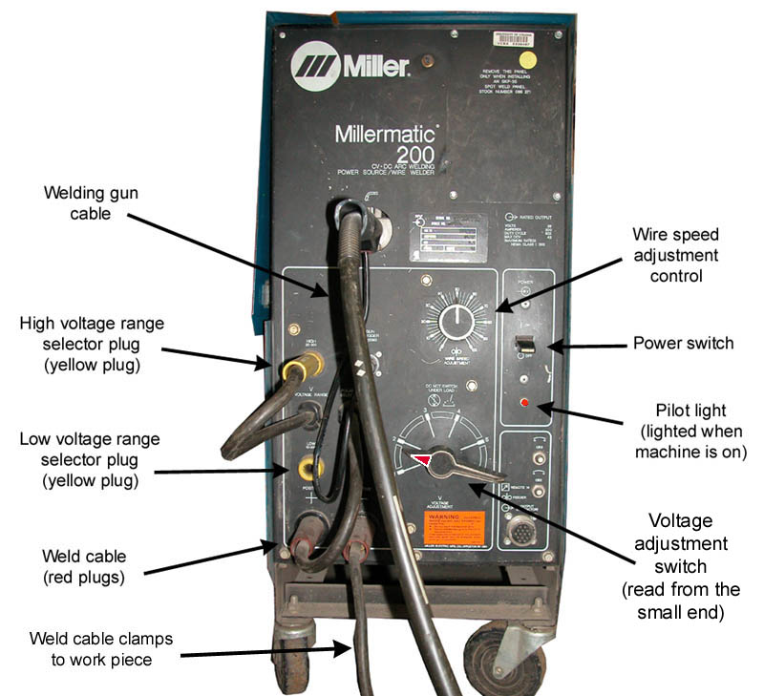
- REFER to instruction manual for further information (see instructor)

