Collaboration
Educator Guidebook
K-5
I Can Build On My Team’s Strengths
I Can Cooperate
I Can Help Find Solutions
I Can Evaluate My Team
TABLE OF CONTENTS
Purpose 3
Changes In Communication?
what we know about collaboration and collaborative learning
Why It’s Important

Self Assessment Rubrics 4
I Can cooperate
i can build on my team strengths
I can evaluate my team
I can help find solutions

Resources 6
General Communication Strategies
I Can cooperate
i can build on my team strengths
I can evaluate my team
I can help find solutions
Purpose
Changes in Communication
Collaboration is increasingly mentioned as an important educational outcome and most models of 21st century education include collaboration as a key skill. The value of collaboration has been assumed for many years, and over the past two decades, we have seen leading businesses and organizations move to facilitate team building and team-based work. The ability to work effectively with others has become a critically important skill for career and life success.
Here is what we know about collaboration and collaborative learning:
- Emphasis on collaboration remains traditional, reflecting older models of interaction
- Use of technology does not always boost collaborative learning or improved digital literacy
- Students learn best from a mix of individual and group-based learning experiences
- Collaboration can enhance the development of critical thinking skills
- Four categories of assessment exist for evaluating collaboration as a process and outcome for both groups and individuals
- Collaborative problem solving is an area to watch with new assessments

Collaboration. P21 Partnership for 21st Century Learning. http://www.p21.org/our-work/4cs-research-series/communication. Web. May 7, 2018

Why it’s important: Students of the digital age are social by nature. They text, post, update, share, chat, and constantly co-create in technological environments with each other. When they are unable to do this in school, they become disengaged and unattached to their learning. Connection and collaboration with others are essential not only to their learning but their mental and emotional health. It is a skill that educators must exercise with them regularly, and understanding Collaboration Fluency will assist with this.

Watanabe-Crockett, Lee. The Critical 21st Century Skills Every Student Needs and Why. Global Digital Citizen Foundation. https://globaldigitalcitizen.org/21st-century-skills-every-student-needs. Aug 2 2016. Web May 6, 2018

Collaboration | 1 | 2 | 3 | 4 | 5
Cooperate | I do not participate with others to accomplish common goals yet. I do not follow guidelines yet. | I sometimes participate with others to accomplish common goals. I sometimes follow guidelines. | I can participate with others to accomplish common goals. I usually follow guidelines. | I always participate with others to accomplish common goals. I respect and follow guidelines. | I always participate with others to accomplish common goals. I respect and follow guidelines and encourage others to as well.
Build team strengths | I rarely work productively with my group. My feedback is mainly negative. | I sometimes work productively with my group on the task at hand. I encourage my team members, but not always in a positive way. | I work productively in my group on the task at hand. I usually encourage my team members in a positive way. | I work productively in my group and I attempt to make sure that everyone is heard by sticking up for group members and inviting them to speak. I help make sure everyone contributes, by encouraging them in positive ways. | I work productively in my group and I actively prevent negativity, promote solutions and positive actions, and make sure every member of the team feels listened to and valued.
Evaluate the team | I rarely acknowledge what my group has accomplished. I don’t praise others yet. | I can praise my team on a job well done, but don’t always do so. | I can personally praise members when work has been done well and/or accomplished on time. | At the end of the group task, I am able to make the team feel proud of the work they have achieved and share our successes with people outside of our team. | At the end of the group task, I am able to make the team feel proud of the work they have achieved. I am able to reflect positively on improvements for next time, and share our successes with people outside of our team.
Find solutions | I do not start solving problems on my own yet. | I sometimes can identify a problem but need support to find solutions. | I can identify a problem but need support breaking it down into smaller tasks. I can start solving the problem. | I can identify a problem, and can brainstorm and suggest strategies for solving. I can collaborate with others to solve it. | I can recognise a problem and break it up into smaller tasks, and collaborate with others to solve it effectively.

General Collaboration Resources
- Ask students to give examples of what Collaboration is and is not.
- Students create posters of what Collaboration looks like, sounds like, and feels in in their words.
- As a group, discuss and create (draw) your ideal classroom. Label the important parts.
- Either share the rubric above with your students, or just share the categories and come up with a rubric that is personalized for your class. Post the rubric somewhere that will ensure it is referred to often.
- Setting the Norms for Group Work and Collaboration. This website has posters, and various student inventories and assessments for self-reflection and group reflection.
http://www.thinkingcollaborative.com/norms-collaboration-toolkit/
- Video- Collaboration: https://www.youtube.com/watch?v=Po40I4c94R0
- Book List:
  - Lousy Rotten Sticky Grapes
  - Frederick- Leo Lionni
  - The Enormous Turnip
  - Hugo
  - Yes I Can
  - We Share Everything
  - Franklin Plays the Game
  - Little Red Hen

- Collaboration Games:
  - Paper chain challenge – play in teams and see who can make the longest chain in a set amount of time
  - Web activity – students sit in a circle and pass a ball of yarn back and forth across the circle, forming a giant web. This leads into discussion about how when we are interconnected and work together we are very strong.
  - Pairs or groups have a towel and a beach ball and work together to toss the ball up in the air or to hit targets on the wall
  - Students all stand in a circle holding hands. Students must pass a hula-hoop around the whole circle without anyone letting go of hands.
  - Improv.- teachers sets a scenario with a problem (Eg., lawn mower has ran out of gas). One person starts the scene, then other students jump in with ideas to solve the problem. (I’ll go ges gas-no car though. Next kid comes along with a car and drives (no money). Next kid comes with money, etc.) Student jump in with ideas as they think of them, and it builds on that.
  - Students could plan and preform skits reflecting what collaboration is not, and then what it is.

Design Your Classroom For Collaboration in a 21st Century Space
Display:  - Genius bar  - Activate back wall  - Studio corners  - White boards with one device for immediate collaboration  - Visual gallery/display at lower levels  - Interactive displays  - Only necessary items shown | Storage:  - Remove clutter  - Not used in last year…toss  - Individual white boards  - Make containers, bins, etc easy to identify  - Critical thinking games ( labeled clearly, lego, marble works, puzzles,e tc)
Furniture:  - Easy to move around  - Create space  - Circle/kidney tables  - Bigger tables  - Matts  - Big pillows  - Comfy chairs  - Circle of chairs  - Yoga balls, stools  - Shell shaped chairs that rock | Teaching Zone:  - Moved into class  - Clean, efficient space  - Useable  - SMARTboard easily seen by all
Personality:  - colour  - promote collaboration, student lead learning, exploration, digital technologies, creativity  - lights off, lamps used  - blues and greens have calming affects | Other:  “ Active Student Learning”  - classroom corners: critical thinking corner, creativity corner  - quiet space/ booths “ Cave space”  - walking lanes  - Tinker Station  - Video booth from a fridge box

Questions to Consider:
- What are your key routines and activities?

- When are classroom successes amplified?

- When are challenges seen by physical environment?

- How do your students learn best?

- Identify THREE priorities you would like to transform. ( Example: peer to peer learning, environment of trust and comfort, flow and mobility, teaching zone efficiency, storage, student furniture)

- Decide what you feel is already working: ( keep class motos, beliefs, displays, etc)

- What isn’t working in your classroom and brainstorm ways to tackle this issue.

- What supplies and materials do students use most often? Brainstorm the best ways to store them.

Adapted from TheThirdTeacher+, http://www.edutopia.org/blog/steps-to-redesign-your-classroom-melanie-kahl ( December, 2103).

I Can Cooperate Resources
Collaboration | 1 | 2 | 3 | 4 | 5
Cooperate | I do not participate with others to accomplish common goals yet. I do not follow guidelines yet. | I sometimes participate with others to accomplish common goals. I sometimes follow guidelines. | I can participate with others to accomplish common goals. I usually follow guidelines. | I always participate with others to accomplish common goals. I respect and follow guidelines. | I always participate with others to accomplish common goals. I respect and follow guidelines and encourage others to as well.

Videos:
Good teamwork and bad teamwork | https://www.youtube.com/watch?v= fUXdrl9ch_Q&t=31s |  | 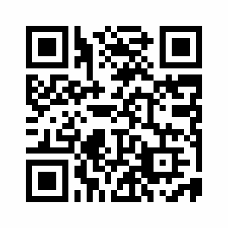
Cooperation | https://www.youtube.com/watch?v=uL5mHE3H5wE |  | 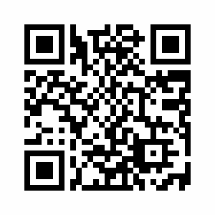
Social Skills for 4 to 6 year olds | https://www.youtube.com/watch?v=SwS2E1WPDlo |  | 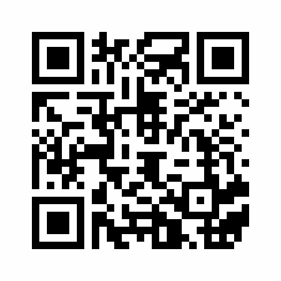
Work together as a team | https://www.youtube.com/watch?v=TZqFYtWCWXg |  | 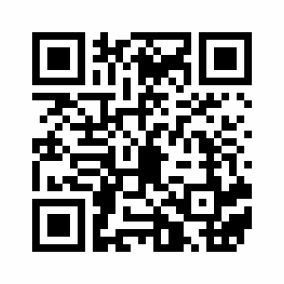
Sesame Street: Big Bird sings "That's Cooperation" | https://www.youtube.com/watch?v=kihZUsADQTQ |  | 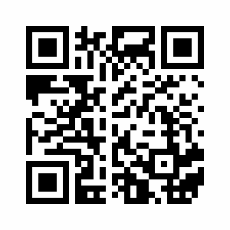
Posters and Visuals
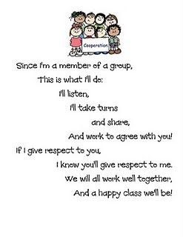 |  | 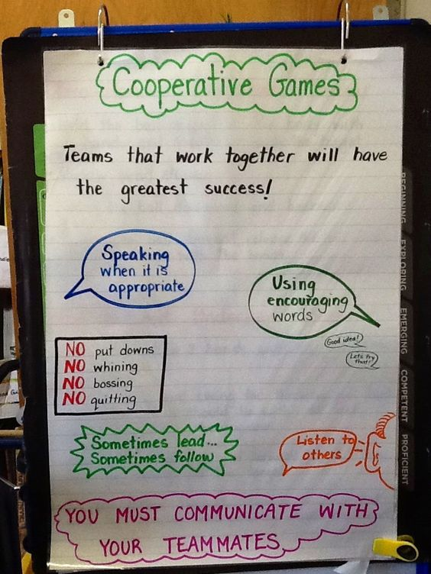

Collaboration | 1 | 2 | 3 | 4 | 5
Build team strengths | I rarely work productively with my group. My feedback is mainly negative. | I sometimes work productively with my group on the task at hand. I encourage my team members, but not always in a positive way. | I work productively in my group on the task at hand. I usually encourage my team members in a positive way. | I work productively in my group and I attempt to make sure that everyone is heard by sticking up for group members and inviting them to speak. I help make sure everyone contributes, by encouraging them in positive ways. | I work productively in my group and I actively prevent negativity, promote solutions and positive actions, and make sure every member of the team feels listened to and valued.
I Can Build On My Team’s Strengths Resources

Collaboration | 1 | 2 | 3 | 4 | 5
Evaluate the team | I rarely acknowledge what my group has accomplished. I don’t praise others yet. | I can praise my team on a job well done, but don’t always do so. | I can personally praise members when work has been done well and/or accomplished on time. | At the end of the group task, I am able to make the team feel proud of the work they have achieved and share our successes with people outside of our team. | At the end of the group task, I am able to make the team feel proud of the work they have achieved. I am able to reflect positively on improvements for next time, and share our successes with people outside of our team.
I Can Evaluate My Team Resources

I Can Help Find Solutions Resources
Collaboration | 1 | 2 | 3 | 4 | 5
Find solutions | I do not start solving problems on my own yet. | I sometimes can identify a problem but need support to find solutions. | I can identify a problem but need support breaking it down into smaller tasks. I can start solving the problem. | I can identify a problem, and can brainstorm and suggest strategies for solving. I can collaborate with others to solve it. | I can recognise a problem and break it up into smaller tasks, and collaborate with others to solve it effectively.

