Ottawa high school student dies after explosion at school

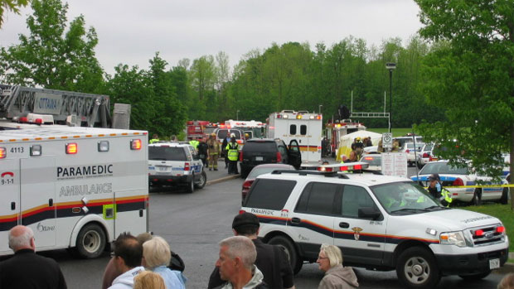

May 26, 2011

By CBC News
CBC News

The 18-year-old critically injured in an explosion Thursday at an Ottawa high school has died from his injuries, CBC News has learned.
The 18-year-old student critically injured in an explosion Thursday at an Ottawa high school has died from his injuries.
CBC News has confirmed that Eric Leighton died Thursday evening in hospital, following an explosion during an auto shop class at Mother Teresa Catholic High School.
Emergency crews were called to the scene at 10:40 a.m. Thursday morning after an empty 55 US gallon drum containing oil residue exploded in the school's auto shop class, according to a joint statement from Ottawa police, fire services and paramedics.
Leighton was rushed to Ottawa Hospital's Civic campus. His injuries were considered life threatening and at one point, he was revived after having no vital signs.
On Thursday evening, students returned to the school to join friendship and sympathy circles. Classmates of Leighton's described him as popular and athletic. 'Everybody loved him'
"He was one of our main athletes. He was like the jock of the school and he was so popular, and everybody loved him," said Nick Romain, one of the teen's classmates.
"There was not one person who Eric didn't affect, who he didn't talk to, and it just breaks my heart. He was a close friend and it sucks that this happened."
The last time Brenna Thompson saw Eric was at the prom last Friday. "He was really into sports, like lacrosse. He was really good," she said, holding back tears. "He had a little sister and stuff. He always looked out for her and he cared about everybody."
Four other students and one teacher were taken to hospital as a precaution to check for possible concussive injuries.
A hazardous materials team has deemed the school safe.
A drum of oil in the shop is believed to have ignited, causing the blast, according to witnesses. It is not known exactly how the drum exploded, but students from the class said it contained peppermint oil, which is combustible when exposed to heat.
Apparently building barbecues
Police Const. Marc Sousy and fire services spokesman Marc Messier both said the students were believed to be building barbecues in the class.
The school of about 1,400 was evacuated and students transported to Longfields-Davidson Heights Secondary School. In a release, the Ottawa Catholic School Board said a team of psychologists, staff and chaplains was at Longfields-Davidson Heights to provide emotional counselling to staff and students.
Students and a teacher told CBC News that the school's public address system was down, and the order to evacuate had to be given from class to class.
Ottawa Mayor Jim Watson issued a statement expressing shock over the incident. "My heart goes out to the students and teachers at the school, their families and their friends," he said.

http://www.cbc.ca/news/canada/ottawa/story/2011/05/26/ottawa-school-explosion.html

https://www.scribd.com/doc/144684102/Leighton-family-lawsuit-against-school-board-teacher

