Table of Contents (click on icon to access specific section)

Profile
<Insert picture here> | First Name, Last Name  <Insert brief bio here> | What is important to you?
Key Interests and Motivators | At work | Outside of work
Preferred Work Style
How would you like feedback delivered? (i.e., written, verbal, with positive first, with positive second, short and direct, etc.))
How do you like to process data and observation notes?
(i.e., talk to process, think time alone, time to write, other?)
What else do you want me to know about you as a teacher and learner?
When you need a little pick-me-up or encouragement, something that we might do/say/procure that you’d really appreciate
Favorites | Candy: <insert here>  Snack: <insert here>  On campus beverage of choice: <insert here>  Breakfast item: <insert here>

<INSERT CAMPUS VISION HERE>

Note: This document is a template to help you think and collect information in a way that others have found useful. It is not perfect. Feel free to organize your goal and vision in another way that make sense to you (in collaboration with your coach or Kristen).
Personalized Learning Classroom Vision Template

Goal: What my students and I will accomplish during the 2018-2019 school year.
NON-ACADEMIC SMART GOAL(S)
What work will students produce that will demonstrate that they have reached the goal?
How will you measure whether or not students have met the goal at the end of the year?
Why does this goal matter?
Mantra: a one-liner, Synthesize your class goal into one student friendly sentence.
Your Mantra
What can you do to introduce this?
What can you do everyday to reinforce this?
Connection to Campus Vision, <insert campus vision>
How does your mantra and class goal reinforce the vision you have set with your colleagues?

The World Series Playbook
PL Rubric: Phase 1 Self-Assessment + Circuit Training
In Phase 1 of the PL Coaching + Development rubric, prioritized strands are foundational skills in a personalized learning environment. Without these as a baseline, increasingly complex personalization will be challenging.

- Phase 1 Self-Assessment (Click here for video of directions)
  - Review the rubric row
  - Copy + paste the PL light bulb icon (below) in the box that represents your current proficiency level.
  - Provide a rationale on why you selected the proficiency level that you did.
  - Note: There is a space to link resources and capture insight as you dig deeper into each indicator.

Example

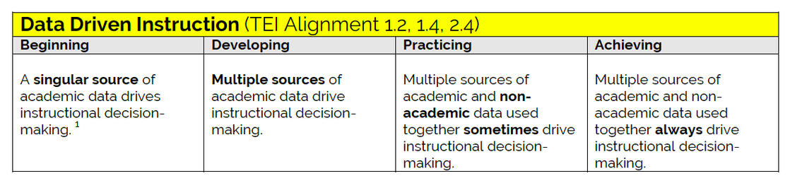
Rationale: 3/6 week common assessment, daily DOL’s, and TEK-aligned products of learning from the independent station determine student grouping for extension + intervention every week. I do not use any non-academic data at this point in my instruction.
Resources I want to check-out:  - Google forms |  | Notes:  - Students are able to articulate a rationale grounded in data for why they are working on their current task.  - In PLCs, teachers regularly analyze academic and non-academic data together to make decisions on how to best support all students.

Self-Assessment:

Rationale:
Resources I want to check-out: |  | Notes:

Self-Assessment:
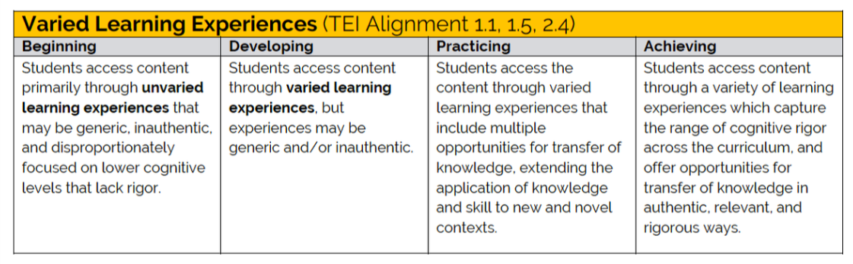
Rationale:
Resources I want to check-out: |  | Notes:

Self-Assessment:
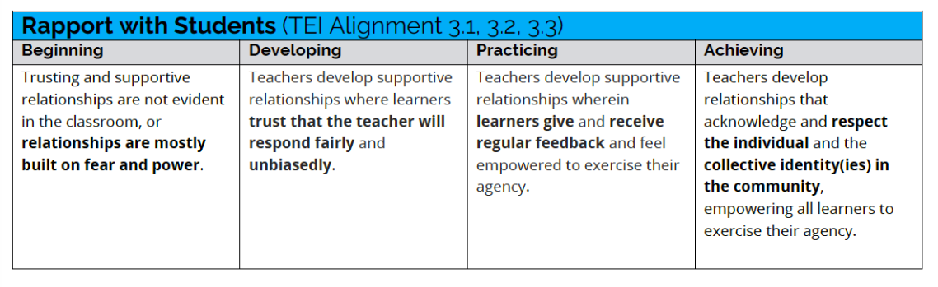
Rationale:
Resources I want to check-out: |  | Notes:

Self-Assessment:
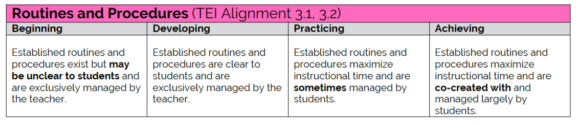
Rationale:
Resources I want to check-out: |  | Notes:

Self-Assessment:
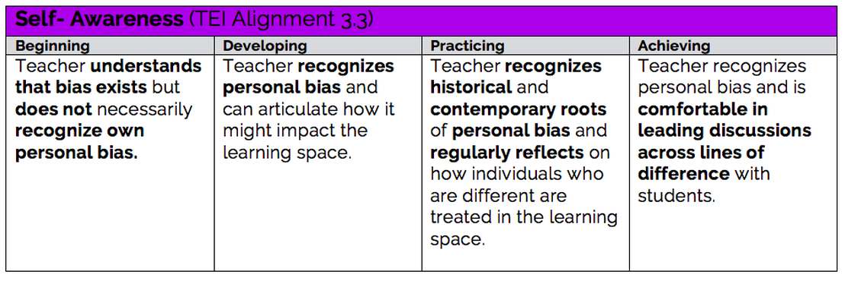
Rationale:
Acknowledge your identity, values, emotions + biases and reflect on how it might impact your classroom

 |  | 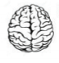 | 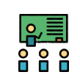
https://static1.squarespace.com/static/57c6b79629687fde090a0fdd/t/58dbe553e6f2e1051b333a6f/1490806101842/Empathy+Techniques+for+Pursuing+Educational+Equity.pdf
<type values here> | <type emotions here> | <type biases here> | <type impact on classroom here>

Phase 1 Reflection
Now that you have had time to explore the PL Toolbox, exemplars from PL teachers that align to Phase 1 of the rubric, and created goals for each indicator, respond to the following guiding questions to reflect on how this experience and new learning will impact your PL practice.

How does using a Learner Profile empower you to drive your learning and advocate for what you need in order to be successful?
What are 1-2 BIG takeaways you have after the Phase 1 Circuit Training?

