Scholastic and Hello Reader have partnered to bring you some terrific resources. Check out the Scholastic website for purchasing options:
Level 1: https://goo.gl/Yx5mMX
Level 2: https://goo.gl/KPizo8

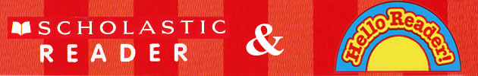

Scholastic Talk About:
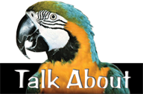
Grades 1–8
Get your ELL students Talking, Comprehending, and Writing
Talk About is a series of non-fiction books designed to provide models of everyday English Language for students who are learning English or who have limited English language skills regardless of their age or grade. Talk About introduces your students to the structure, patterns, and vocabulary of everyday language through talking, reading, and writing.

Ordering information: http://education.scholastic.ca/category/TALK-ABOUT

Very Easy True Stories: A Picture-Based First Reader:

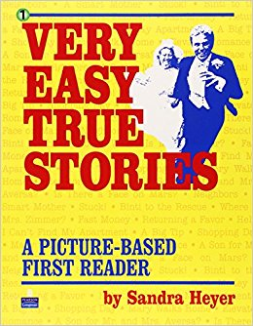

Hands-On English Language Learning:

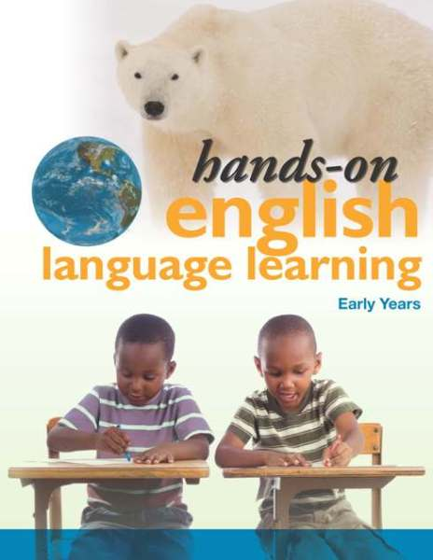

Early Years: http://www.portageandmainpress.com/product/hands-on-english-language-learning-early-years/

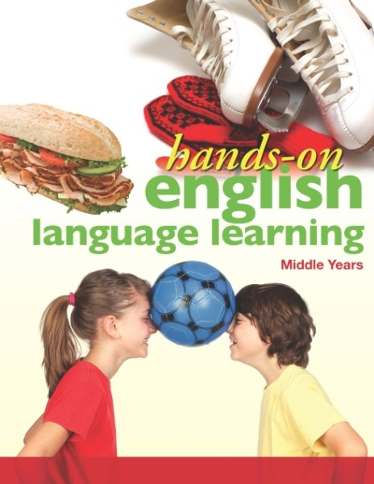

Middle Years: http://www.portageandmainpress.com/product/hands-on-english-language-learning-middle-years/

Tumblebooks: Sign in with your library card to access lots of great books

