When you are consider these apps, please contact the Sun West tech office to inquire about our volume-purchasing program.
Make brief notes by the apps that you explore so that you can report back to the group.
Sight Words by Photo Touch: (free download)
A fun and addictive way to learn sight words by sight, sound & touch
https://itunes.apple.com/us/app/sight-words-by-photo-touch/id421341850?mt=8

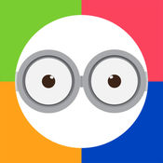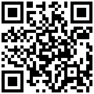

BrainPOP Featured Movie: (free download)
Learn something new every day!
https://itunes.apple.com/ca/app/brainpop-featured-movie/id364894352?mt=8

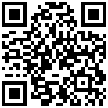

Fun English: (Android App - free download)
English Learning Games for Kids. Educational activities to teach kids how to read, speak & spell in English.
https://play.google.com/store/apps/details?id=com.pumkin.fun&hl=en

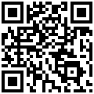

Seesaw: App (free download) and web-based
Student driven digital portfolios and simple parent communication.
https://web.seesaw.me/
https://itunes.apple.com/ca/app/seesaw-the-learning-journal/id930565184?mt=8
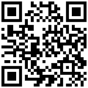
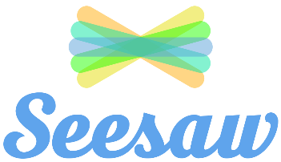

Duolingo: App (free download) and web-based
Duolingo is the world's most popular way to learn a language. It's 100% free, fun and science-based. Practice online on duolingo.com or on the apps!
https://www.duolingo.com/
https://itunes.apple.com/ca/app/duolingo/id570060128?mt=8
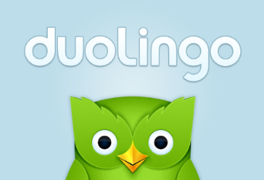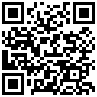

Dragon Dictation: (free download)
Dragon Dictation is an easy-to-use voice recognition application.
https://itunes.apple.com/ca/app/dragon-dictation/id341446764?mt=8

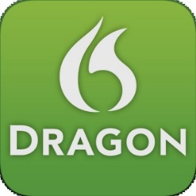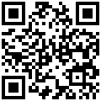
Book Creator: App (free download) and web-based
https://bookcreator.com/
https://itunes.apple.com/ca/app/book-creator-for-ipad/id442378070?mt=8

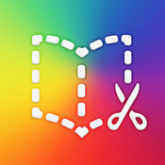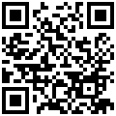

Microsoft Translator: App (free download from Microsoft, Google and Apple)
Microsoft Translator enables you to translate text or speech, have translated conversations, and even download languages to use offline.
https://play.google.com/store/apps/details?id=com.microsoft.translator&hl=en
https://itunes.apple.com/ca/app/microsoft-translator/id1018949559?mt=8
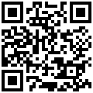
https://www.microsoft.com/en-ca/store/p/translator/9wzdncrfj3pg

