CommonLit has a FREE collection of hundreds of short stories, poems, historical documents, and more for students in grades 5-12. The texts selections include fiction and non-fiction. The collection can be searched and filtered by lexile, grade, theme, genre, book pairings, literary device and units (a new feature).
CommonLit lessons include reading passages and associated question sets. Teacher can assign lessons digitally by creating classes of students, or the lessons can be printed and distributed to the class.
Students can TRANSLATE words and phrases into other languages or hear the READ ALOUD. Guided Reading Mode helps struggling readers with a supportive, extra layer of questions.
Once your students turn in their assignments, they are reading for your feedback. You can easily score their responses with one click!
You can access FREE reports that identify where your student need extra support or remediation.
There are a number of ways to use CommonLit with the students in your class:
- Digitally (on computers)
- Printables only
- Digital and print
Creating a Commonlit account:
- Visit www.commonlit.org to set up a free account as an educator.
- You will be given the option of setting up a class in which you can enter your students. The students will need to set up an account as well.
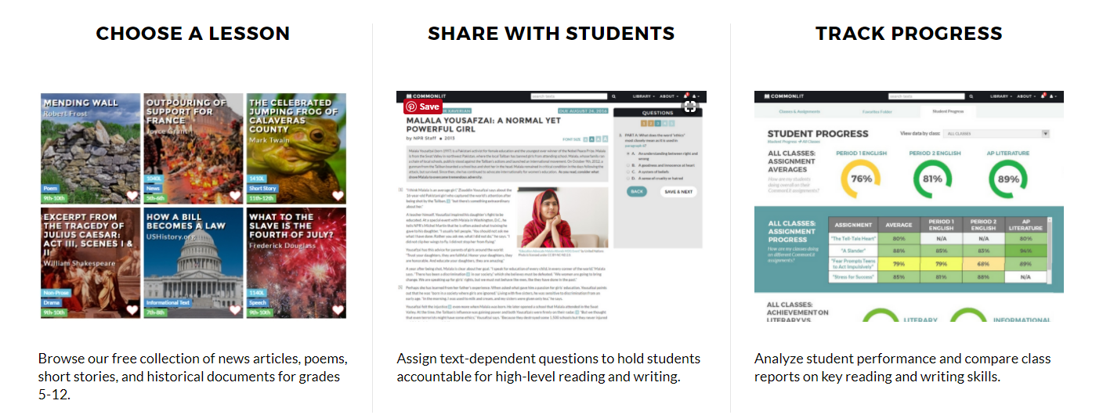
- Assignments and reports can be generated for the students in your class.

