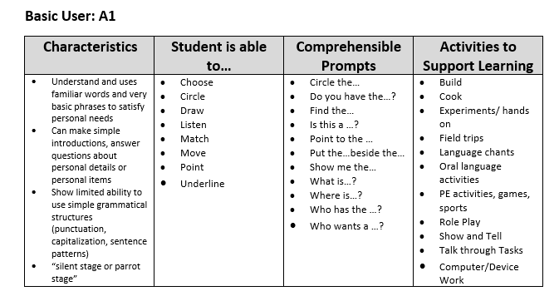
RESOURCES:
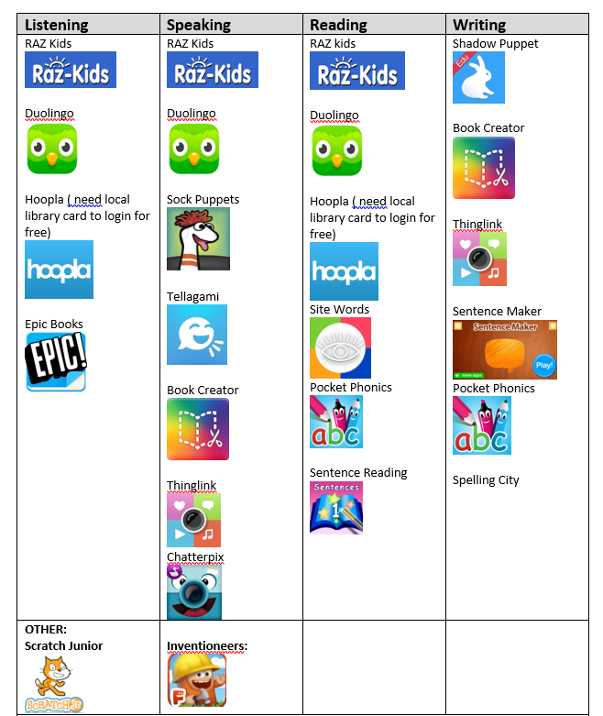
CFR ASSESSMENT TOOLS:
Initial Interview:
<<Initial EAL Interview.docx>>

Entering:
Entering Assessment A
<<Entering Assessment A.pdf>>

Entering Assessment A Part 2
<<Entering Assessment A part 2.pdf>>

EAL Math Assessment
<<EAL Math Assessment.pdf>>

WEBSITES:
Alphabetantics Wiki: http://alphabetantics.wikispaces.com/Aa
Browser Books: https://sites.prairiesouth.ca/legacy/cassidy.kathy//browserbooks/counting.htm
Site Word Sets: https://sites.prairiesouth.ca/legacy/cassidy.kathy//s_words_index.htm
Online Reading: https://staff.prairiesouth.ca/sites/kcassidy/reading/
Reading Strategies Wiki: http://readingstrategiesthatwork.wikispaces.com/home
A Variety of Videos showcasing EAL teaching strategies

CREATING GRAPHIC ORGANIZERS:
http://graphicorganizer.net/

https://www.worksheetworks.com/miscellanea/graphic-organizers.html

http://freeology.com/graphicorgs/

http://www.visiblethinkingpz.org/VisibleThinking_html_files/VisibleThinking1.html

http://www.techlearning.com/blogentry/9736

http://education.wm.edu/centers/ttac/documents/packets/graphicorganizers.pdf

