Exemplar:
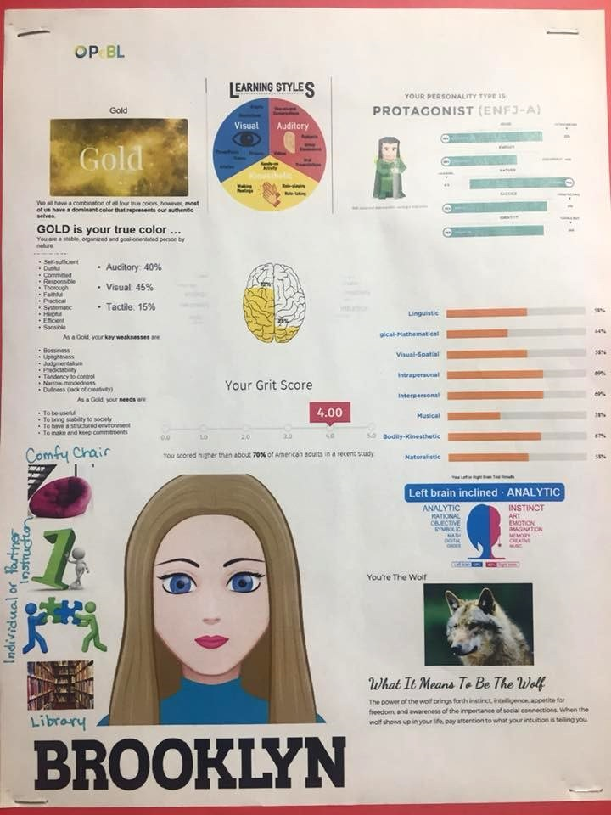

Grade 5-12 LEARNING PROFILE
“You learn not because you have to but because it is who you are”
Name:____________
Find a picture of where you work best and paste it on your profile. You may pick more than one.
Where do I work best?
Desk | Hallway | Library | On Computer
Comfy Chair | Somewhere Private | Table | Other:

I learn best with this type of instruction:

Whole Class Instruction | Small Groups | Partners | Individually

Personality Test:
1. Identify your four letter personality type combination (example: INTF)

2. Identify three strengths and three weaknesses that are associated with this personality type.
Strengths:

Challenges:

3. Identify characteristics of your personality that stick out to you:

How to collect Learner Profile information
Please snip it all Quiz results onto another document and save it to the Open Public Drive.

- Name & Pictures that describe you
- Students can draw, use clipart or real photos to describe them.

- Learning Environments
- See page above.
- Students can fill it out manually where they learn best. Add a picture from the internet about where you work best.
- See attached document for printable version and ideas for students
- What type of instruction do you prefer? Individually, whole class, partners, or small groups.

- Personality Color
- https://lonerwolf.com/true-colors-personality-test/

- Multiple Intelligence
- https://www.edutopia.org/multiple-intelligences-assessment

- Learning Styles
- http://www.educationplanner.org/students/self-assessments/learning-styles-quiz.shtml

- Left & Right Brain
- http://braintest.sommer-sommer.com/en/
- https://www.arealme.com/left-right-brain/en/

- Spirit Animal Online Resources:
- http://www.spiritanimal.info/spirit-animal-quiz/

- Grit Scale
- https://angeladuckworth.com/grit-scale/

- Personality Test
- https://www.16personalities.com/free-personality-test
- Copy and Paste your information into this document.
- Email yourself the result as a precautionary measure.

- Make a Characture
- www.avatarmaker.com

