**Exemplar**

**Credits to Shelley Follensbee**

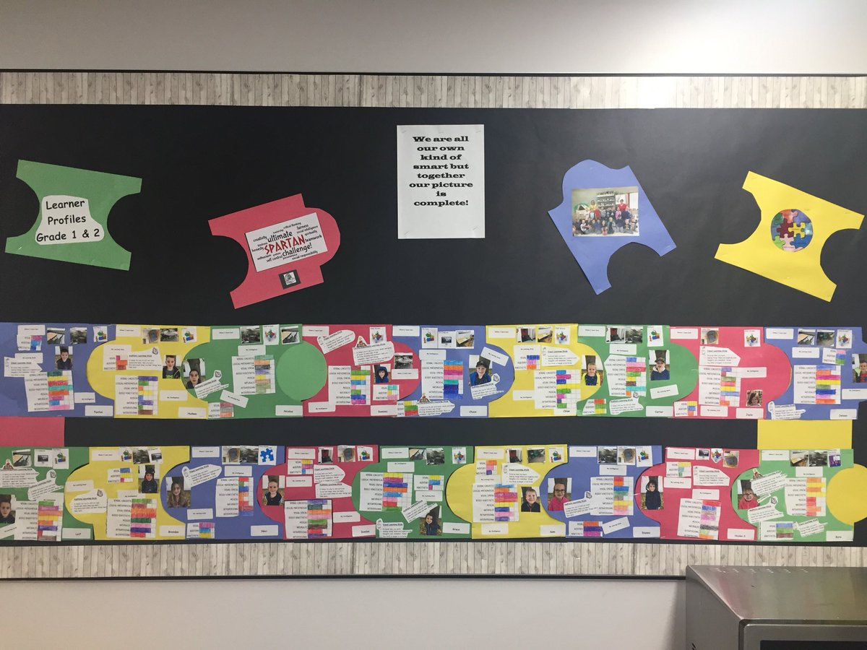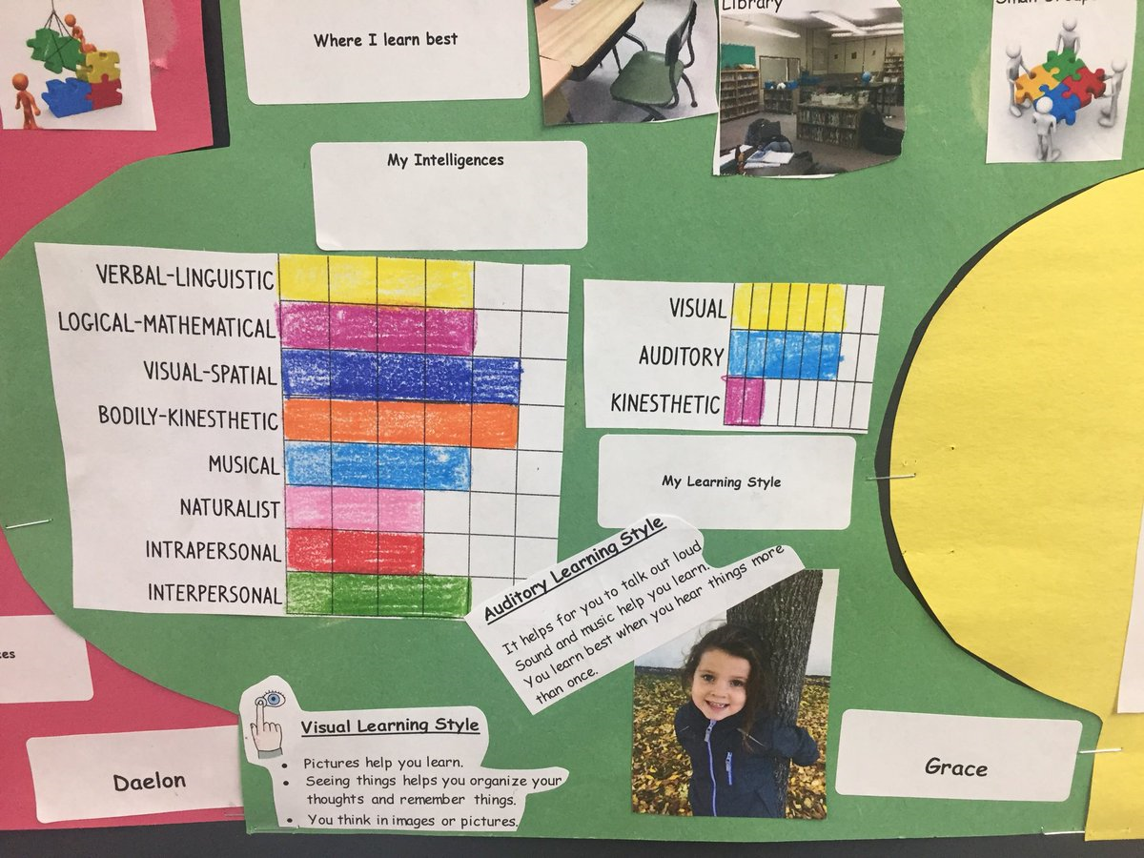

**Grade 1-3 LEARNING PROFILE**

|  |  |  |  |
| --- | --- | --- | --- |
| Where do I work best? (Put in pics from your school) | | | |
| Desk | Hallway  C:\Users\nichole.nessbredy\AppData\Local\Microsoft\Windows\INetCache\Content.Word\IMG_1194.JPG | Library  C:\Users\nichole.nessbredy\AppData\Local\Microsoft\Windows\INetCache\Content.Word\IMG_1193.JPG | On Computer  [Image result for COMPUTER](https://www.google.ca/url?sa=i&rct=j&q=&esrc=s&source=images&cd=&cad=rja&uact=8&ved=2ahUKEwj4p6qvv7vdAhW5GDQIHf3cD_oQjRx6BAgBEAU&url=https://www.hsn.com/shop/computers/ec0027&psig=AOvVaw1e2Rjx8g3Ej5Vd6yIyjtyO&ust=1537048863015075) |
| Comfy Chair | Somewhere Private  C:\Users\nichole.nessbredy\AppData\Local\Microsoft\Windows\INetCache\Content.Word\IMG_1195.JPG | Table | Other:  C:\Users\nichole.nessbredy\AppData\Local\Microsoft\Windows\INetCache\Content.Word\IMG_1199.JPG |

|  |  |  |  |
| --- | --- | --- | --- |
| I learn best with this type of instruction: | | | |
| Whole Class Instruction | Small Groups  [Image result for small group instruction puzzle](https://www.google.ca/url?sa=i&rct=j&q=&esrc=s&source=images&cd=&cad=rja&uact=8&ved=2ahUKEwjk-8z6lrvdAhXRIjQIHb9PCe4QjRx6BAgBEAU&url=https://sites.google.com/a/nau.edu/weilawke-technology-plan/implementation/professional-development&psig=AOvVaw2YV4j6dgI8ind9PczudpTF&ust=1537038000613923) | Partners  [Image result for whole group instruction puzzle](https://www.google.ca/url?sa=i&rct=j&q=&esrc=s&source=images&cd=&cad=rja&uact=8&ved=2ahUKEwjF-Kewl7vdAhVhGTQIHbrmAAMQjRx6BAgBEAU&url=http://youreflcorner.blogspot.com/2014/06/are-you-familiar-with-jigsaw-reading.html&psig=AOvVaw21PTkKA0HqQRQdLmTuvezX&ust=1537038118703418) | Individually |

**LEARNING STYLE SURVEY**

[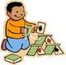](http://www.google.com/imgres?imgurl=http://www.picturesof.net/_images/A_Kid_Building_a_House_Cards_Royalty_Free_Clipart_Picture_090626-154828-844009.jpg&imgrefurl=http://www.picturesof.net/search_term_pages/playing_cards.html&usg=__GNI7EWwETy-EHWWIkWuOK-xtYWc=&h=99&w=100&sz=4&hl=en&start=46&zoom=1&itbs=1&tbnid=u6zziCjHhsrnKM:&tbnh=81&tbnw=82&prev=/images?q%3Dcartoon%2Bkid%2Bbuilding%26start%3D40%26hl%3Den%26sa%3DN%26gbv%3D2%26ndsp%3D20%26tbs%3Disch:1&ei=cyVgTd2JK8GqlAeohpXbCw)**1. I learn best when I…**

[](http://www.google.com/imgres?imgurl=http://www.clker.com/cliparts/3/0/3/8/1194986541442028018ear_-_body_part_nicu_buc_01.svg.hi.png&imgrefurl=http://www.clker.com/clipart-4337.html&usg=__npvJccP0KWMOFunfA1pf8A0y3yU=&h=599&w=360&sz=31&hl=en&start=6&zoom=1&itbs=1&tbnid=Mf_JrxWcaFaEmM:&tbnh=135&tbnw=81&prev=/images?q%3Dcartoon%2Bear%26hl%3Den%26sa%3DG%26gbv%3D2%26tbs%3Disch:1&ei=eSNgTeXdDsX_lgectszgCw)[](http://www.google.com/imgres?imgurl=http://www.picturesof.net/_images/Cartoon_Eyeballs_Royalty_Free_Clipart_Picture_081025-014900-295042.jpg&imgrefurl=http://www.picturesof.net/search_term_pages/eyeball.html&usg=__MT1eIgWzGgIyDgoZYCMs2x8r4MU=&h=100&w=89&sz=3&hl=en&start=4&zoom=1&itbs=1&tbnid=3rhvo8HYH8RuBM:&tbnh=82&tbnw=73&prev=/images?q%3Dcartoon%2Beyeball%26hl%3Den%26gbv%3D2%26tbs%3Disch:1&ei=JiNgTa2gI8Gclgfgy-n2Cw)

**see hear do**

**2. I like to do my work…**

[](http://www.google.com/imgres?imgurl=http://everydaywishes.net/cartoon_boy_25674847_std.jpg&imgrefurl=http://everydaywishes.net/page72.html&usg=__YLTvtPYCEiJAG28QO9wVY22K6Dc=&h=412&w=305&sz=10&hl=en&start=2&zoom=1&itbs=1&tbnid=wgoFmdS4aDB6GM:&tbnh=125&tbnw=93&prev=/images?q%3Dcartoon%2Bboy%26hl%3Den%26gbv%3D2%26tbs%3Disch:1&ei=OyRgTbO6MIO0lQfuo4n4Cw)

[](http://www.google.com/imgres?imgurl=http://jokesprank.com/blog/wp-content/uploads/2011/01/student-cartoon.gif&imgrefurl=http://jokesprank.com/blog/hindi-sms-jokes/hilarious-bad-hindi-shayari-sms-student-shayari-sms-jokes-arz-kiya-hain.html/attachment/student-cartoon&usg=__ArPQs-gdc4iNHkNbJISADr6Uq8E=&h=177&w=300&sz=24&hl=en&start=17&zoom=1&itbs=1&tbnid=MIjJJHPjjDMHfM:&tbnh=68&tbnw=116&prev=/images?q%3Dcartoon%2Bstudent%2Bdoing%26hl%3Den%26gbv%3D2%26tbs%3Disch:1&ei=6CNgTdWZI8GBlAfVtO3WCw)

**by myself in my group**

[](http://www.google.com/imgres?imgurl=http://www.vertigo-go.com/blogpics/sad-face&imgrefurl=http://vertigo-go.com/blog/category/random/&usg=__Ffw1ikIxYb4Pjuf05_LmyxC6JII=&h=250&w=250&sz=26&hl=en&start=3&zoom=1&itbs=1&tbnid=feYwvmUWG-AyrM:&tbnh=111&tbnw=111&prev=/images?q%3Dsad%2Bface%26hl%3Den%26sa%3DG%26gbv%3D2%26tbs%3Disch:1&ei=JSZgTb-HHsWAlAfQ763iBw)

[](http://www.google.com/imgres?imgurl=http://meds.queensu.ca/assets/happy-face-istock-456.jpg&imgrefurl=http://meds.queensu.ca/postgraduate/program_directors/pd_manual/happy_director&usg=__0kimwQqQ7_rM8ccs9XOmvrJ2mB4=&h=305&w=456&sz=18&hl=en&start=3&zoom=1&itbs=1&tbnid=opHv3-viCjqtlM:&tbnh=86&tbnw=128&prev=/images?q%3Dhappy%2Bface%26hl%3Den%26gbv%3D2%26tbs%3Disch:1&ei=9SVgTczSE8SBlAeBvMzkCw)

**3. I like it quiet.**

**4. When learning our sight words I like to:**

[](http://www.google.com/imgres?imgurl=http://www.dreamstime.com/girl-talking-thumb10303468.jpg&imgrefurl=http://www.dreamstime.com/royalty-free-stock-photos-girl-talking-image10303468&usg=___LUuRYz4E8__C2AHaRmgjqn-xo8=&h=450&w=375&sz=44&hl=en&start=4&sig2=5t6TV00gqZ27a5O0t0LD-w&zoom=1&um=1&itbs=1&tbnid=4_aqfCW6iczk_M:&tbnh=127&tbnw=106&prev=/images?q%3Dcartoon%2Bgirl%2Btalking%26um%3D1%26hl%3Den%26client%3Dgmail%26rls%3Dgm%26tbs%3Disch:1&ei=eUlgTa78NYKclgeMzpzxCw)[](http://www.google.com/imgres?imgurl=http://patricpeake.files.wordpress.com/2009/12/pencil1.jpg&imgrefurl=http://patricpeake.wordpress.com/ask-mpg/&usg=__o8GAukaMqnHXfpkNsPkv6siiXhA=&h=500&w=500&sz=28&hl=en&start=4&sig2=ybmqkSL7GhNQifON0yx_Sg&zoom=1&um=1&itbs=1&tbnid=j3Jf-Ioo6_qwWM:&tbnh=130&tbnw=130&prev=/images?q%3Dpencil%26um%3D1%26hl%3Den%26client%3Dgmail%26sa%3DN%26rls%3Dgm%26tbs%3Disch:1&ei=cUhgTczWKoSdlgfU0PD4Cw)

[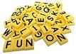](http://www.google.com/imgres?imgurl=http://ateachersupply.com/cart/images/Uppercase%20Tiles%2011.99%20%20EI1853.gif&imgrefurl=http://ateachersupply.com/cart/index.php?main_page%3Dproduct_info%26cPath%3D162_165_184%26products_id%3D245&usg=__SdKLo31xD_54z7K6xlaRHRPfwnc=&h=157&w=220&sz=21&hl=en&start=4&sig2=O-Xv40VJi9kRd64lrQ579Q&zoom=1&um=1&itbs=1&tbnid=XrXU_ZlOCDUaMM:&tbnh=76&tbnw=107&prev=/images?q%3Dletter%2Btiles%26um%3D1%26hl%3Den%26client%3Dgmail%26sa%3DN%26rls%3Dgm%26ndsp%3D18%26tbs%3Disch:1&ei=4UhgTZ-gJYP7lwfwho3iCw)

**write them spell them out loud**

**build them with letters**

[](http://www.google.com/imgres?imgurl=http://patricpeake.files.wordpress.com/2009/12/pencil1.jpg&imgrefurl=http://patricpeake.wordpress.com/ask-mpg/&usg=__o8GAukaMqnHXfpkNsPkv6siiXhA=&h=500&w=500&sz=28&hl=en&start=4&sig2=Eu8O8w2p0f57HKHA0ivYtw&zoom=1&um=1&itbs=1&tbnid=j3Jf-Ioo6_qwWM:&tbnh=130&tbnw=130&prev=/images?q%3Dpencil%26um%3D1%26hl%3Den%26client%3Dgmail%26rls%3Dgm%26tbs%3Disch:1&ei=pkpgTZHRA4O8lQe4h83pCw)[](http://www.google.com/imgres?imgurl=http://www.vectorstock.com/composite/213272/boy-idea-vector.jpg&imgrefurl=http://www.vectorstock.com/royalty-free-vector/213272-boy-idea-vector&usg=__iDEl0a1lueoE_3LVgpYhrRBTnx8=&h=400&w=380&sz=13&hl=en&start=6&sig2=YFreaqx7dqj6OaovtNlNrQ&zoom=1&um=1&itbs=1&tbnid=q5KWNd4ifWqf7M:&tbnh=124&tbnw=118&prev=/images?q%3Dcartoon%2Bboy%2Btalking%26um%3D1%26hl%3Den%26client%3Dgmail%26rls%3Dgm%26tbs%3Disch:1&ei=JkpgTcJOhIKUB5fRhPEL)**5. I like to…**

**count numbers out loud write numbers**

**[](http://www.google.com/imgres?imgurl=http://www.vertigo-go.com/blogpics/sad-face&imgrefurl=http://vertigo-go.com/blog/category/random/&usg=__Ffw1ikIxYb4Pjuf05_LmyxC6JII=&h=250&w=250&sz=26&hl=en&start=3&zoom=1&itbs=1&tbnid=feYwvmUWG-AyrM:&tbnh=111&tbnw=111&prev=/images?q%3Dsad%2Bface%26hl%3Den%26sa%3DG%26gbv%3D2%26tbs%3Disch:1&ei=JSZgTb-HHsWAlAfQ763iBw)6. I enjoy adding more detail to my sentences and pictures.**

**[](http://www.google.com/imgres?imgurl=http://meds.queensu.ca/assets/happy-face-istock-456.jpg&imgrefurl=http://meds.queensu.ca/postgraduate/program_directors/pd_manual/happy_director&usg=__0kimwQqQ7_rM8ccs9XOmvrJ2mB4=&h=305&w=456&sz=18&hl=en&start=3&zoom=1&itbs=1&tbnid=opHv3-viCjqtlM:&tbnh=86&tbnw=128&prev=/images?q%3Dhappy%2Bface%26hl%3Den%26gbv%3D2%26tbs%3Disch:1&ei=9SVgTczSE8SBlAeBvMzkCw)**

**7. My favorite free choice center is…**

[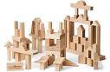](http://www.google.com/imgres?imgurl=http://www.dandelionsummers.com/assets/images/advanced_blocks.jpeg&imgrefurl=http://www.dandelionsummers.com/html/building_block.html&usg=__uL19BLXYxgjf-ZwTekAngUMV3jo=&h=293&w=450&sz=28&hl=en&start=1&sig2=zJzi5dk6AuFBKhD3ztv-IA&zoom=1&um=1&itbs=1&tbnid=5xLSUXCqIo9mZM:&tbnh=83&tbnw=127&prev=/images?q%3Dblocks%26um%3D1%26hl%3Den%26client%3Dgmail%26rls%3Dgm%26tbs%3Disch:1&ei=q0xgTeCwJMaAlAf1ns30Cw)[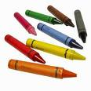](http://www.google.com/imgres?imgurl=http://www.sweetpeatowels.com/crayons.jpg&imgrefurl=http://www.sweetpeatowels.com/picture%20gallery&usg=__FaSAVxYxe0UPxhBpfRq45C45vJU=&h=300&w=300&sz=20&hl=en&start=4&sig2=Bz3pE8qrhgOL4EvGYUQPpg&zoom=1&um=1&itbs=1&tbnid=vW2oTIiJvrUiHM:&tbnh=116&tbnw=116&prev=/images?q%3Dcrayons%26um%3D1%26hl%3Den%26client%3Dgmail%26rls%3Dgm%26tbs%3Disch:1&ei=hktgTczLNoa8lQfFsozbCw)

[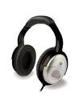](http://www.google.com/imgres?imgurl=http://www.popgadget.net/images/X-Fi-Headphones-Creative.jpg&imgrefurl=http://www.popgadget.net/2007/09/draft_headphone.php&usg=__c9doDuaapUDH6e6TPQqLnp3IgH4=&h=400&w=333&sz=30&hl=en&start=3&sig2=0_1vo3TiUXLBu6FPyxcRig&zoom=1&um=1&itbs=1&tbnid=JIflyy3O9gAbgM:&tbnh=124&tbnw=103&prev=/images?q%3Dheadphones%26um%3D1%26hl%3Den%26client%3Dgmail%26rls%3Dgm%26tbs%3Disch:1&ei=rUtgTZbtG8OclgeDo5jqCw)

**art and writing blocks and puzzles**

**listening (book on tape)**

[](http://www.google.com/imgres?imgurl=http://www.picturesof.net/_images_300/Cartoon_Little_Boy_Jumping_Rope_Royalty_Free_Clipart_Picture_090115-013251-524042.jpg&imgrefurl=http://www.picturesof.net/pages/090115-013251-524042.html&usg=__HIV7z8soR4mZeH3I2h_tboqNhlw=&h=300&w=271&sz=20&hl=en&start=4&sig2=3g_bb0a7QyzApKWOsMax_A&zoom=0&um=1&itbs=1&tbnid=rfAN_W5Vh0RIHM:&tbnh=116&tbnw=105&prev=/images?q%3Dcartoon%2Bkid%2Bjump%2Broping%26um%3D1%26hl%3Den%26client%3Dgmail%26rls%3Dgm%26tbs%3Disch:1&ei=YU1gTeX6LoT7lwfB6a31Cw)**8. At recess I play…**

[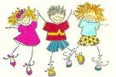](http://www.google.com/imgres?imgurl=http://sacramentoscoop.com/wp-content/uploads/2009/05/cartoon-children-playing.jpg&imgrefurl=http://sacramentoscoop.com/2009/05/05/&usg=__tCr7Y8z8KRKAKDR285S7gdrhRMU=&h=415&w=620&sz=87&hl=en&start=1&sig2=ml9HQxWr8Tt0Kw7PfQX4KQ&zoom=1&um=1&itbs=1&tbnid=T2BulCCASFNIJM:&tbnh=91&tbnw=136&prev=/images?q%3Dcartoon%2Bkids%2Bplaying%26um%3D1%26hl%3Den%26client%3Dgmail%26rls%3Dgm%26tbs%3Disch:1&ei=Ak1gTYLZOsT7lwfv67HWCw)

**with my friends play by myself**

**9. My favorite time at school is…**

[](http://www.google.com/imgres?imgurl=http://www.istockphoto.com/file_thumbview_approve/401798/2/istockphoto_401798-sports-balls.jpg&imgrefurl=http://www.istockphoto.com/stock-photo-401798-sports-balls.php&usg=__oseJK9Z8ZF1igUg_MkhXV1QUo_o=&h=267&w=380&sz=23&hl=en&start=3&sig2=7TZt7MjkeWrBJ4dBI_MYjQ&zoom=1&um=1&itbs=1&tbnid=S29rmvNq2nMI7M:&tbnh=86&tbnw=123&prev=/images?q%3Dsports%2Bballs%26um%3D1%26hl%3Den%26client%3Dgmail%26rls%3Dgm%26tbs%3Disch:1&ei=iU5gTZmlFIKBlAflr8zrCw)[](http://www.google.com/imgres?imgurl=http://blogs.voices.com/buzz/music-notes.jpg&imgrefurl=http://blogs.voices.com/buzz/2008/07/&usg=__FESMm4E1j5o3fcwMg4TgmWlflx8=&h=400&w=400&sz=23&hl=en&start=3&sig2=Sdv8-TJGvT3McpIqL7356A&zoom=1&um=1&itbs=1&tbnid=cxpz731FV9MrYM:&tbnh=124&tbnw=124&prev=/images?q%3Dmusic%26um%3D1%26hl%3Den%26client%3Dgmail%26rls%3Dgm%26tbs%3Disch:1&ei=ZE5gTeKwMMGclgfEzcDbCw)[](http://www.google.com/imgres?imgurl=http://art-canyon.com/wp-content/uploads/2010/10/paint-brush.jpg&imgrefurl=http://art-canyon.com/2010/10/different-types-of-paint-brushes/&usg=__gejFSpfSpn9KpWoN_cnfYGNYsLA=&h=292&w=300&sz=31&hl=en&start=3&sig2=E5N9PNbbOdMlVgdHyshQYw&zoom=1&um=1&itbs=1&tbnid=XX-1cMv2qL2KRM:&tbnh=113&tbnw=116&prev=/images?q%3Dpaintbrush%26um%3D1%26hl%3Den%26client%3Dgmail%26rls%3Dgm%26tbs%3Disch:1&ei=HU5gTdPbLYKglAfzt9DWCw)

[](http://www.google.com/imgres?imgurl=http://cdakiwanis.files.wordpress.com/2009/04/girl-in-desk-cartoon.jpg&imgrefurl=http://cdakiwanis.wordpress.com/2009/04/23/woodland-middle-school-school-within-a-school-program/&usg=__IvkeHf2uD1Us5E_3vXFNFFZydHc=&h=288&w=235&sz=16&hl=en&start=3&sig2=QEXJQJINs10KsqOPxQ1y_Q&zoom=1&um=1&itbs=1&tbnid=E3SKL2OSRkC9iM:&tbnh=115&tbnw=94&prev=/images?q%3Dcartoon%2Bstudent%2Bat%2Bdesk%26um%3D1%26hl%3Den%26client%3Dgmail%26rls%3Dgm%26tbs%3Disch:1&ei=RE9gTbGBHIOclgeKpdzlCw)**art music p.e.**

[](http://www.google.com/imgres?imgurl=http://www.istockphoto.com/file_thumbview_approve/12052247/2/istockphoto_12052247-happy-cute-litte-boy-kid-reading-book-cartoon-illustration.jpg&imgrefurl=http://www.istockphoto.com/stock-illustration-12052247-happy-cute-litte-boy-kid-reading-book-cartoon-illustration.php&usg=__fuvtAbIxI5RXp_hsq-TGMApjEHw=&h=364&w=380&sz=44&hl=en&start=6&sig2=b-al_SJ3mZkDCGqYdwQ-SA&zoom=1&um=1&itbs=1&tbnid=wySUDMjvOU2niM:&tbnh=118&tbnw=123&prev=/images?q%3Dcartoon%2Bkid%2Breading%26um%3D1%26hl%3Den%26client%3Dgmail%26rls%3Dgm%26tbs%3Disch:1&ei=5k5gTZSMJ8KqlAfok8zxCw)

[](http://www.google.com/imgres?imgurl=http://l.thumbs.canstockphoto.com/canstock0257044.jpg&imgrefurl=http://www.canstockphoto.com/illustration/children.html&usg=__BkLdYkhD5jqMME5B_O8aMdQfvp8=&h=150&w=121&sz=23&hl=en&start=8&sig2=044SwDXomUEEUdV3b-W1rQ&zoom=1&um=1&itbs=1&tbnid=7idNZ0i9Vbm_RM:&tbnh=96&tbnw=77&prev=/images?q%3Dcartoon%2Bkids%2Bworking%2Btogether%26um%3D1%26hl%3Den%26client%3Dgmail%26rls%3Dgm%26tbs%3Disch:1&ei=i09gTejoBIOdlgeO9Kj2Cw) **quiet reading independent work time**

**learning centers (group work)**



Page 1

**How Do I Learn?**

Place a check (**✓**) in all the blanks that describe you. The list with the greatest number of checks is how you like to learn best.



**Visual Learning Style**

1. I remember best by writing things down or drawing pictures.

2. I ask for directions to be repeated.

3. I like to read about something rather than hear about it.

4. I am a good speller.

5. I like to learn with posters, videos, and pictures.

6. I am good at reading maps and graphs.

7. When someone is talking, I create pictures in my mind about what they are saying.

8. After school, I like to read books.

9. I like it when my teacher uses lots of pictures when teaching.

10. I can remember something if I picture it in my head.



**How many checks (✓) did you have?**

Remember to place a check (**✓**) in all the blanks that describe you.

Page 2

**Auditory Learning Style**



1. I remember best if I hear something.

2. It is easier for me to listen to a story on tape than to read it.

3. I understand better when I read out loud.

4. I follow spoken directions well.

5. I like to sing or hum to myself.

6. I like to talk to my friends or family.

7. Music helps me learn things better.

8. I can easily remember what people say.

9. It helps when the teacher explains posters or pictures to me.

10. I can remember more about something new if I can talk about it.

 **How many checks (✓) did you have?**

Remember to place a check (**✓**) in all the blanks that describe you.

Page 3



**Tactile/Kinesthetic Learning Style**

1. I remember best if I can make something that tells about what I am learning.

2. I would rather play sports than read.

3. I like playing card or board games to learn new things.

4. I like to write letters or write in a journal.

5. I like it when teachers let me practice something with an activity.

6. I like putting together puzzles.

7. If I have to solve a problem, it helps me to move while I think.

8. It is hard for me to sit for a long time.

9. I enjoy dancing or moving to music.

10. I like to act things out to show what I have learned.

 **How many checks (✓) did you have?**

**Tell Me . . .**

Page 4

Which list had the most (✓) checks?

Which list had the fewest (✓) checks?

Did you have any lists that had the same number of (✓) checks?

If so, which ones?

Do you think the list that had the most checks (✓) tells how you like

to learn best?

**What Does It Mean?**



**Visual Learning Style**



* Pictures help you learn.
* Seeing things helps you organize your

thoughts and remember things.

* You think in images or pictures. **Auditory Learning Style**

It helps for you to talk out loud.

Sound and music help you learn.

You learn best when you hear things more than once.

**Tactile/Kinesthetic Learning Style**

* It helps you to use your body, hands and sense

of touch to learn new things.

* Writing, drawing and movement help you

remember important things.

* You like to show what you have learned by

demonstrating or making projects.

Multiple intelligences Quiz: Questions for Grade 5/6 or Teacher to ask k-1-2 (For Picture below)

**Linguistic**

1. Do you like to read or listen to books?
2. Do you like to write your letters or name?
3. Do you like to talk or tell stories with friends and family?
4. Do you like to listen to friends or family speak?

**Logical Mathmatical**

1. Do you like to count?
2. Do you like to play with puzzles?
3. Are you good at the shape box game?
4. Do you like to do experiments?

**Visual Spatial**

1. Do you like to watch things?
2. Do you like to draw?
3. Can you imagine/picture things in your head?
4. Do you like to colour?
5. Do you like create maps or read them?

**Bodily Kinaesthtic**

1. Do you like to build things?
2. Do you like to act?
3. Do you like to touch things?
4. Do you like to move around? Run? Jump?
5. Do you like to dance?

**Musical**

1. Do you like to sing?
2. Do you like to rap?
3. Do you like to drum? Play an instrument?
4. Do you like to play music?

**Interpersonal**

1. Do you like to share with friends?
2. Do you like to teach others?
3. Do you like to work with others?
4. Do you like to talk out problems with friends?

**Intrapersonal**

1. Do you like to daydream?
2. If you are sad or upset do you speak to your family or go somewhere alone?
3. Do you like yoga?

**Naturalist**

1. Do you like being outside?
2. Do you love being with animals outdoors?
3. Do you care for your pets?
4. Do you like to explore or go on adventures?
5. What is your favorite color? (not in test just for the kids to colour the graph below)

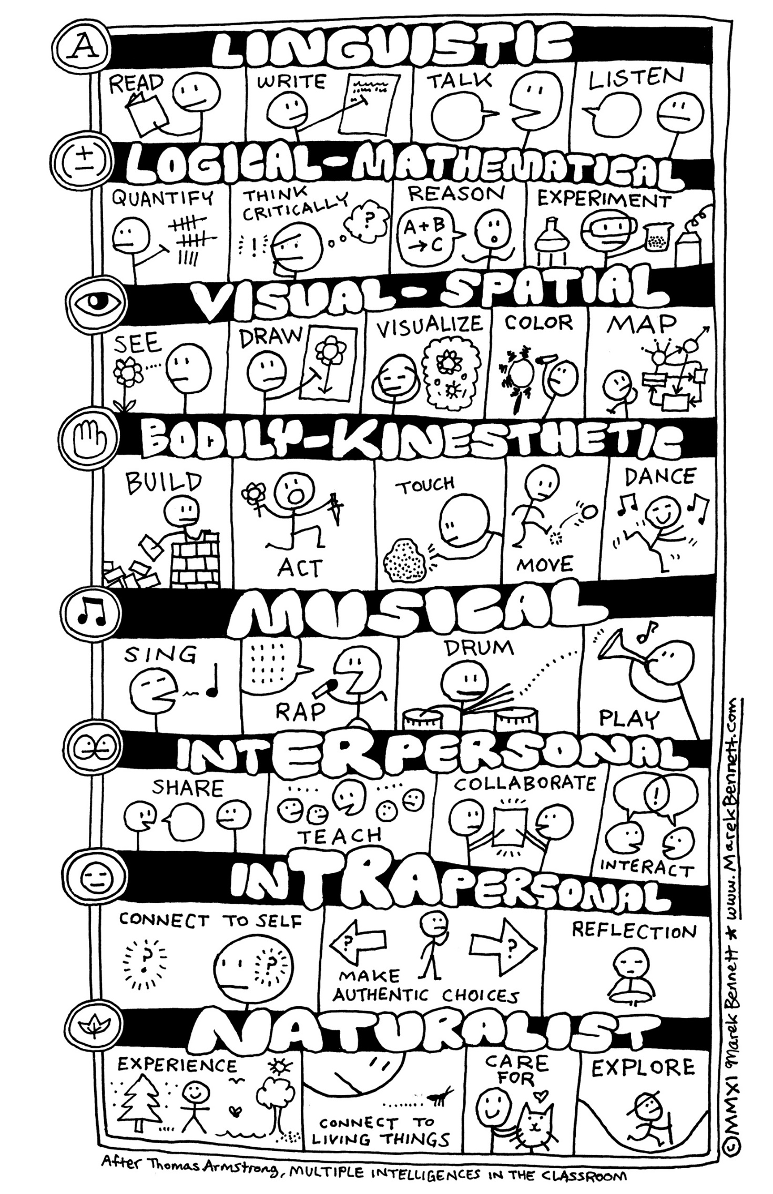

|  |  |  |  |  |  |  |  |  |  |  |  |  |  |  |  |  |  |  |  |  |  |  |  |  |  |  |  |  |  |  |  |  |  |  |  |  |  |  |  |  |  |  |  |  |  |  |  |  |  |  |  |  |  |  |  |  |  |  |  |  |  |  |  |  |  |  |  |  |  |  |  |  |  |  |  |  |  |  |
| --- | --- | --- | --- | --- | --- | --- | --- | --- | --- | --- | --- | --- | --- | --- | --- | --- | --- | --- | --- | --- | --- | --- | --- | --- | --- | --- | --- | --- | --- | --- | --- | --- | --- | --- | --- | --- | --- | --- | --- | --- | --- | --- | --- | --- | --- | --- | --- | --- | --- | --- | --- | --- | --- | --- | --- | --- | --- | --- | --- | --- | --- | --- | --- | --- | --- | --- | --- | --- | --- | --- | --- | --- | --- | --- | --- | --- | --- | --- |
| |  |  |  |  |  |  | | --- | --- | --- | --- | --- | --- | | Learning Style Colour in Graph | | | | | | | Auditory |  |  |  |  |  | | Kinesthetic |  |  |  |  |  | | Visual Spatial |  |  |  |  |  |  |  |  |  |  |  |  | | --- | --- | --- | --- | --- | --- | | Multiple Intelligences Colour in Graph | | | | | | | Linguistic |  |  |  |  |  | | Logical Mathematical |  |  |  |  |  | | Visual Spatial |  |  |  |  |  | | Kinesthetic |  |  |  |  |  | | Musical |  |  |  |  |  | | Interpersonal |  |  |  |  |  | | Intrapersonal |  |  |  |  |  | | Naturalistic |  |  |  |  |  | |