Kindergarten Exemplar
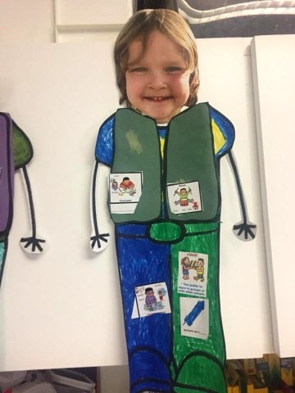

Inside his vest is more of the pictures from these Kindergarten Assessments. This assessment was done in a 40 minute period with the one on one assistance of the grade 5/6 class in Eaton School.

Kindergarten LEARNING PROFILE
Where do I work best? (Put in pictures of your own classroom)
Big TABLE  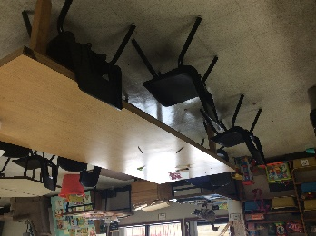 | Hallway  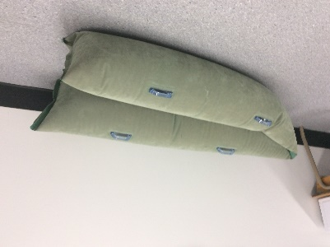 | Library  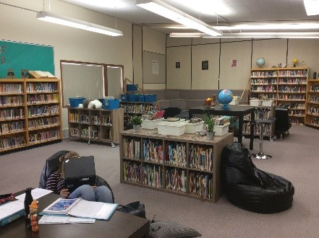 | Floor  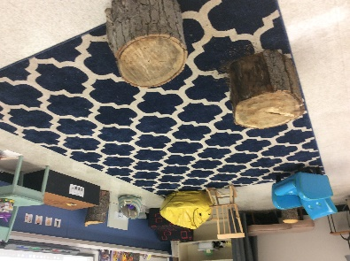
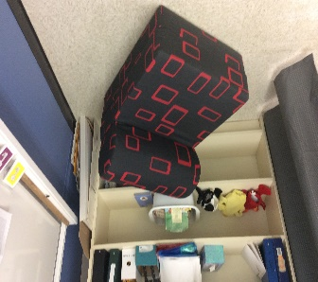  Comfy Chair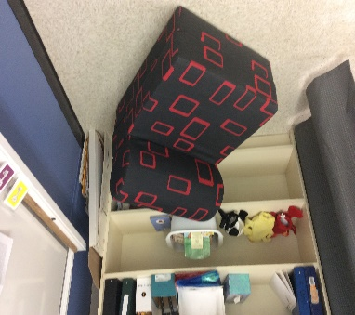 | Somewhere Private | Table  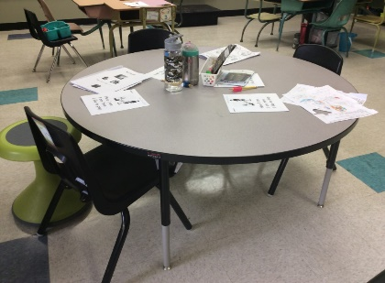 | Other:  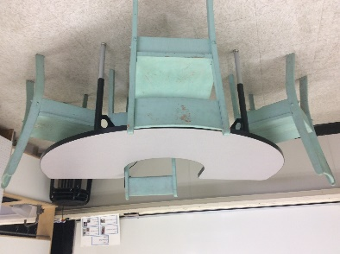

LEARNING STYLE SURVEY
1. I learn best when I…
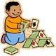

see hear do

2. I like to do my work…

by myself in my group

3. I like it quiet.

4. When learning about Itchy’s alphabet sounds, I like to:

write them Say or Sing them out loud

build them with play-doh or ABC toys
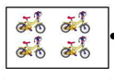
5. I like to…

count numbers out loud write numbers build/show numbers

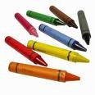
6. My favorite free choice center is…
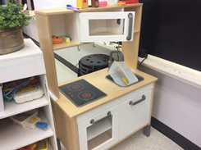
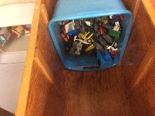
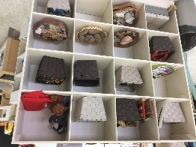
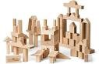
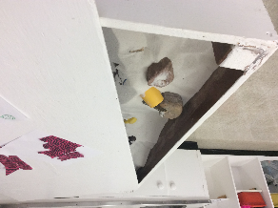

Art Loose Playdough & blocks Puzzles Cars Kitchen
Parts Sand Table

7. At recess I play…

with my friends play by myself
9. My favorite time at school is…

art music gym

quiet reading Play time

little jobs (group work)

Multiple intelligences Quiz: Questions for Grade 5/6 or Teacher to ask k-1-2
Linguistic
- Do you like to read or listen to books?
- Do you like to write your letters or name?
- Do you like to talk or tell stories with friends and family?
- Do you like to listen to friends or family speak?
Logical Mathmatical
- Do you like to count?
- Do you like to play with puzzles?
- Are you good at the shape box game?
- Do you like to do experiments?
Visual Spatial
- Do you like to watch things?
- Do you like to draw?
- Can you imagine/picture things in your head?
- Do you like to colour?
- Do you like create maps or read them?
Bodily Kinaesthtic
- Do you like to build things?
- Do you like to act?
- Do you like to touch things?
- Do you like to move around? Run? Jump?
- Do you like to dance?
Musical
- Do you like to sing?
- Do you like to rap?
- Do you like to drum? Play an instrument?
- Do you like to play music?
Interpersonal
- Do you like to share with friends?
- Do you like to teach others?
- Do you like to work with others?
- Do you like to talk out problems with friends?
Intrapersonal
- Do you like to daydream?
- If you are sad or upset do you speak to your family or go somewhere alone?
- Do you like yoga?
Naturalist
- Do you like being outside?
- Do you love being with animals outdoors?
- Do you care for your pets?
- Do you like to explore or go on adventures?

- What is your favorite color? (not in test just for the kids to colour the graph below)
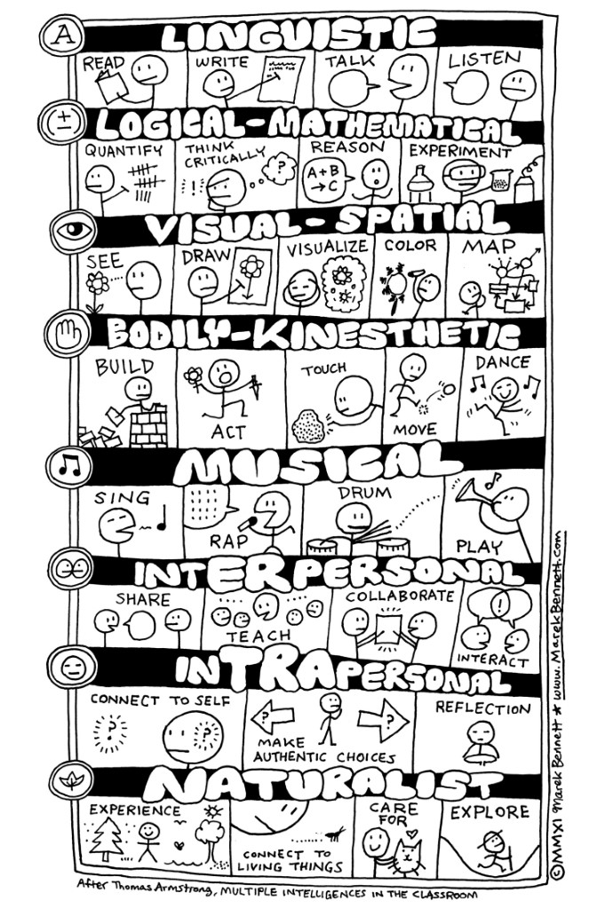

Learning Style Colour in Graph
Auditory

Kinesthetic

Visual Spatial

Multiple Intelligences Colour in Graph
Linguistic

Logical Mathematical
Visual Spatial

Kinesthetic

Musical

Interpersonal

Intrapersonal

Naturalistic

