Grade 3-4 LEARNING PROFILE
“You learn not because you have to but because it is who you are”
Where do I work best? (Put in pictures of your own classroom)
Desk  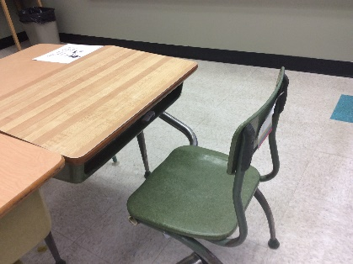 | Hallway  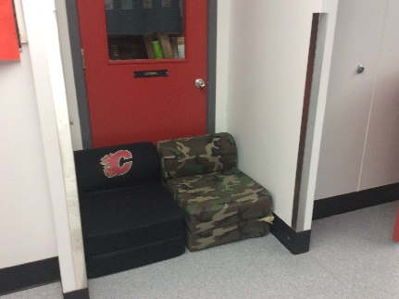 | Library  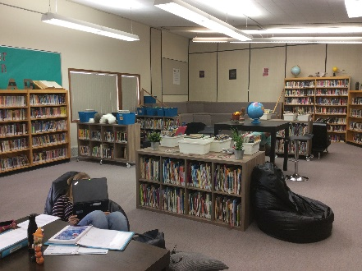 | On Computer  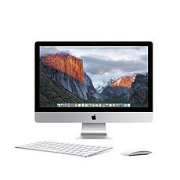
Comfy Chair  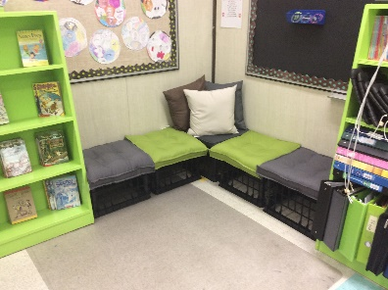 | Somewhere Private  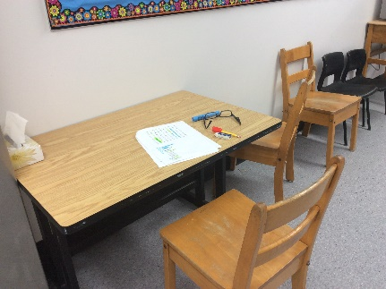 | Table  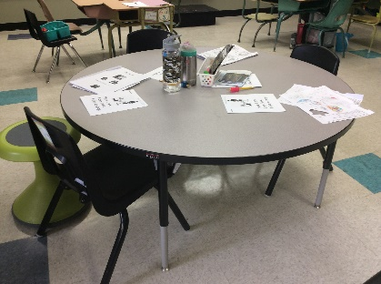 | Other:  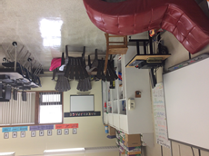

I learn best with this type of instruction:

Whole Class Instruction | Small Groups | Partners | Individually  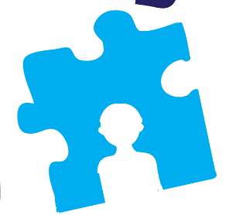

How to collect Learner Profile information
Grade 3/4
Please snip it all Quiz results onto another document and save it to the Open Public Drive.

- Name & Pictures that describe you
- Students can draw, use clipart or real photos to describe them.

- Learning Environments
- See page above.
- Students can fill it out manually where they learn best. Add a picture from the Boxes about where you work best. You may pick more than one.
- See attached document for printable version and ideas for students
- What type of instruction do you prefer? Individually, whole class, partners, or small groups.

- Personality Color
- Best to do this Quiz as a whole class discussion on smartboard to explain some of the vocabulary
- https://ces-personnel.ca.uky.edu/files/true_colors_test.pdf
- Quiz is above. Fill in and hand in to your teacher or helper.
- Students can snip-it the colour that they are.

- Multiple Intelligence
- https://www.edutopia.org/multiple-intelligences-assessment

- Learning Styles
- http://www.educationplanner.org/students/self-assessments/learning-styles-quiz.shtml
- Include this picture and write your results underneath

- Left & Right Brain
- http://braintest.sommer-sommer.com/en/

- Spirit Animal Online Resources:
- http://www.spiritanimal.info/spirit-animal-quiz/

- Create your Own Avatar
- https://www.avatarmaker.com

