NAME:
MEASURING PRACTICE - INCHES

Figure 1

1) As a group with the teacher you will label the increment for each line above. Your
measurements will range from 1” (inch) to 1/16” (inch). Make note how the length of the
lines change with each increment.

Figure 2
B A G E F C D J H I

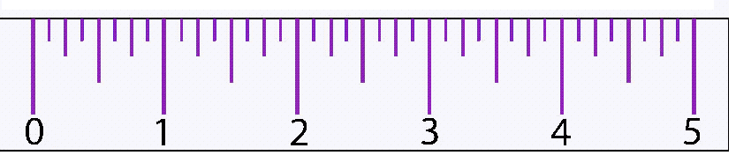

- Using Figure 2 write the measurement shown by each marking.

A._____” B. _____” C._____” D. _____” E._____”

F._____” G. _____” H._____” I. _____” J._____”

Figure 3 A B F C G H D I E J

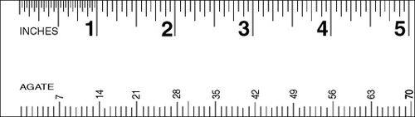

- Using Figure 3 write the measurement shown by each marking.

A._____” B. _____” C._____” D. _____” E._____”

F._____” G. _____” H._____” I. _____” J._____”

IMPERIAL MEASUREMENT TEST

Figure 4
A B C D E F G H I J

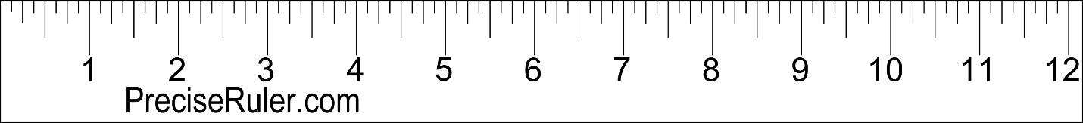

- Using Figure 4 write the measurement shown by each marking.

A._____” B. _____” C._____” D. _____” E._____”

F._____” G. _____” H._____” I. _____” J._____”

Figure 5
A B C D E F G H I J

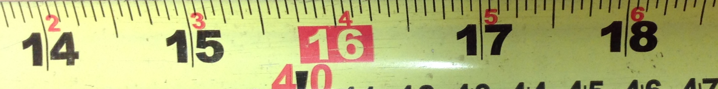

- Using Figure 5 write the measurement shown by each marking.

A._____” B. _____” C._____” D. _____” E._____”

F._____” G. _____” H._____” I. _____” J._____”

